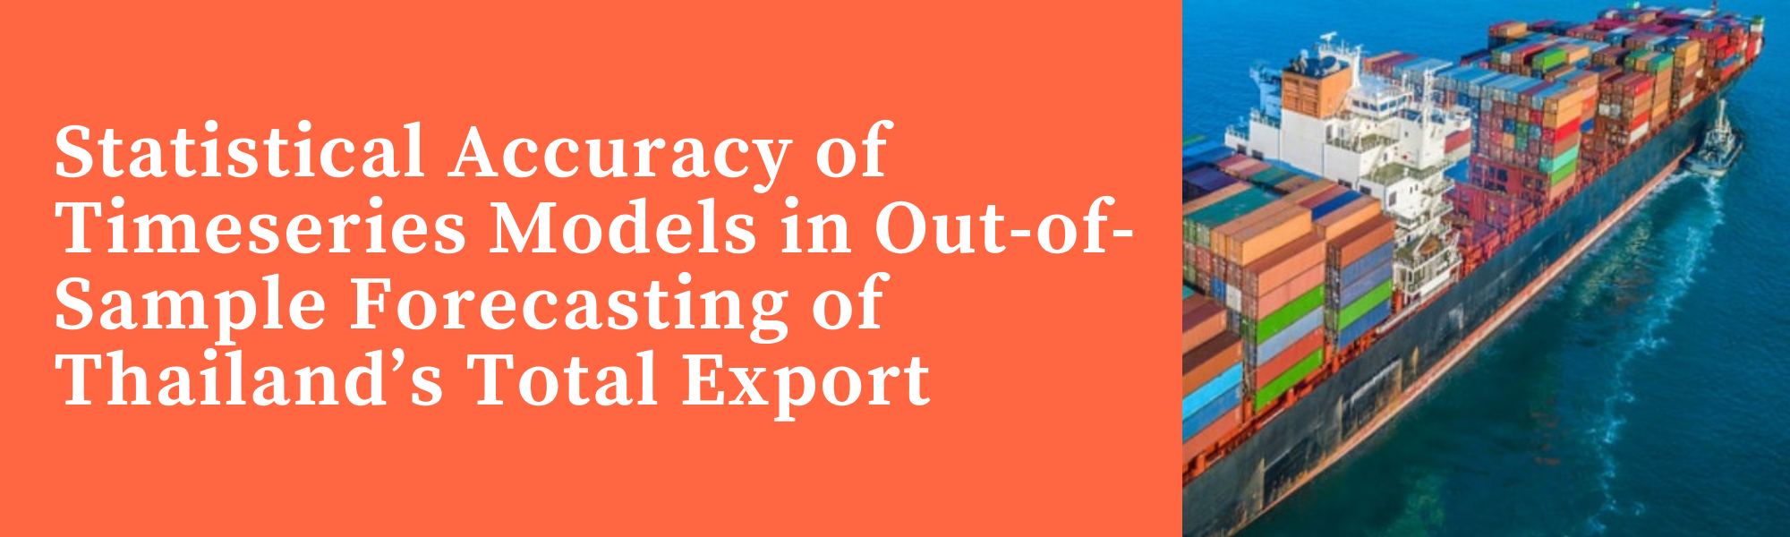

|  |  |
| --- | --- |
| Wilfred Edward Tan | **May 26, 2024** |
| **Problem Statement:**  **MoM Forecast of Thai Total Export Value (USD Millions)** | |

|  |  |  |
| --- | --- | --- |
| What I Know | What I Don’t Know | What I Found |
| Primary Factors:   * Historical Export Dataset   Secondary Factors:   * Thai Currency Strength to major export partners (US, China, Japan, Vietnam, Malaysia) * Weather, El Nino & Commodity Prices * GDP of partners & FDI Domestic Inflows | 1. Between Time-series Analysis of Primary & Factor Analysis of Secondaries, which should I prioritize 2. Industry Approaches/ Models 3. Seasonality Concerns | 1. On public datasets, Time-Series Analysis Present the best bang for buck, and outperforms multi-secondary-factor analysis and simple econometric models (More advanced and expensive survey and supply models will perform better) 2. Simple models like EMA, Auto-regressive models have outperformed more complicated models 3. Cross-Yearly MoM Deseasonality such as US Census X-13ARIMA preferred for economic data |

**Sub-Thesis: Key Learning Points I found**

|  |  |  |
| --- | --- | --- |
| No-change hypothesis is the best predictor as most exports have seasonal pattern but rare volatility surprises. This supports the idea of decomposition to tighten unnecessary error. | SARIMAX works best in Out-of-Sample prediction of Total and Individual Component Export Forecast | Re-constructing Total Exports from individual components have accumulated error affecting scale. However, I found that trend is preserved well and differs by a span of linear combinations. Optimization of linear combinations improved R^2 Significantly. |
| Timeseries have statistical AR properties and assumptions using Augmented Dickey-Fuller, KPSS, and ACF-PACF analysis | Forecasts are generally stable and near the actual but the model loses accuracy due to strong outlier surprises. This cannot be modeled on historical AR properties and require Surveys and Sentiment Factor Analysis | Weights are generally stable but require transformation due to Multi-collinearity from Sum=1 Constraint resulting in ill-conditioned matrix/singularity. Vector-AR and traditional regression models not recommended. DCR regression has higher R^2 then other models. Inverse-transformation back to original scale was found to result in forecast spike, hence a percentile-CAP simple algo was used. |

|  |
| --- |
| **Forecast: April 2024 Thai Total Export Value** |

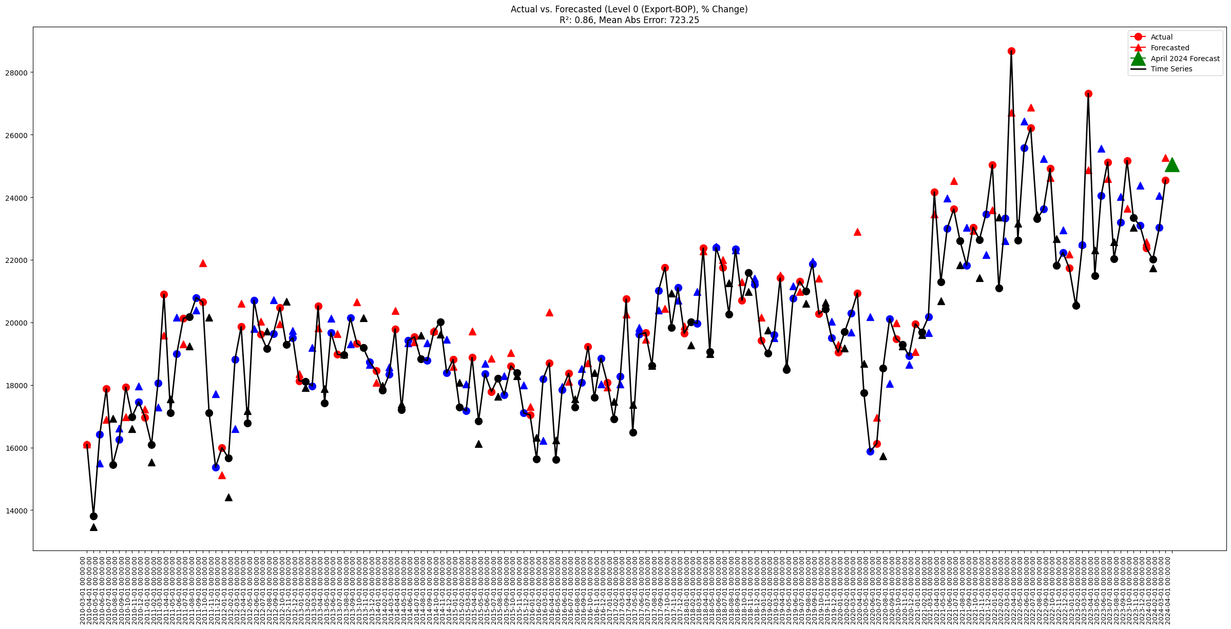

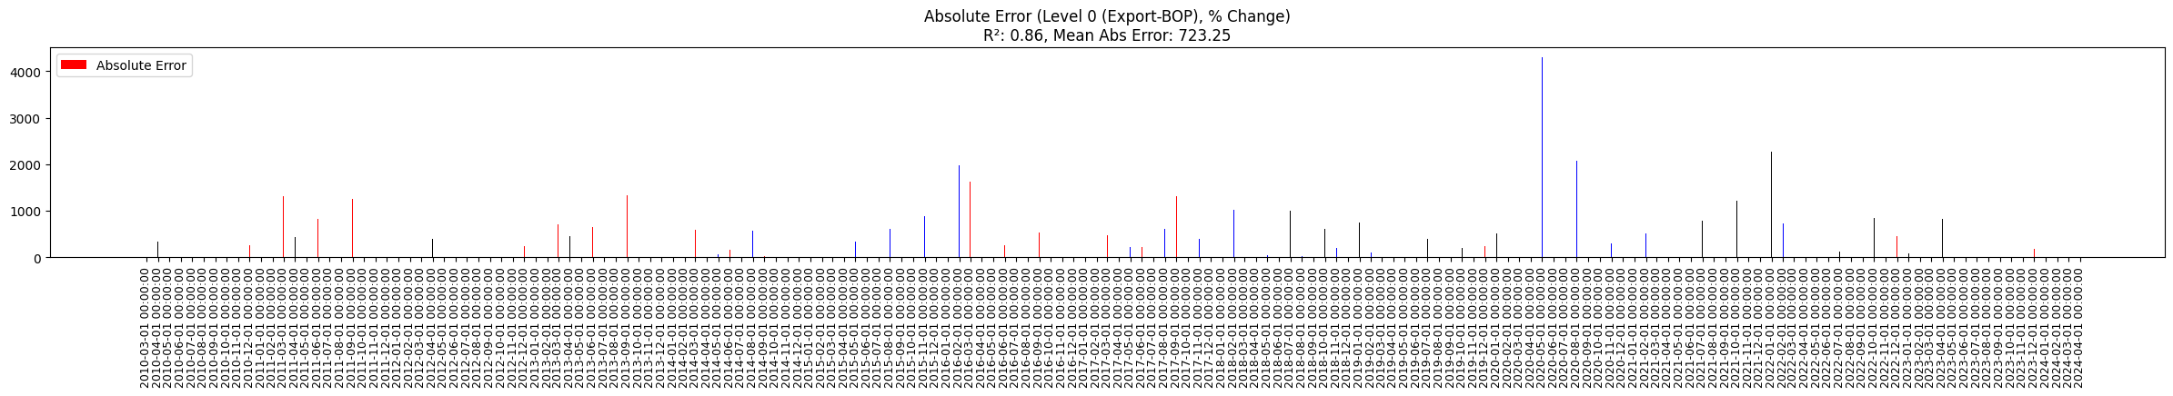

Figure 1. Export-BoP Rolling Out-of-Sample Forecast using Original TimeSeries with no Optimisation. ***R^2=0.86   
Table below contains the forecast values from different models for April 2024*** *(Unit : Millions of US Dollars)*

|  |  |  |
| --- | --- | --- |
| **Level 0 April 2024   (Export-BOP)** | **Level 1 April 2024   (Export-BOP)** | **Level 2 April 2024   (Export-BOP)** |
| Forecast: **25058.04** *(Out-of-Sample R^2:* ***0.86****)* | Forecast: **23787.26** *(Out-of-Sample R^2:* ***0.70****)* | Forecast: **25433.42** *(Out-of-Sample R^2:* ***0.75****)* |

*Result & Analysis of Models are located in BoT_Exports/3_stitching_series.ipynb*

**Discussion**

Level 0 Model is a Single Time Series Analysis directly on Export-BOP. This is the simplest model out of the three and the best performing historically as it does not consist of cumulative errors compared to the other two models which are reliant on 2 moving predictions 1) components weightage forecast, and 2)export value forecast. Model Hit and Miss Time Series visualization is shown above.

In Comparison, the benchmark, exponential smoothing (R^2: 0.63) underperforms all three models . Exponential smoothing is chosen as it has the least Mean Squared Error compared to simple econometric and more complex time series models across regimes. Generally, factor models like regression are harder to train and not recommended for predicting Export Value due to varying correlation over time.

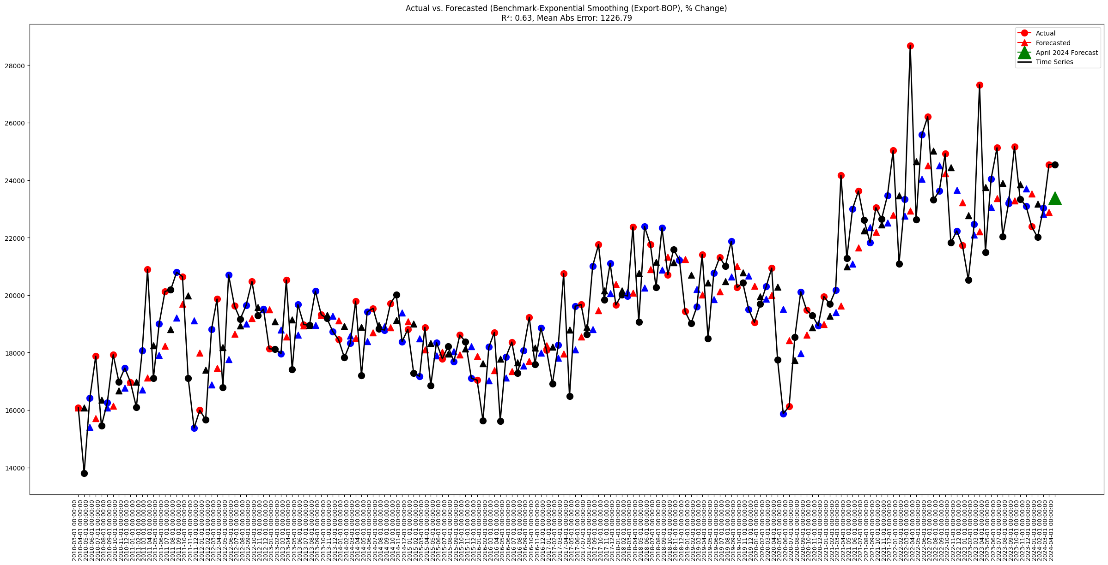

Level 1 & 2 Models present more room for improvement as they are constructed from the individual components which may benefit from more advanced individual component factor analysis. On a lower level compared to level 0, most of the component time series are statistically well-behaved and stable trend withing a band. I found that it is easy to control the outlier forecast, however, the main issue in the model misbehaving is due to sudden surprise spikes with no historical trend indication. This is impossible to forecast without the use of more advanced leading factors like supply survey, News Sentiment Analysis, and Policy/Business Health. I have downloaded Nino 3.4, FDI, Gold, Thai-USD FX and top Trading partners GDP from World Bank, FREDAPI, and other online public sources, but a quick dirty analysis showed little leading impact on export values, suggesting it being priced in (Did not include in the submission folder as the data was not actionable and hence i focused more primary timeseries forecast. To note: Level 1 and 2 has scaling issues when building back the combined weighted timseries and linear combination optimization was used. **Disclaimer:** Running a full walkforward optimization was computationally not feasible in the timespan, hence the linear combination adjustment was experimental and not rigorous in nature. However, Level 0 model is completely out-of-sample and rigorously simulated. Level 1 and 2 are also walk-forward out-of-sample simulated, with the exception of the linear-combination adjustment.

**Pre-linear-combination-adjusted:**

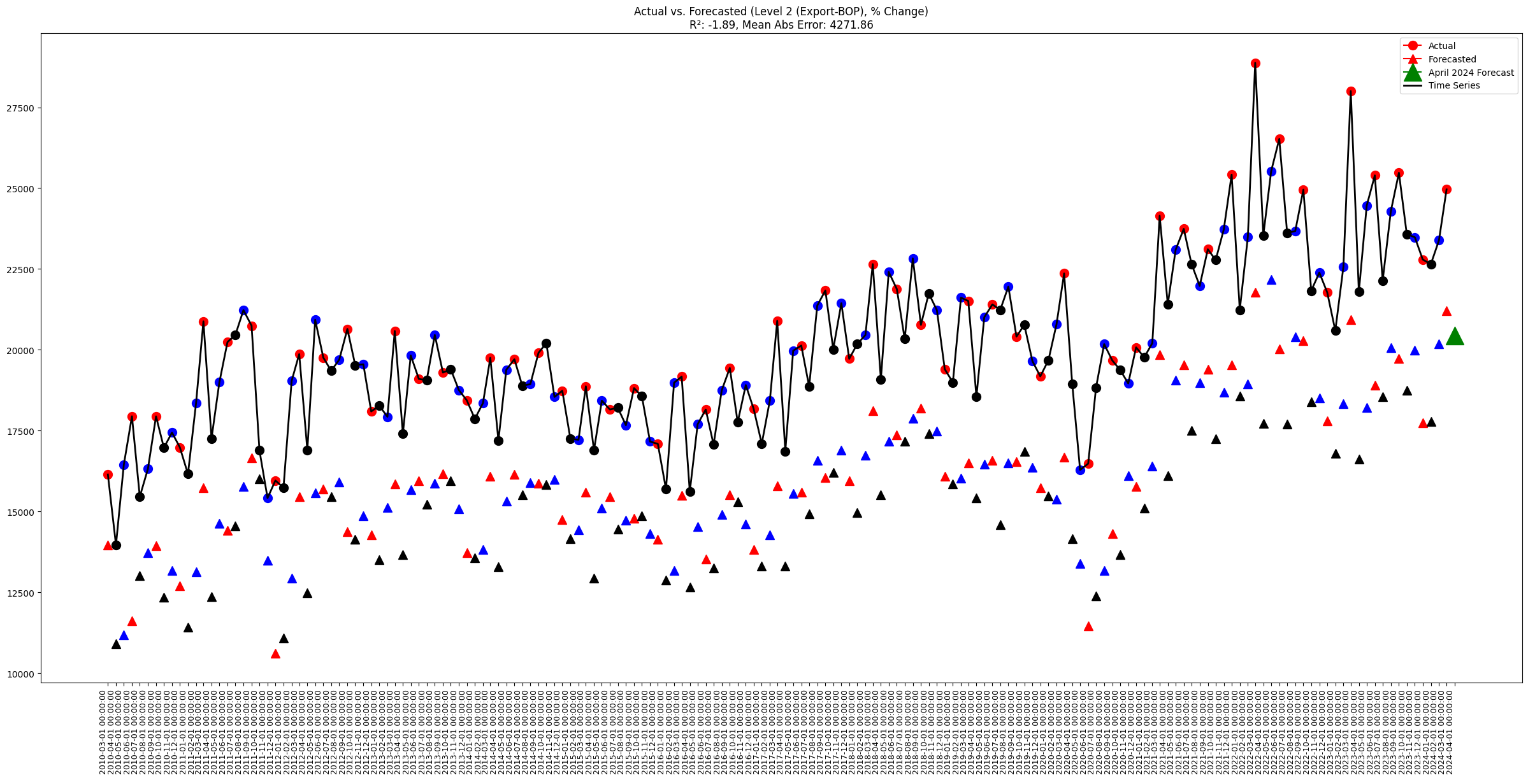

**Post-linear-combination-adjusted:**

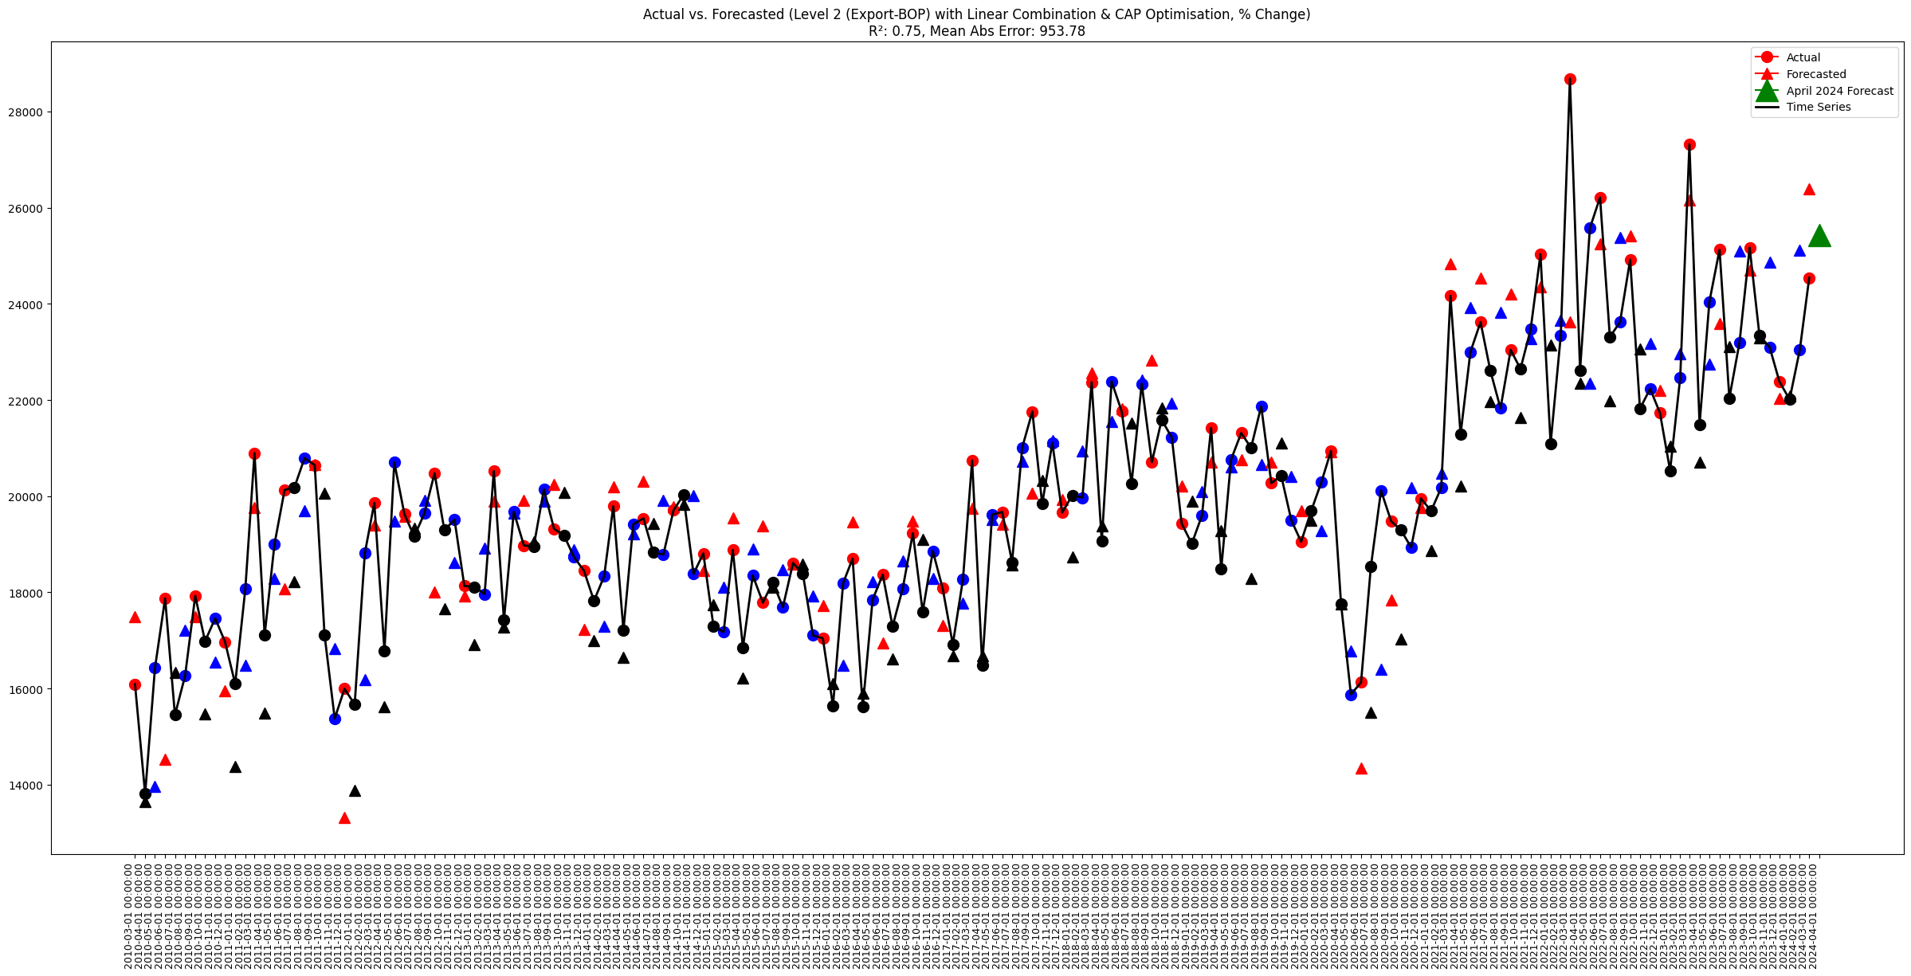

**Individual Components Stability Charts are in Appendix**

|  |
| --- |
| **Methodology** |

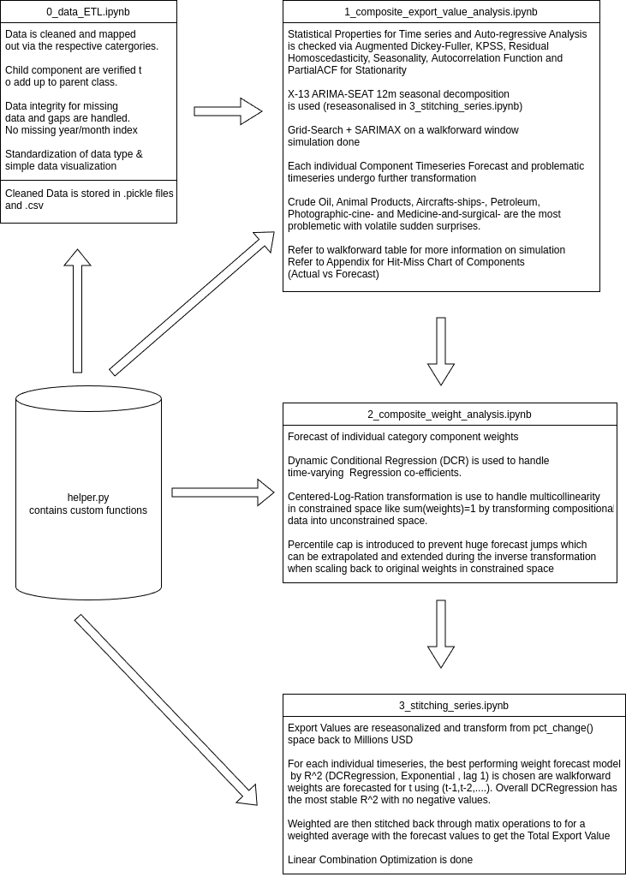

|  |
| --- |
| **Conclusion** |

* Historically Out-of-sample data can be predicted with statistical accuracy for Thailand Export Value
* There exist room for improvement via further stabilizing and introduction of factor analysis in the individual components, for example rolling correlation of Rice and El-Nino/Weather, commodities   
  with similar class products
* More rigorous testing should be done for optimization to prevent overfit (applicable to level 1and 2)
* However, usually simple models (level 0) that work well throughout regime without need for optimization are the best are they are robust and least likely to have compounding error across regime changes
* This project has taught me alot with structuring my approaches, focusing on the better return per time approaches, and solving matrix and re-construction errors which I am grateful for.

|  |
| --- |
| **Bibliography** |

1. **Kongcharoen, C., & Kruangpradit, T. (2013, June 23). Autoregressive Integrated Moving Average with Explanatory Variable (ARIMAX) Model for Thailand Export. Faculty of Economics, Thammasat University, Thailand; Thailand Ministry of Commerce.**
   * **Key Point:** This study finds that ARIMAX models with trade partners’ leading indicators outperform ARIMA models in forecasting exports to China, the EU, and the USA.
2. **Mahmoud, E., Motwani, J., & Rice, G. (1989). Forecasting US Exports: An Illustration Using Time Series and Econometric Models. American Graduate School of International Management, USA; Grand Valley State University, USA.**
   * **Key Point:** The study shows that simple time series techniques can forecast US exports more accurately than econometric models, emphasizing complementary forecasting approaches.
3. **Yusiana, E., Hakim, D. B., Syaukat, Y., & Novianti, T. (2022). Analysis of factors influencing Thai rice trade based on Gravity model. IOP Conference Series: Earth and Environmental Science, 951, 012039.**
   * **Key Point:** The gravity model identifies factors like GDP, distance, rice prices, production, and exchange rates influencing Thai rice exports, with importers' GDP and real exchange rates positively correlated.
4. **Pumjaroen, J., Vichitthamaros, P., & Sethapramote, Y. (2020). Forecasting Economic Cycle with a Structural Equation Model: Evidence from Thailand. School of Applied Statistics, National Institute of Development Administration, Thailand.**
   * **Key Point:** PLS-SEM model outperforms alternative models in forecasting Thailand's economic cycle, incorporating short, medium, and long-term composite leading indices.
5. **Dave, E., Leonardo, A., Jeanice, M., & Hanafiah, N. (2022). Forecasting Indonesia Exports using a Hybrid Model ARIMA-LSTM. Computer Science Department, Bina Nusantara University, Indonesia.**
   * **Key Point:** A hybrid ARIMA-LSTM model achieves the lowest error metrics in forecasting Indonesia’s exports, outperforming standalone models with a MAPE of 7.38%.
6. **Tyagi, A., & Shah, U. (2021). Modeling the Direction and Volume of Trade Flows in Global Crisis, COVID-19. The Institution of Engineers (India).**
   * **Key Point:** The ARIMA model shows that New Zealand's trade economy declined during the COVID-19 pandemic, recommending trade in essential goods to balance the economy.
7. **Romyen, A., Liu, J., & Sriboonchitta, S. (2019). Export–output growth nexus using threshold VAR and VEC models: Empirical evidence from Thailand. Economies, 7(2), 60.** 
   * **Key Point:** The TVAR model predicts Thailand's export-output growth, capturing inter-relationships and regime shifts, useful for multivariate time series analysis and forecasting.
8. **Kamoljitprapa, P., Polsen, O., & Abdullahi, U. K. (2023). Forecasting of Thai International Imports and Exports Using Holt-Winters’ and Autoregressive Integrated Moving Average Models. Journal of Applied Science and Emerging Technology (JASET) Vol, 22(3), 252955.** 
   * **Key Point:** Holt-Winters’ multiplicative model is recommended for forecasting Thai imports and exports, producing the lowest MAE and RMSE values, considering the impact of COVID-19.

|  |
| --- |
| **Appendix** |

**Summary of Thailand Export Macro Outlook**

**Foreign Direct Investment (FDI)**

* FDI brings in capital and advanced technologies, enhancing productivity and competitiveness in Thailand's manufacturing sector.
* Significant benefits observed in the electronics and automotive sectors.
* In January 2024, foreign direct investors committed nearly $200 billion in approved projects, a 40% increase over January 2023.
* FDI inflows positively correlate with Thailand's export growth, particularly in manufacturing, which receives the largest share of FDI.
* FDI helps integrate Thailand into global value chains (GVCs) and expands export markets.
* Foreign-owned firms accounted for around 60% of Thailand's total exports in 2021.
* OECD estimates foreign ownership increases productivity by 90%, wages by 20%, and export intensity by 70% in manufacturing compared to domestic firms.

**Supply by Thailand, Demand by Foreign Buyers (Key Goods)**

* **Sugar**: Expected 18% drop in production due to severe drought in the 2023/24 growing season, reducing output to 9 million tons.
* **Rubber**: Price increase in March 2024 due to supply shortages and high demand from the automotive and tire sectors.
* **Steel**: Challenges from cheap Chinese imports leading to an 11% decline in domestic production and sales from April to December 2023.
* **Semiconductors**: Sony's investment of 2.3 billion baht in 2023 to set up a new fabrication facility.

**Global Foreign Demand**

* **Semiconductors**: Projected 4.5% decline in global sales in Q1 2024 due to weakening consumer demand for electronic goods.
* **Vehicles**: Expected 3-4% decline in global light vehicle sales in Q1 2024, impacting Thai automotive exports.
* **Machinery**: Forecasted 5-7% decline in global demand for construction machinery in Q1 2024.
* **Chemicals/Plastics**: Expected growth of 2-3% and 3-4% respectively in global demand in Q1 2024, driven by construction, automotive, and consumer goods sectors.

**Currency Strength/Exchange Rate Dynamics**

* **Depreciation Against the US Dollar**: The baht has depreciated significantly, losing nearly 4% against the dollar in January 2024.
* **Impact of Foreign Investment**: Foreign investors selling Thai equities and bonds contributed to the baht's depreciation.
* **Regional Currency Dynamics**: The baht is among the weakest emerging market currencies, expected to weaken further to around 37.20 baht per US dollar.

**Economic Health of Domestic & Foreign Indicators**

* **Trade Balance**: Thailand recorded a trade deficit of $11.48 billion in 2022, continuing into 2024 with a $1.16 billion deficit in March 2024.
* **Inflation Rate**: Variable, with an increase to 0.19% in April 2024 from -0.47% in March 2024.
* **GDP Growth**: Modest growth of 1.5% year-on-year in Q1 2024, avoiding a technical recession with a quarterly growth of 1.1%.
* **Private Consumption and Investment**:
  + Private consumption rose by 6.9% year-on-year in Q1 2024.
  + Private investment increased in new industries and services, though public investment contracted.
* **Tourism**: Significant driver of economic activity, with 13.16 million foreign tourists from January to May 2024, up 39% year-on-year.

**Key Export Markets**

* Top export destinations in 2021:
  + United States: $41,225 million (15.46% share).
  + China: $36,577 million (13.72% share).
  + Japan: $24,558 million (9.21% share).
  + Vietnam: $12,276 million (4.60% share).
  + Malaysia: $11,875 million (4.45% share).

**Individual Export Value Forecast**

**Example Statistical Checks**

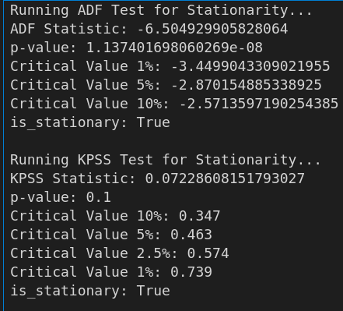

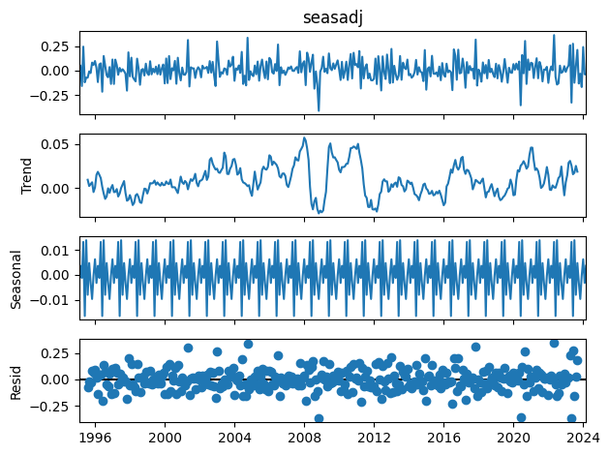

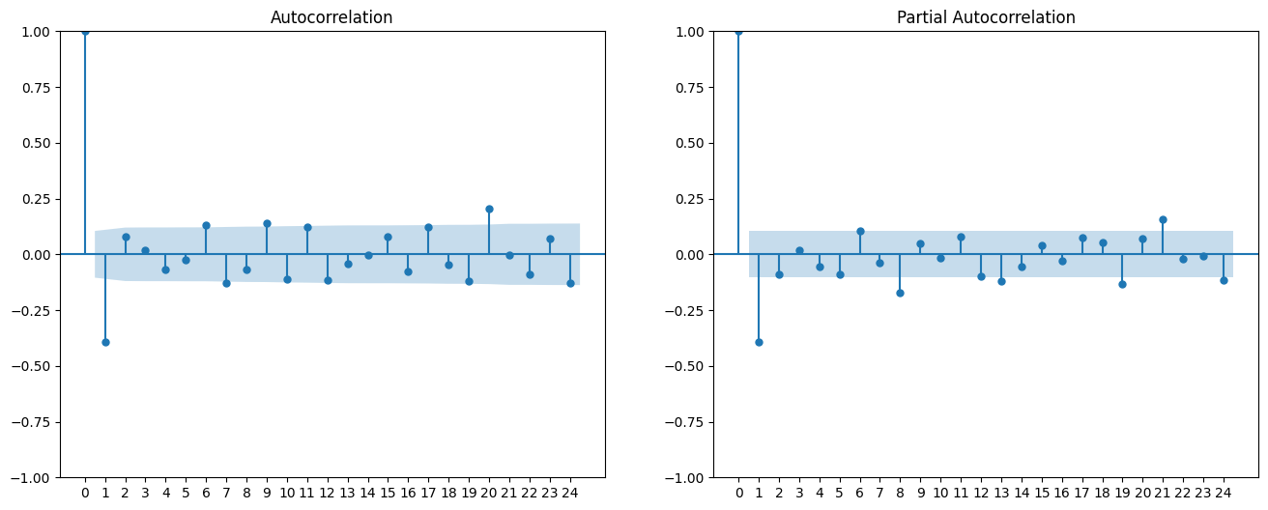

**Forecast Hit-Miss**

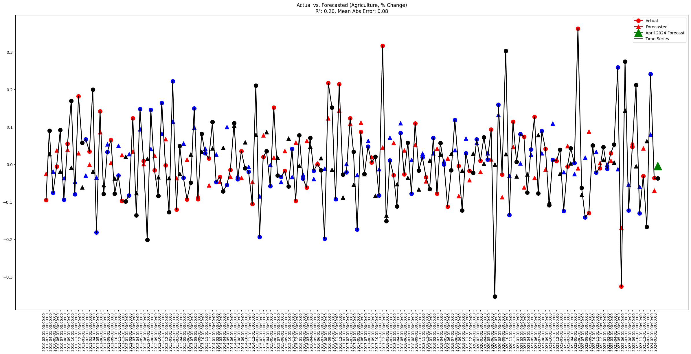

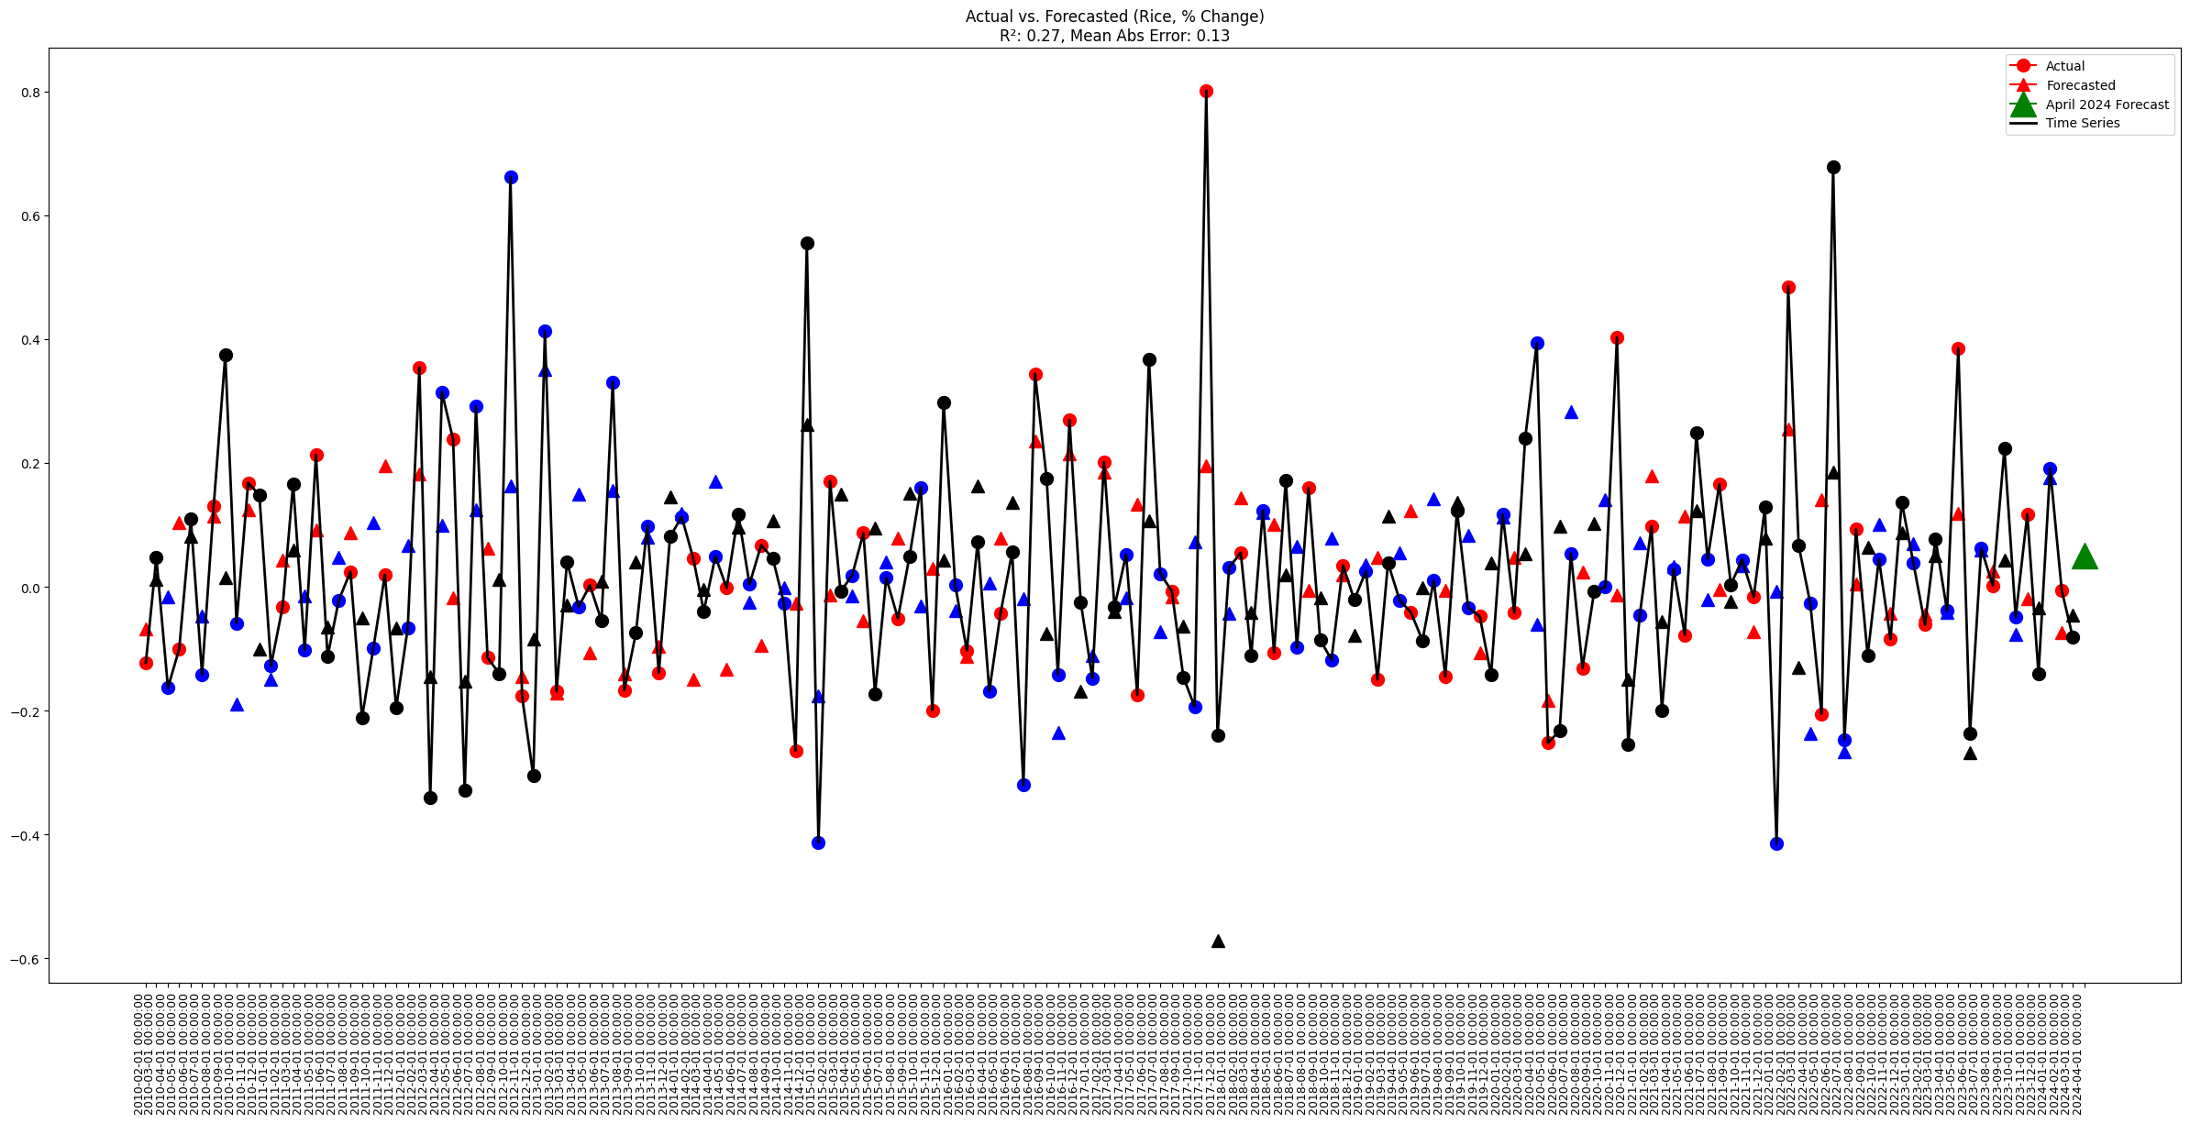

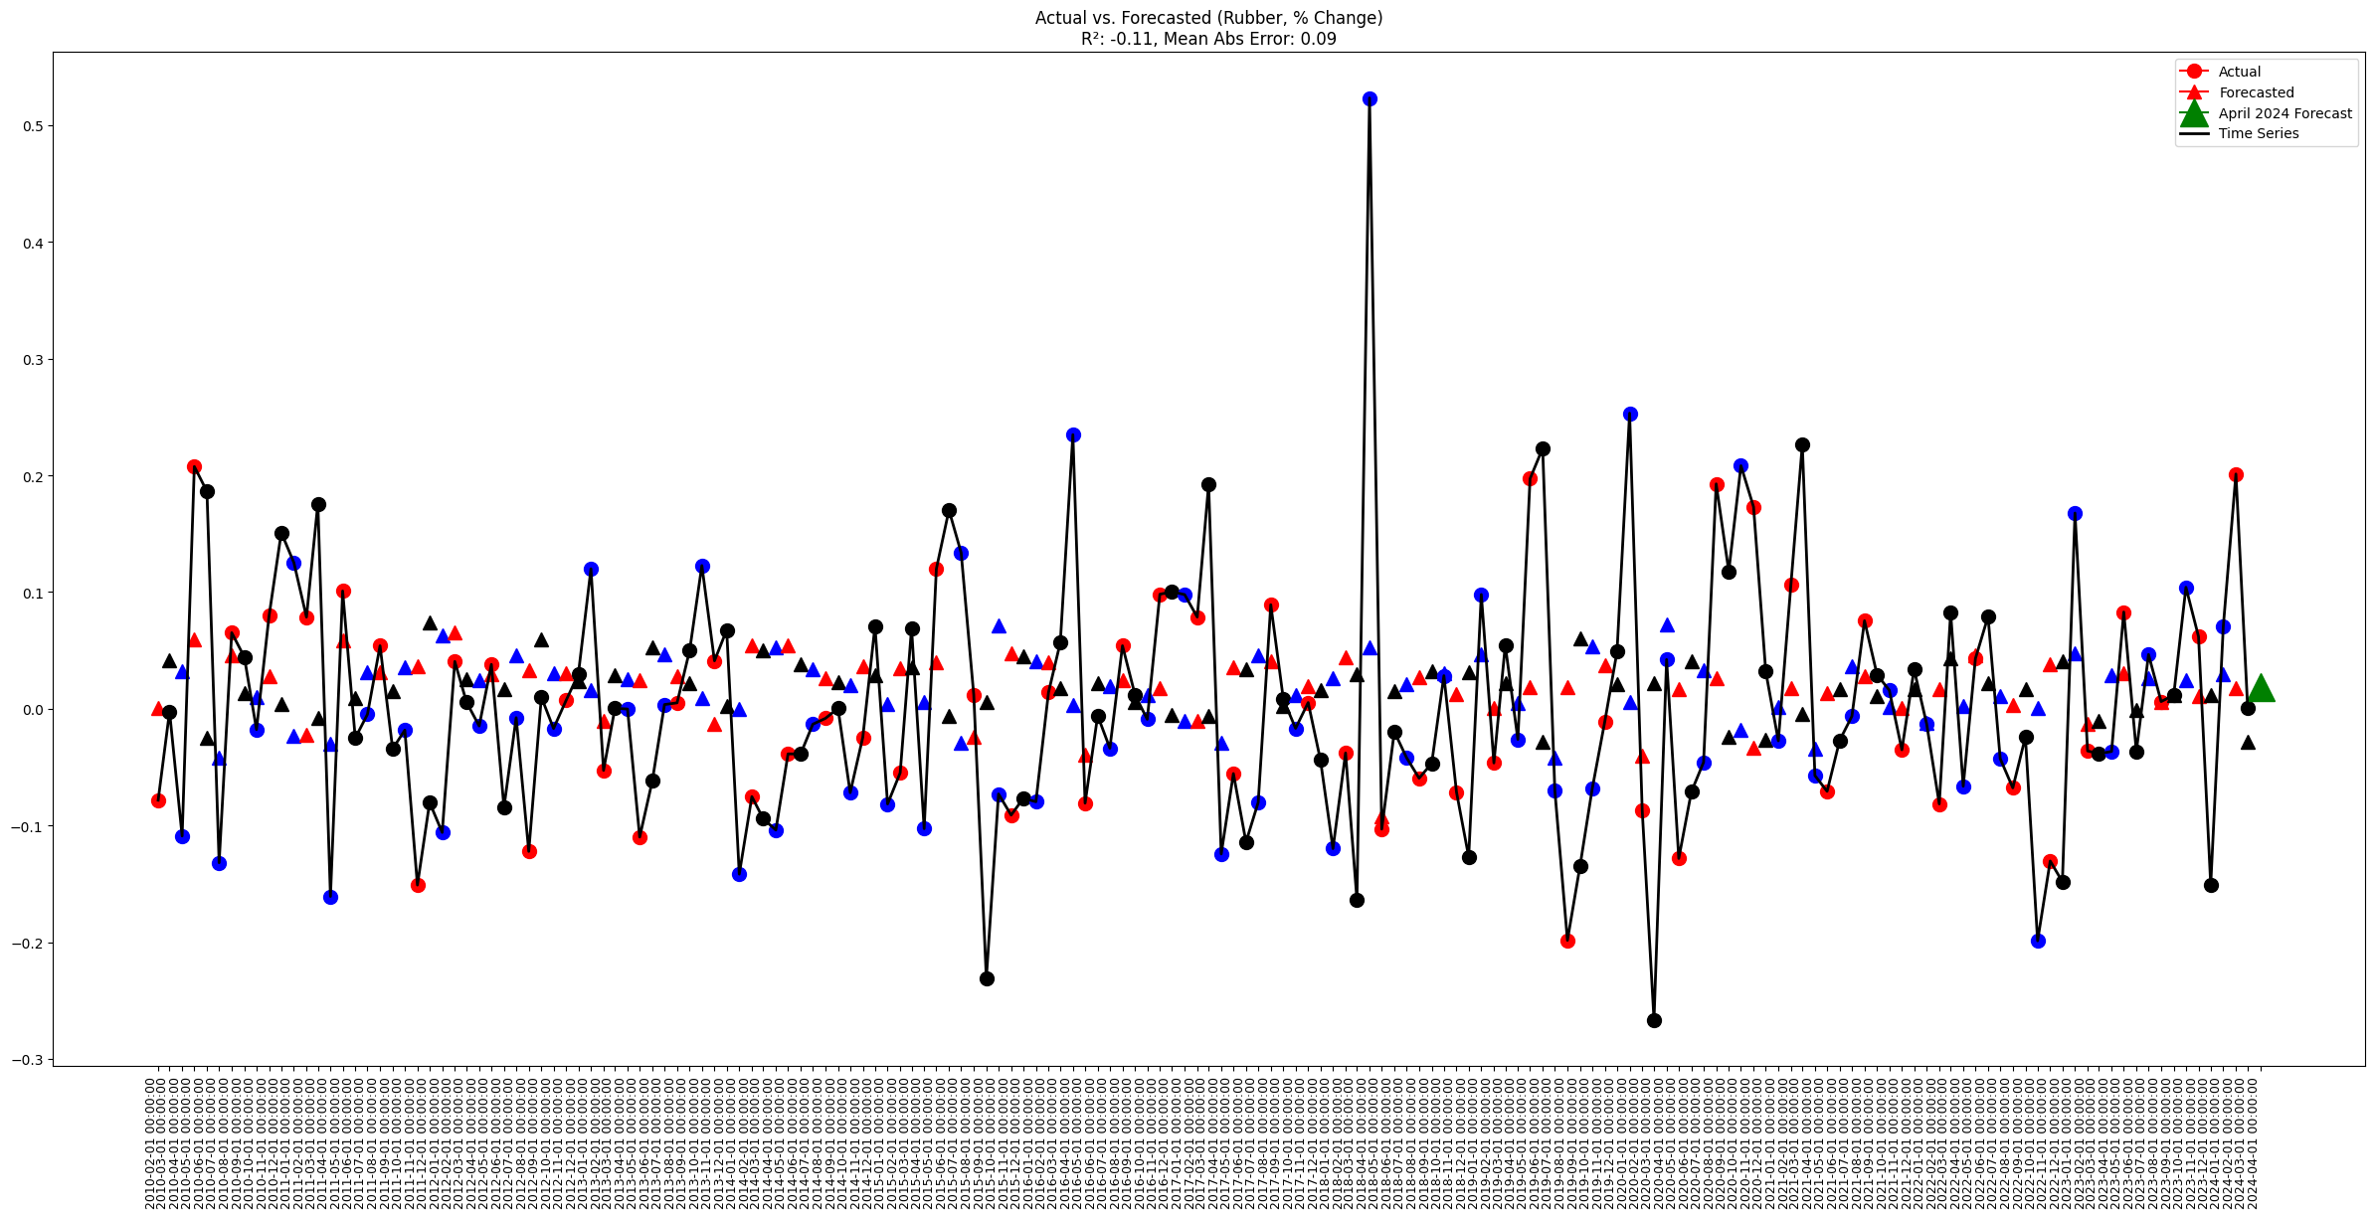

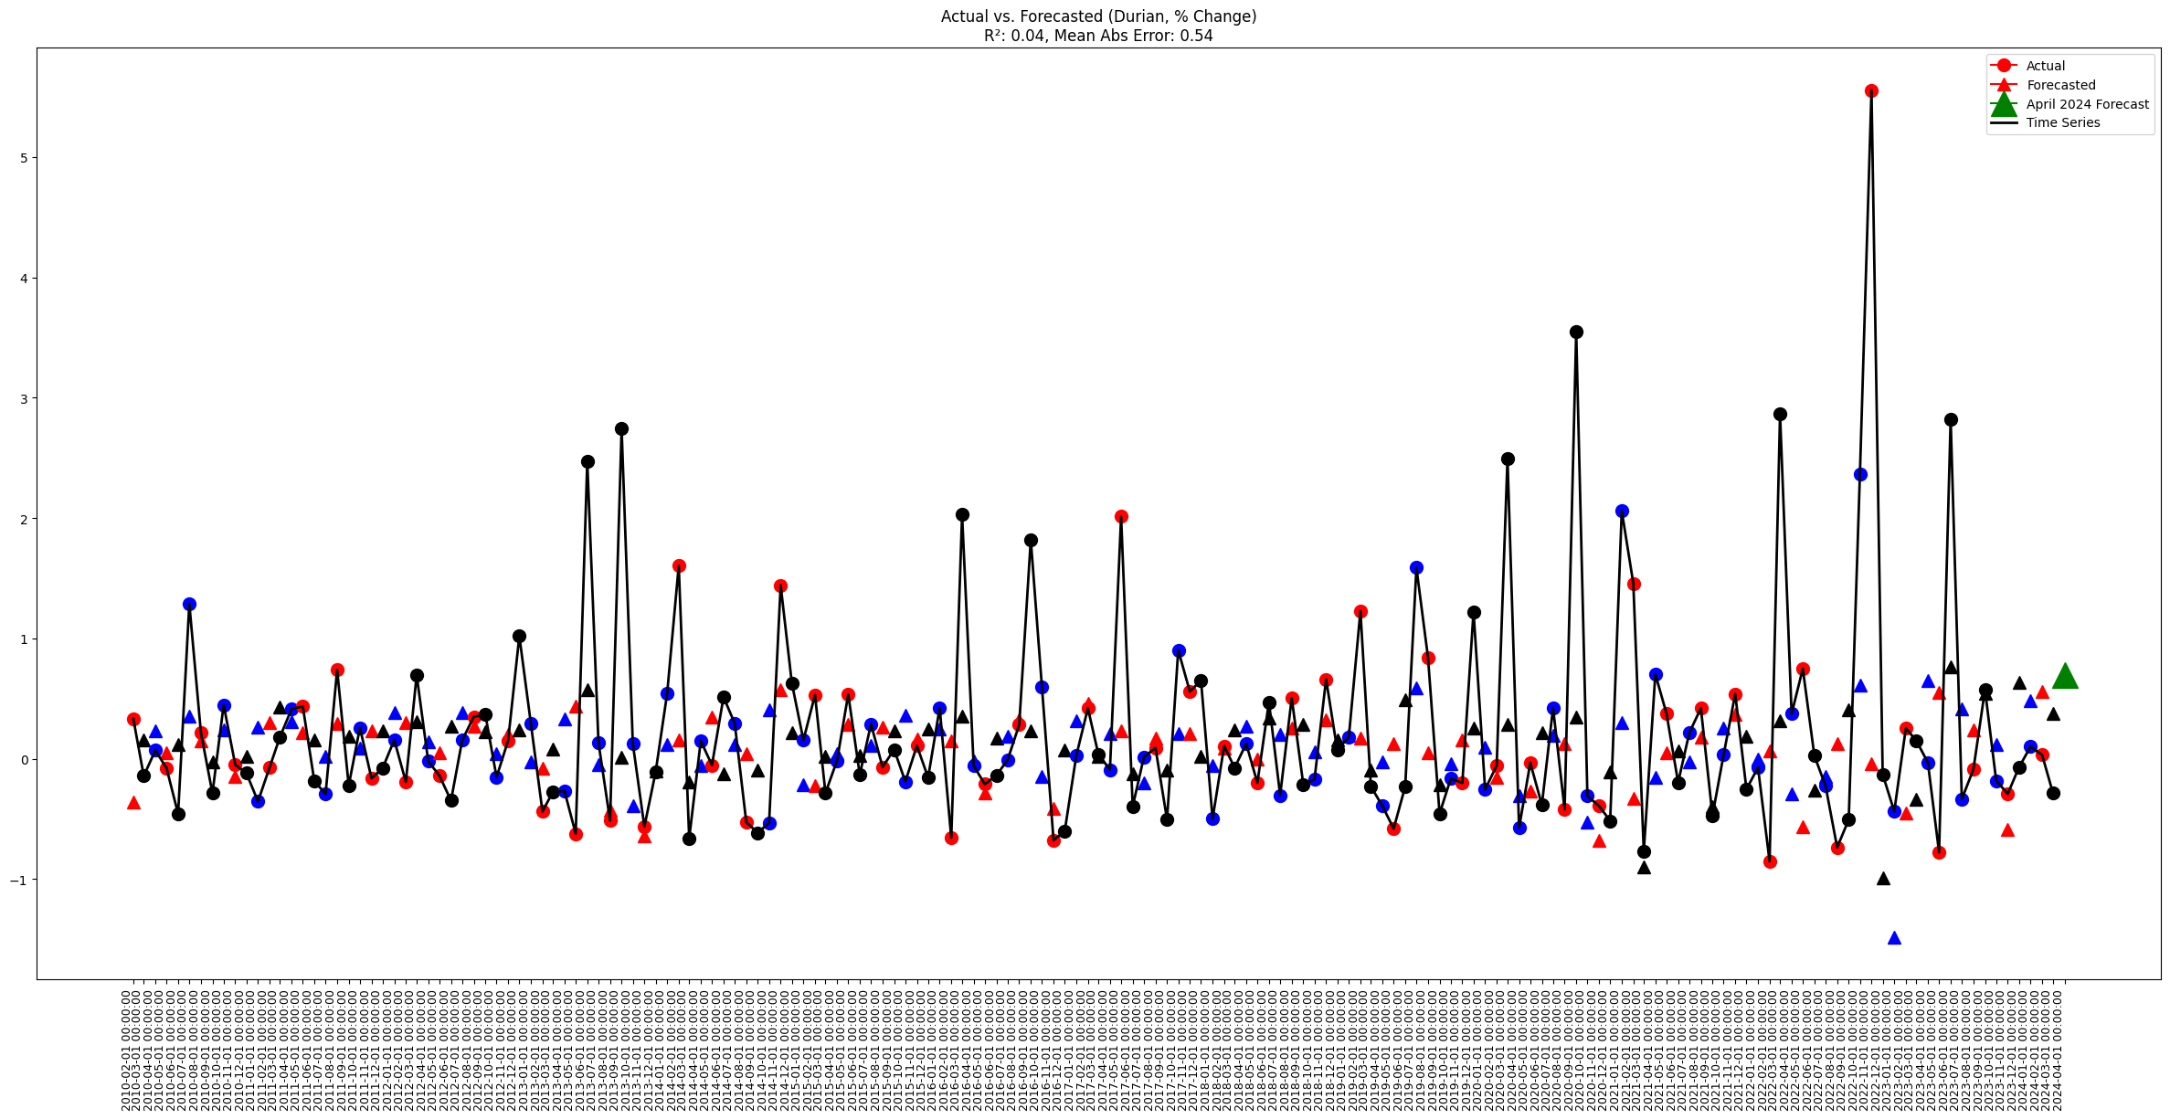

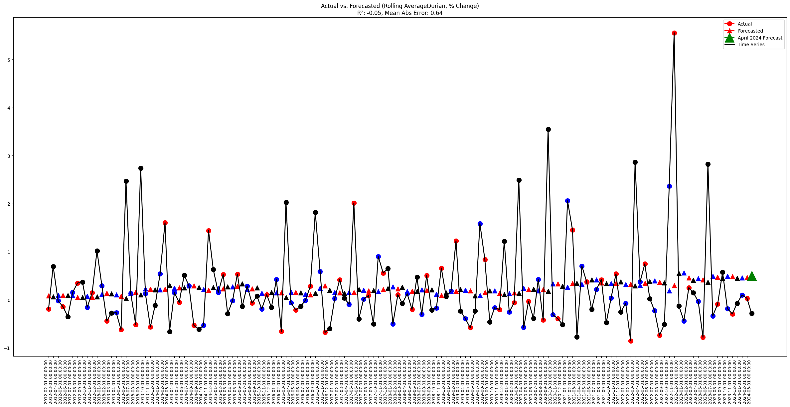

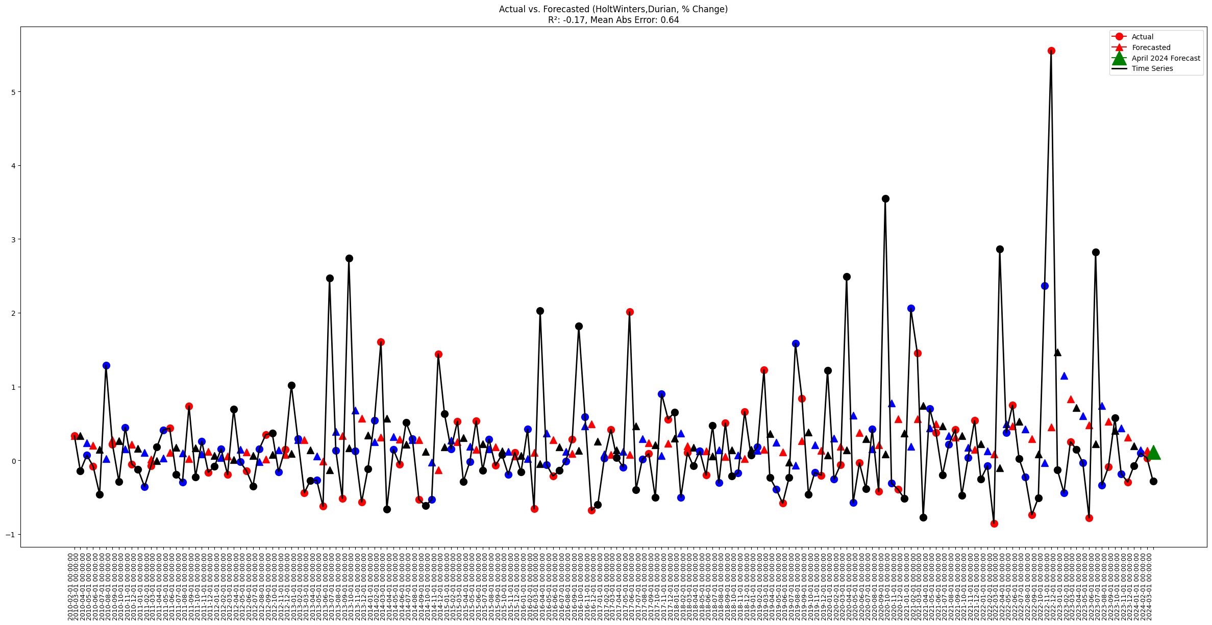

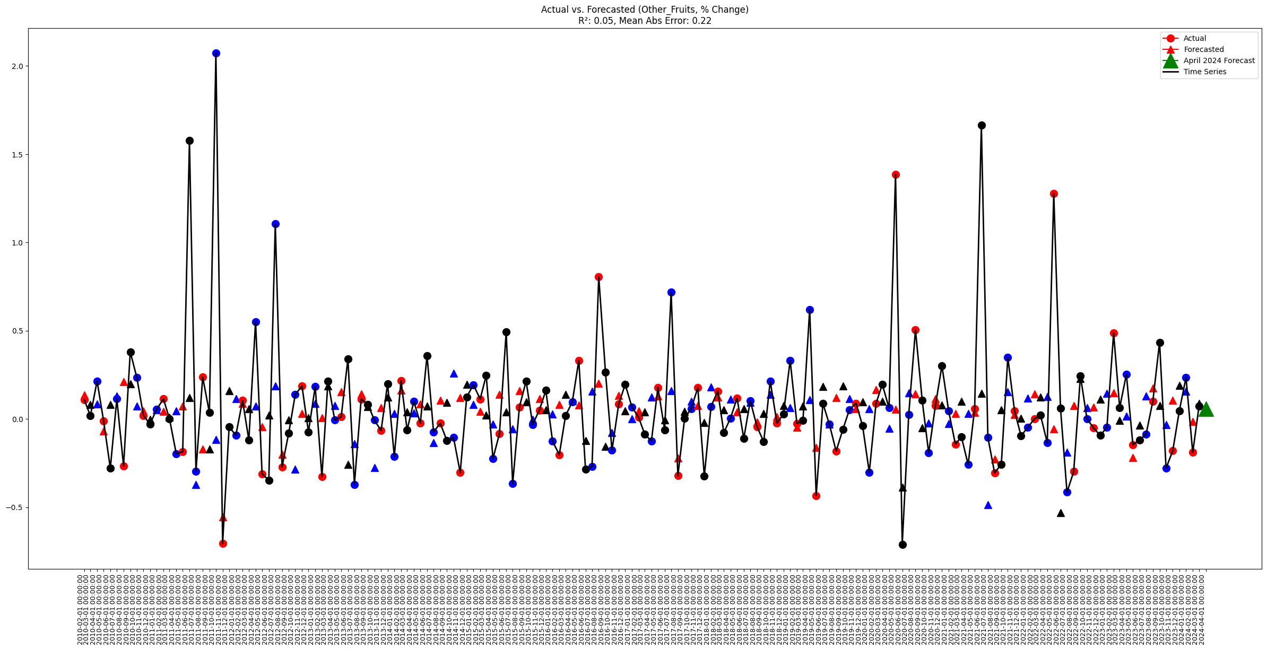

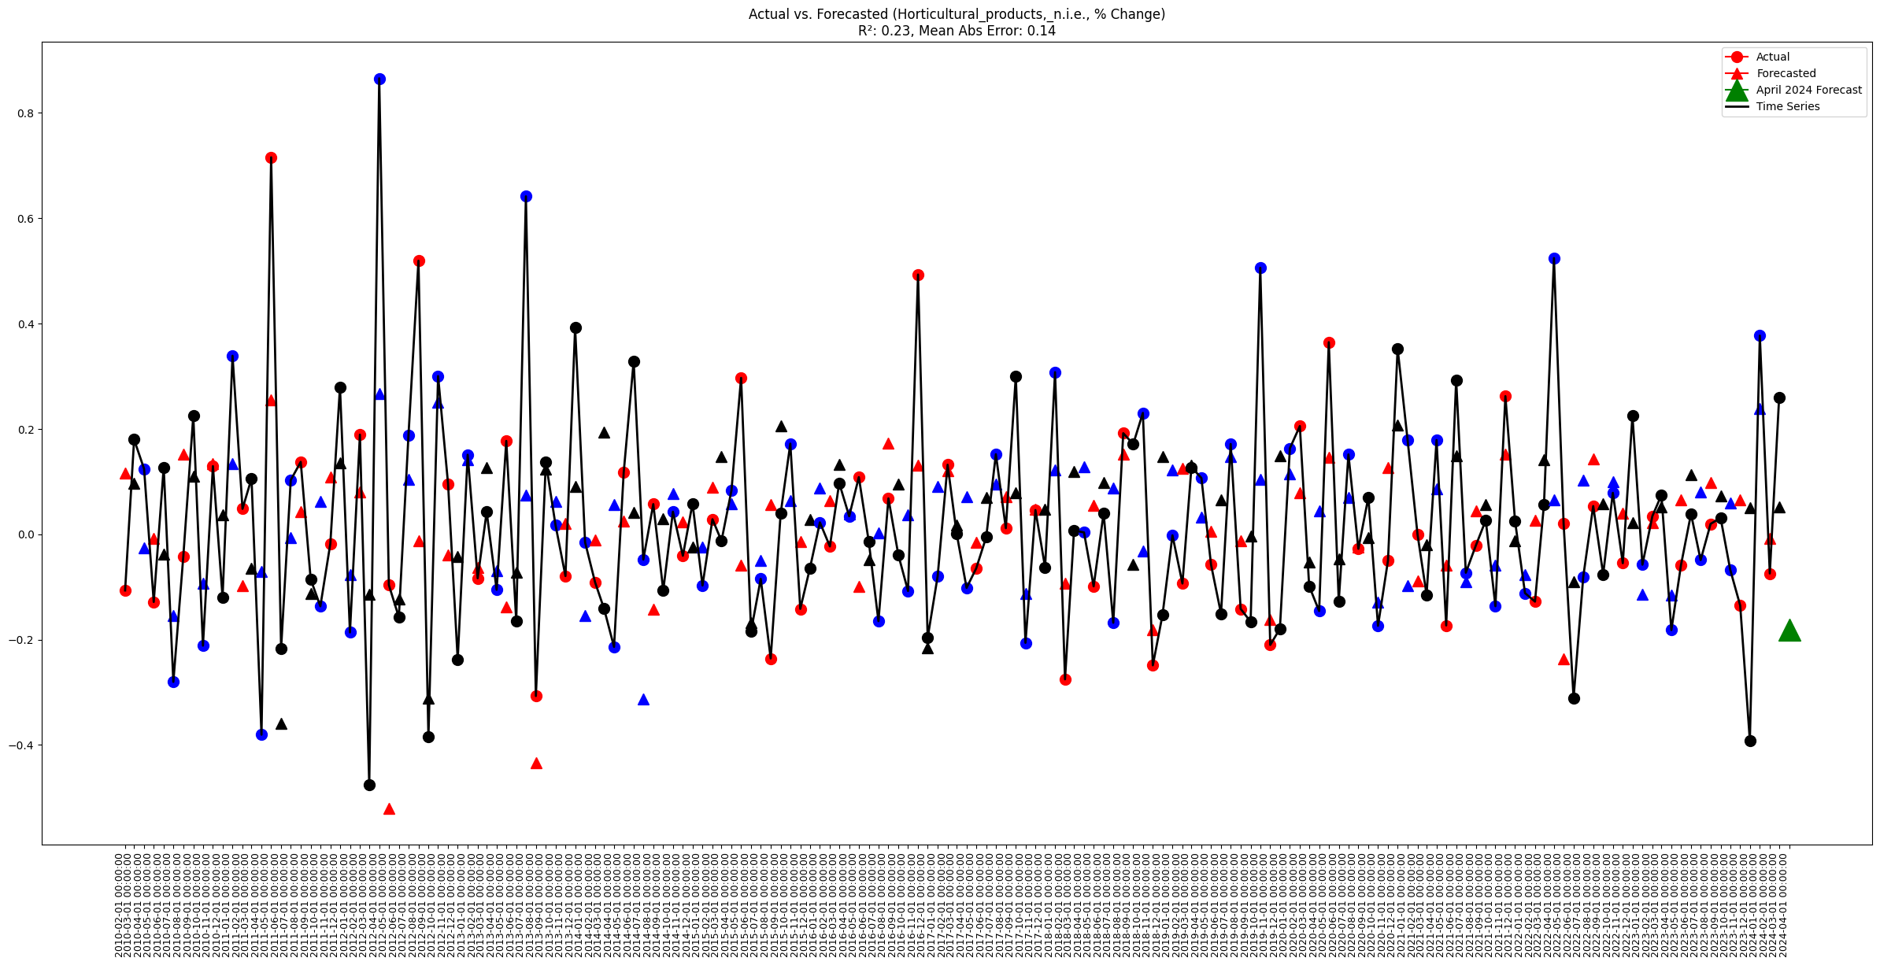

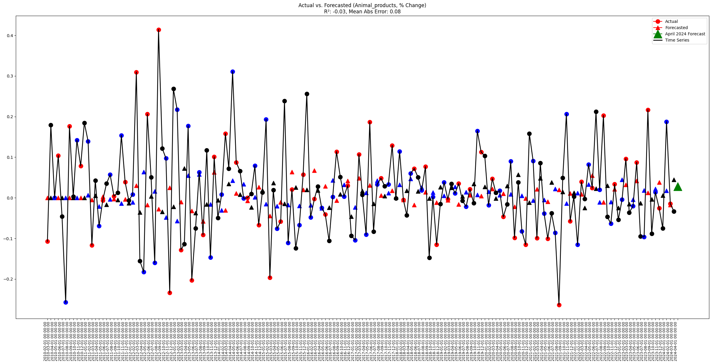

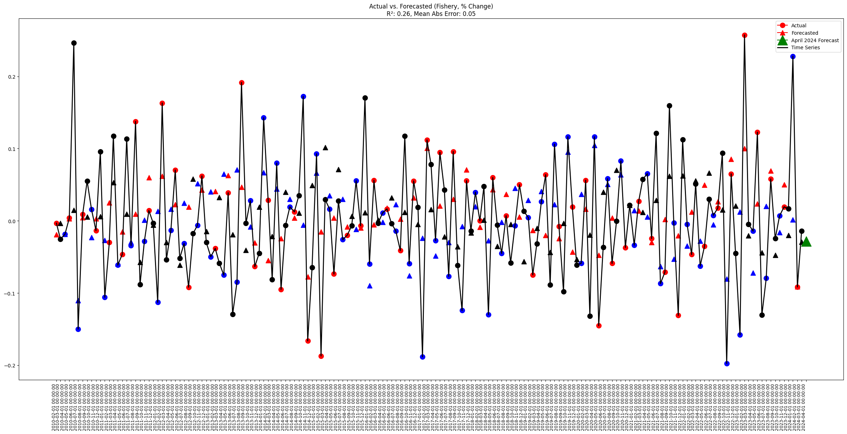

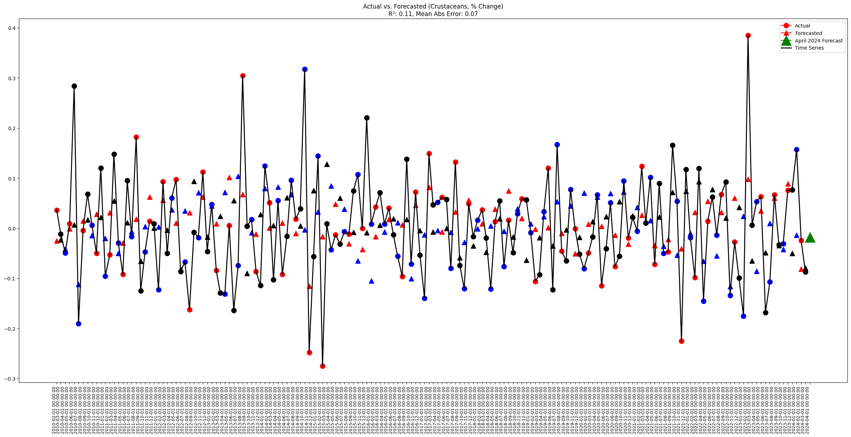

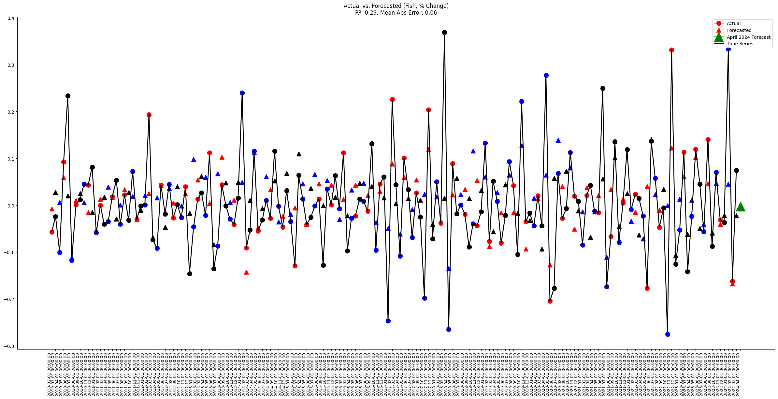

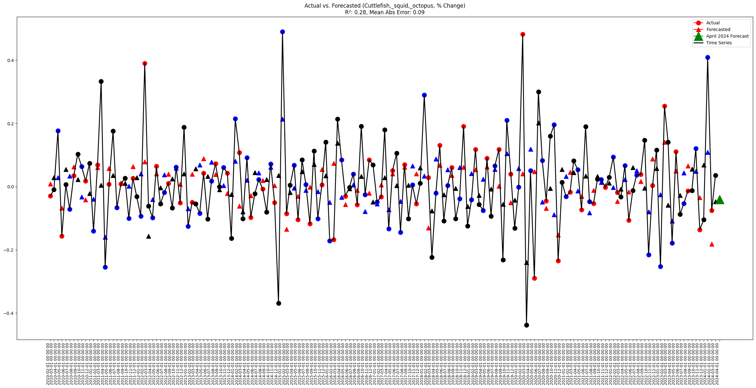

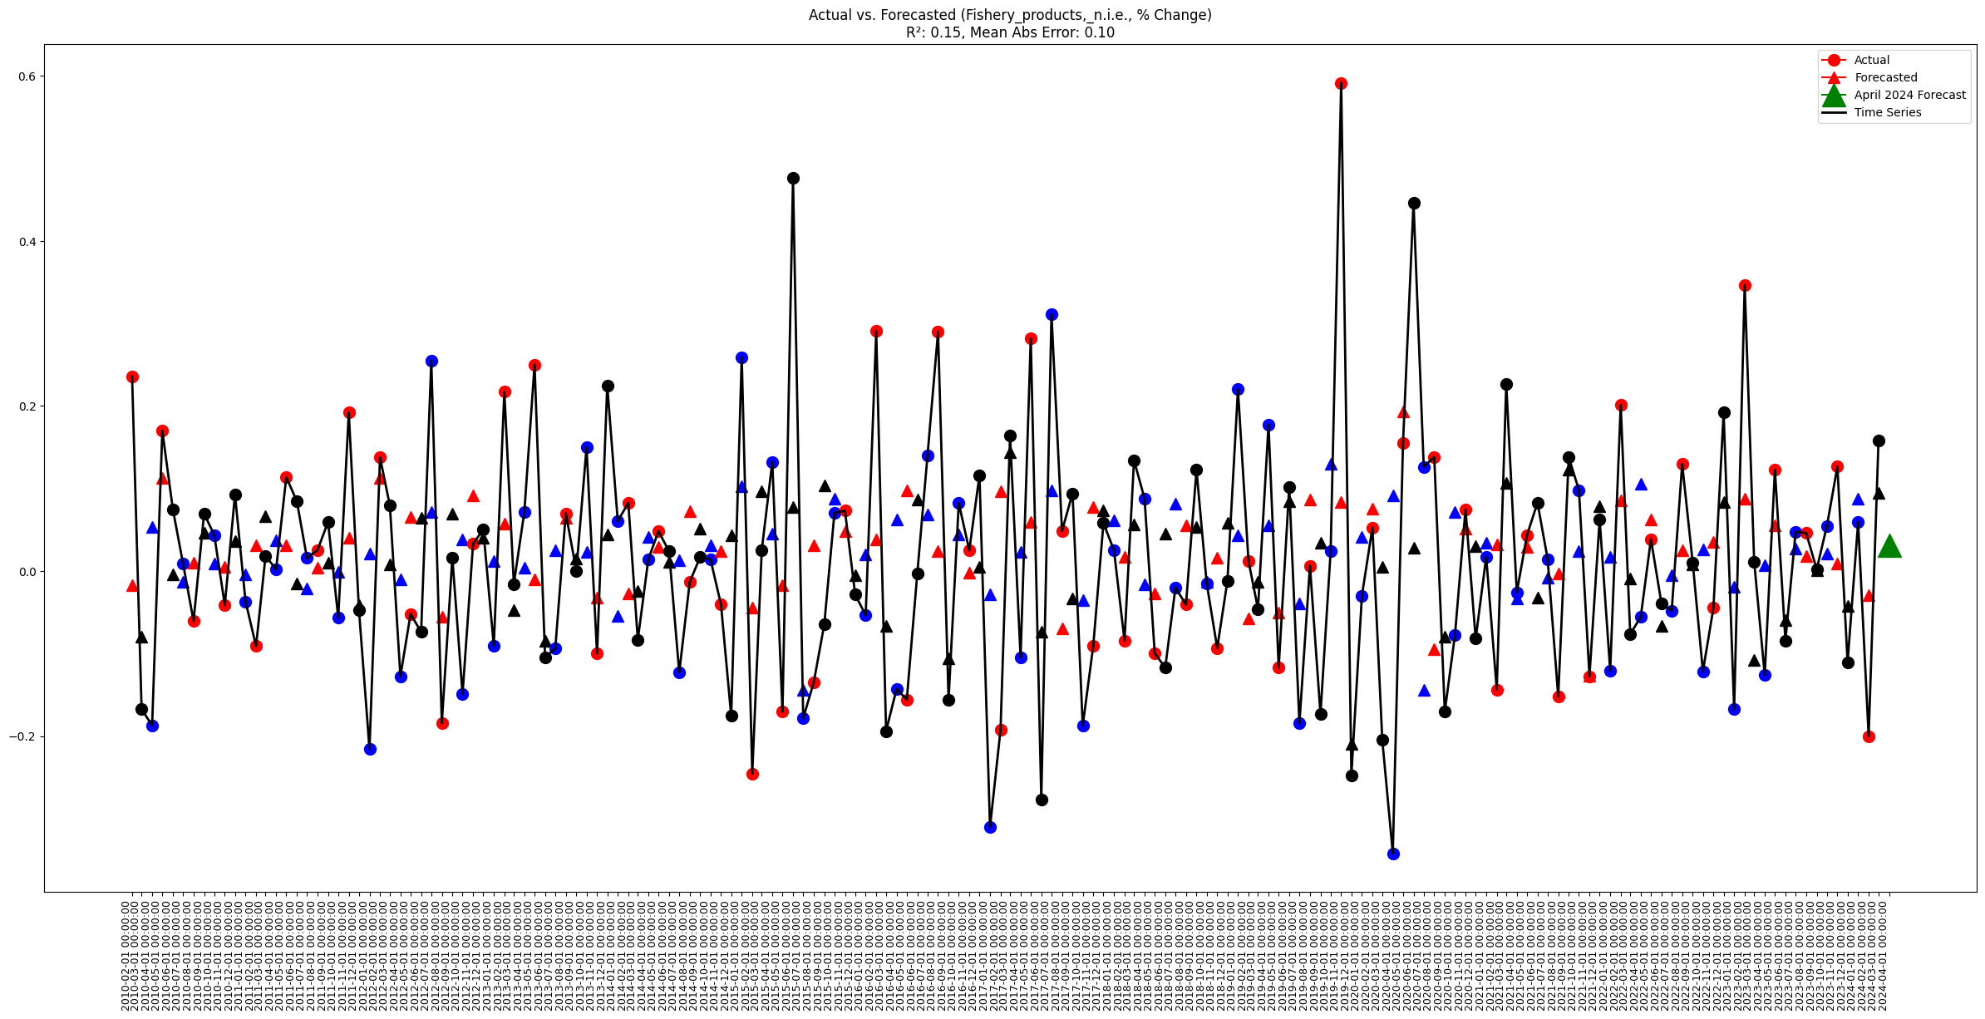

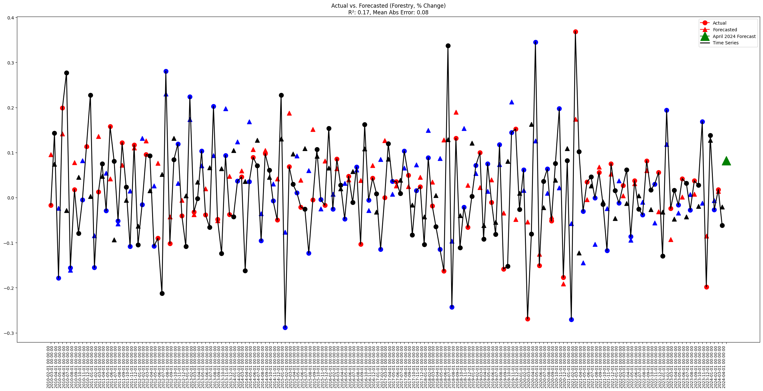

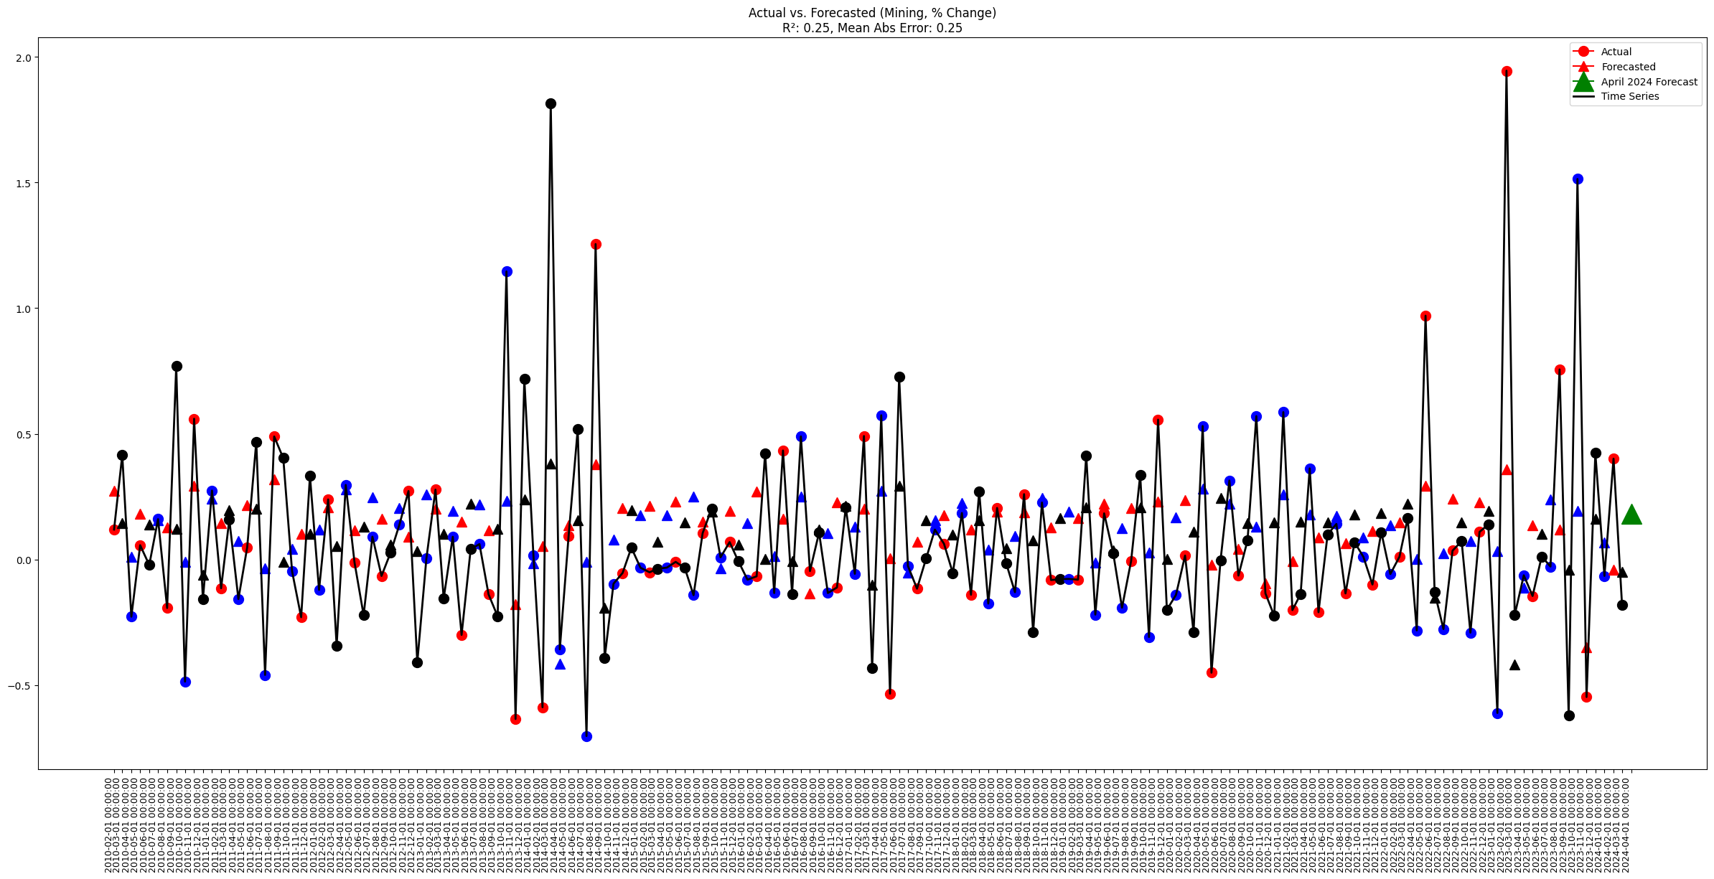

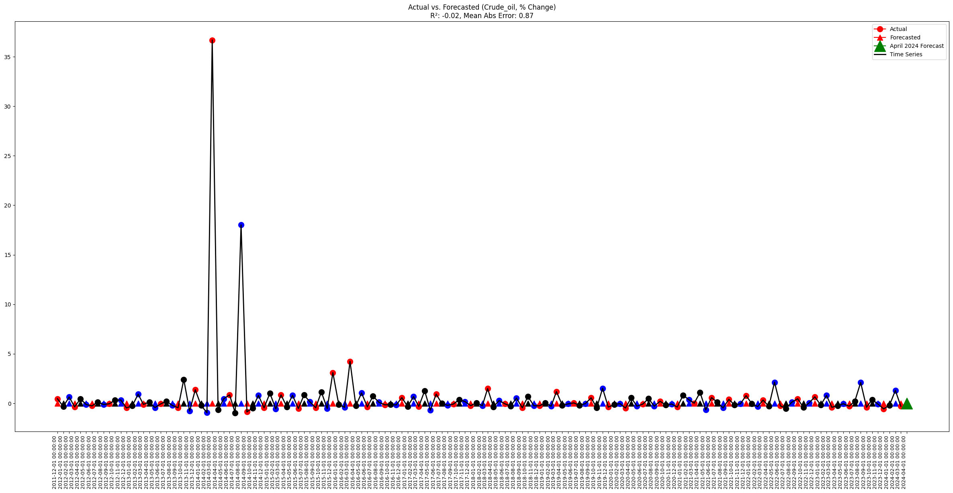

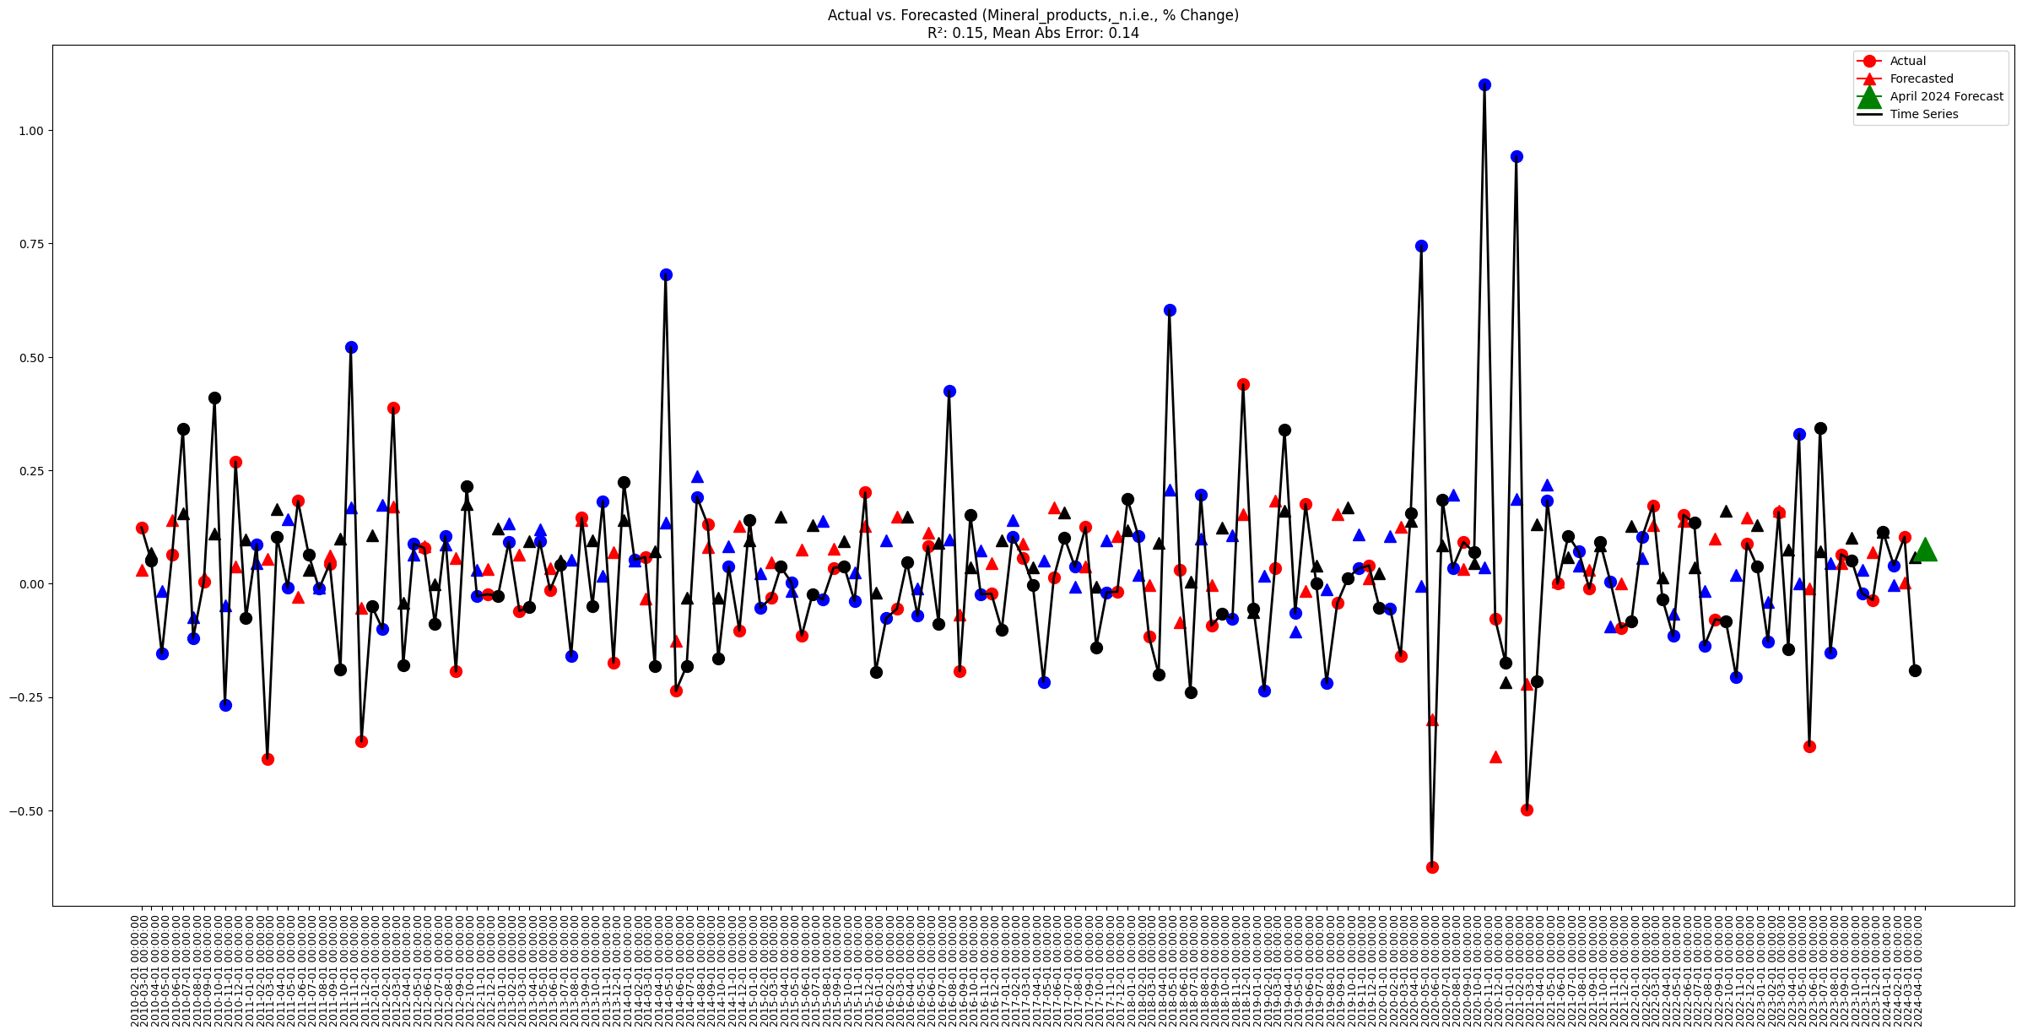

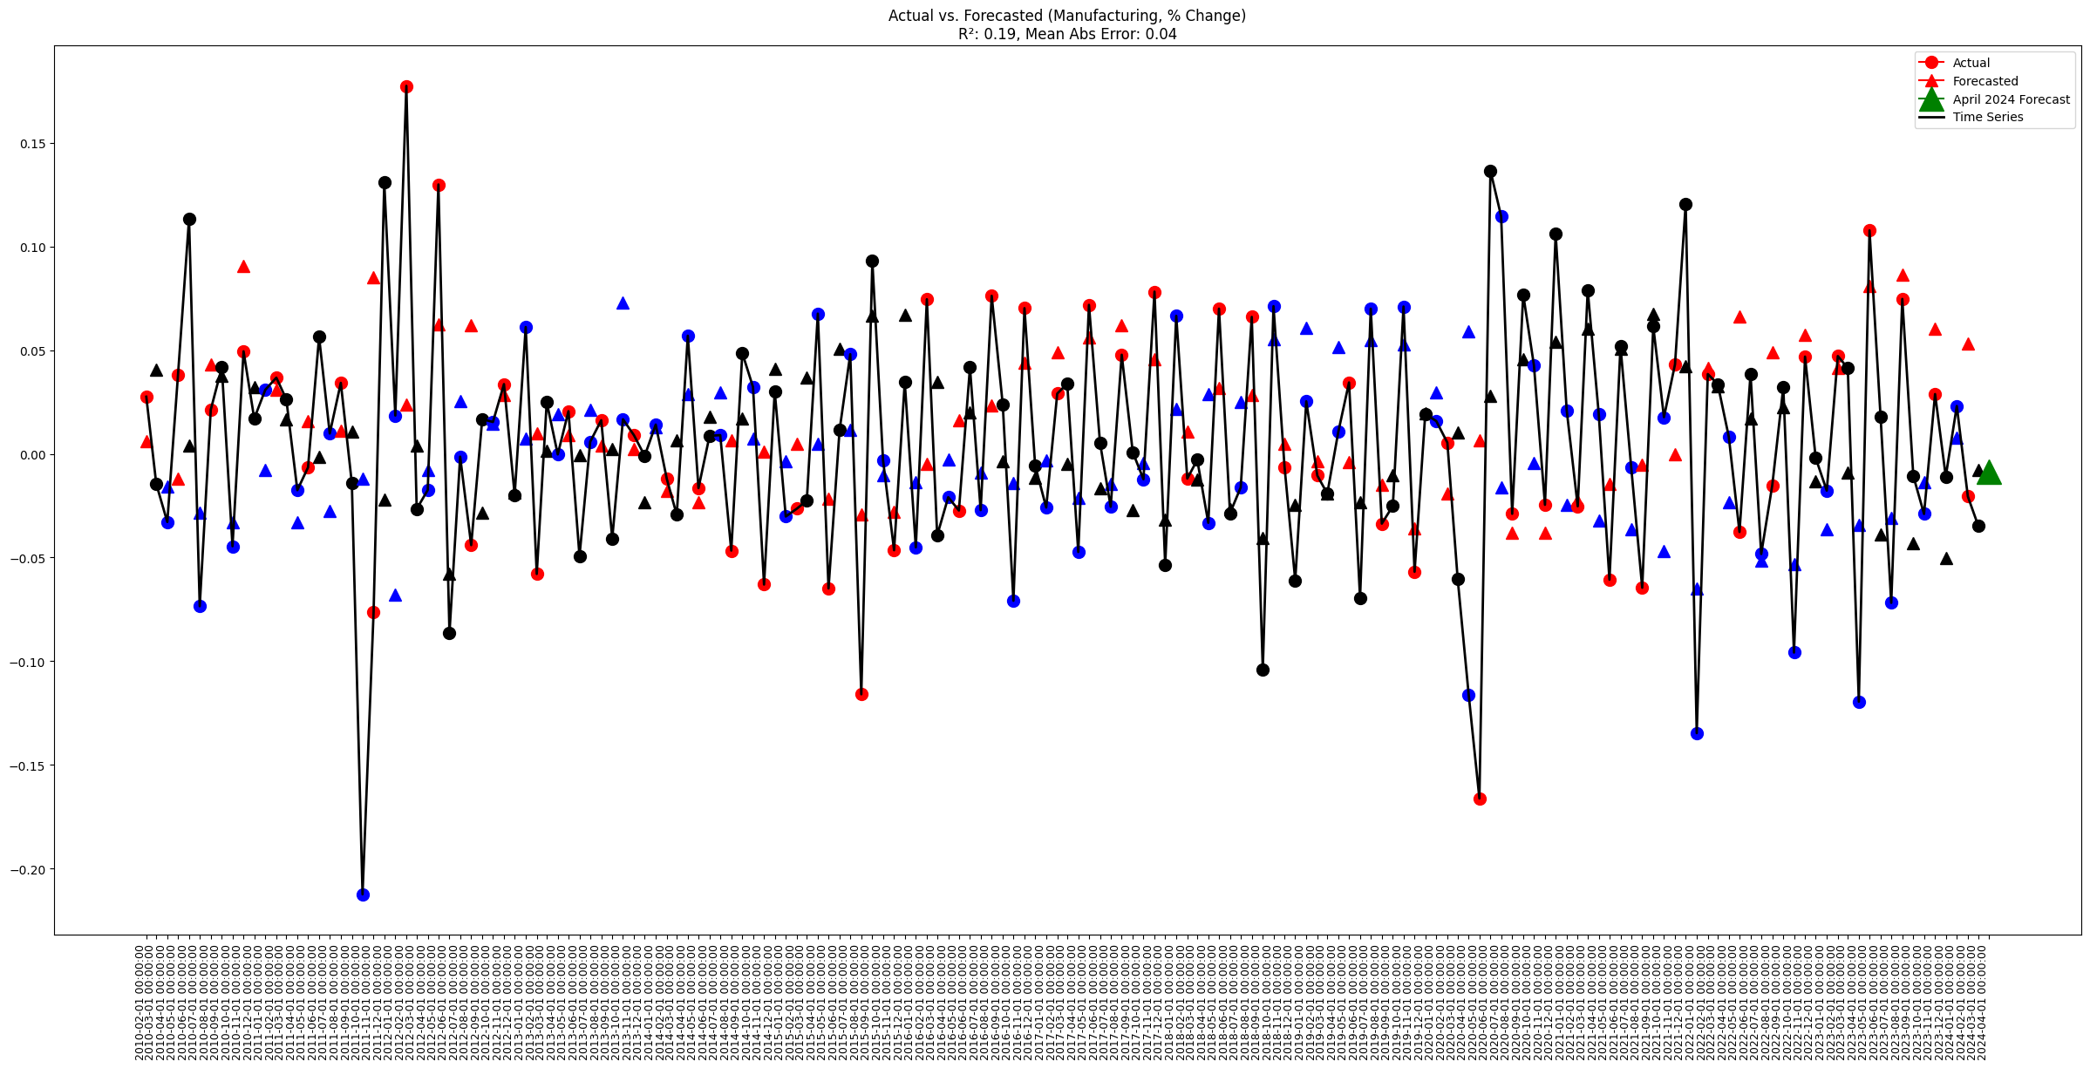

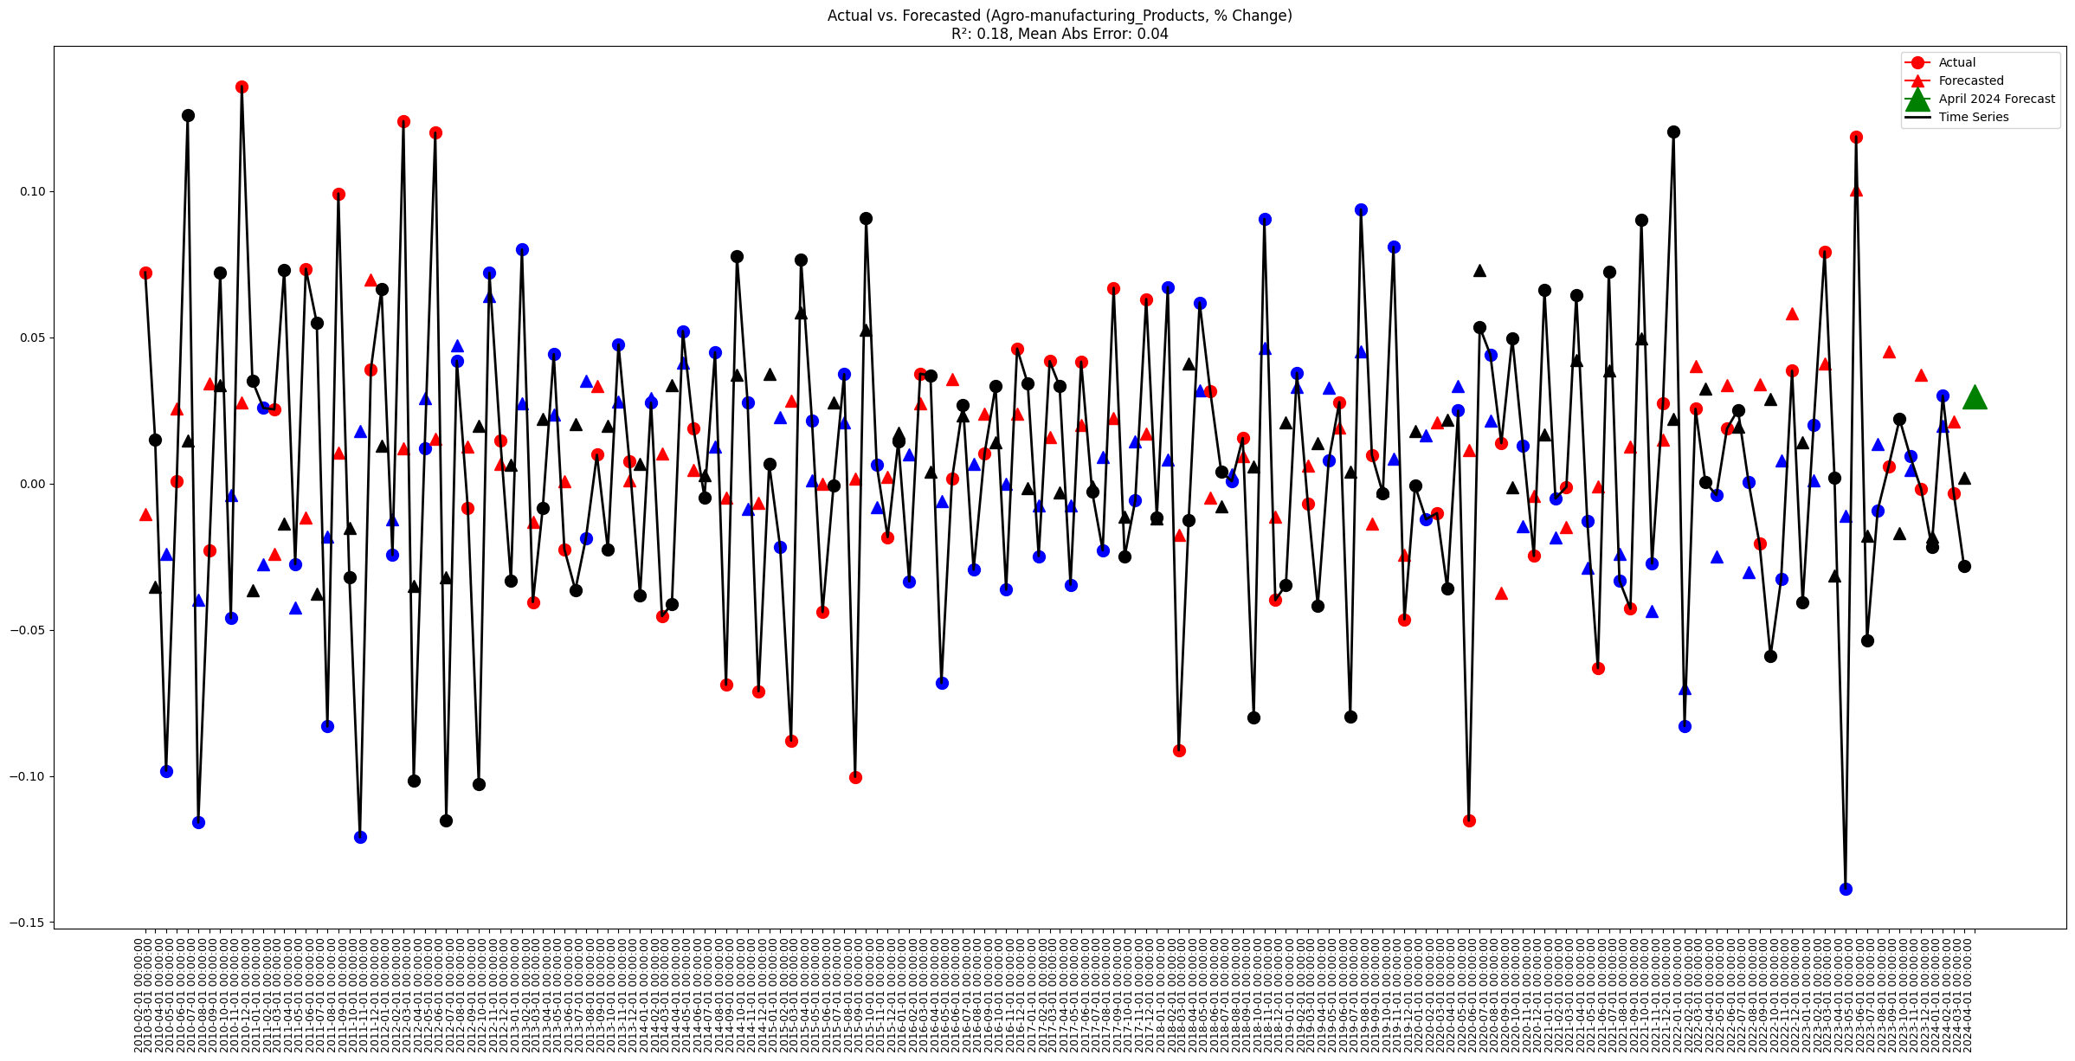

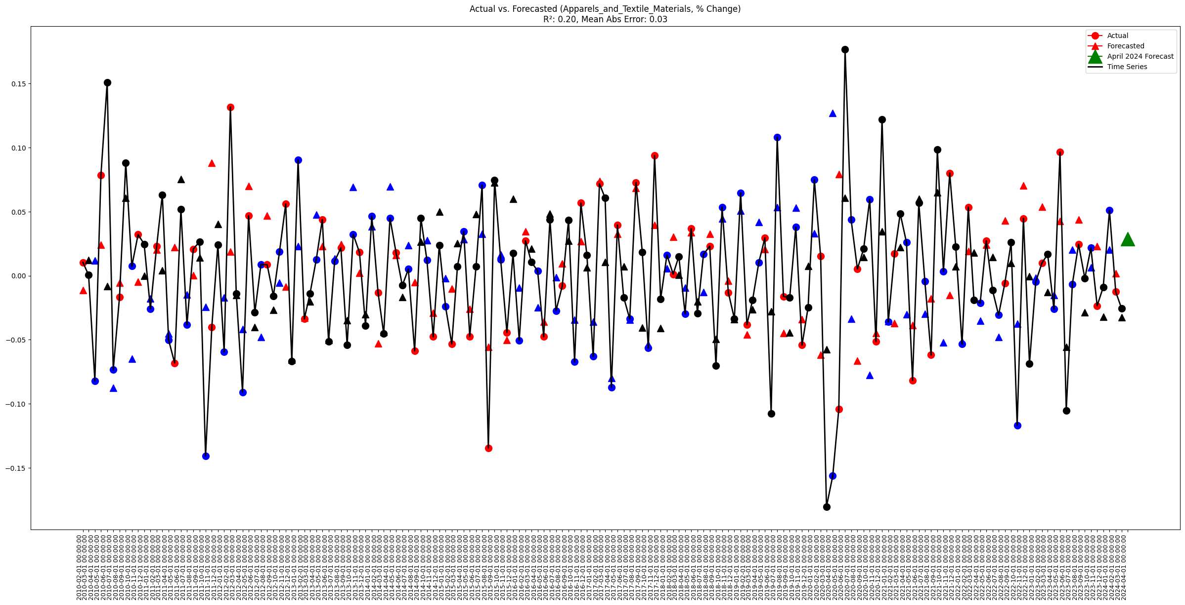

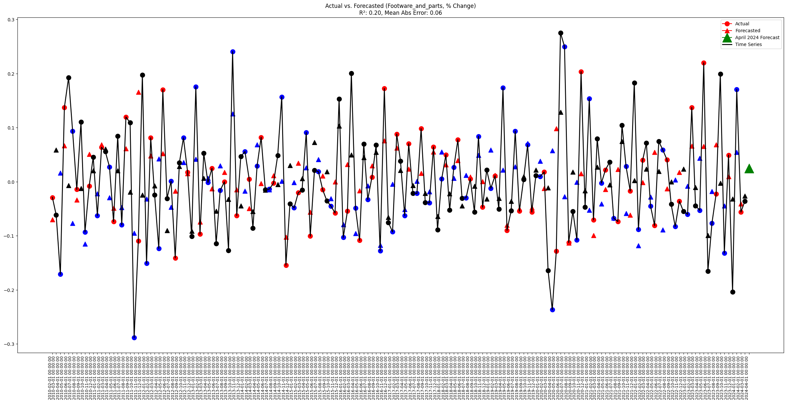

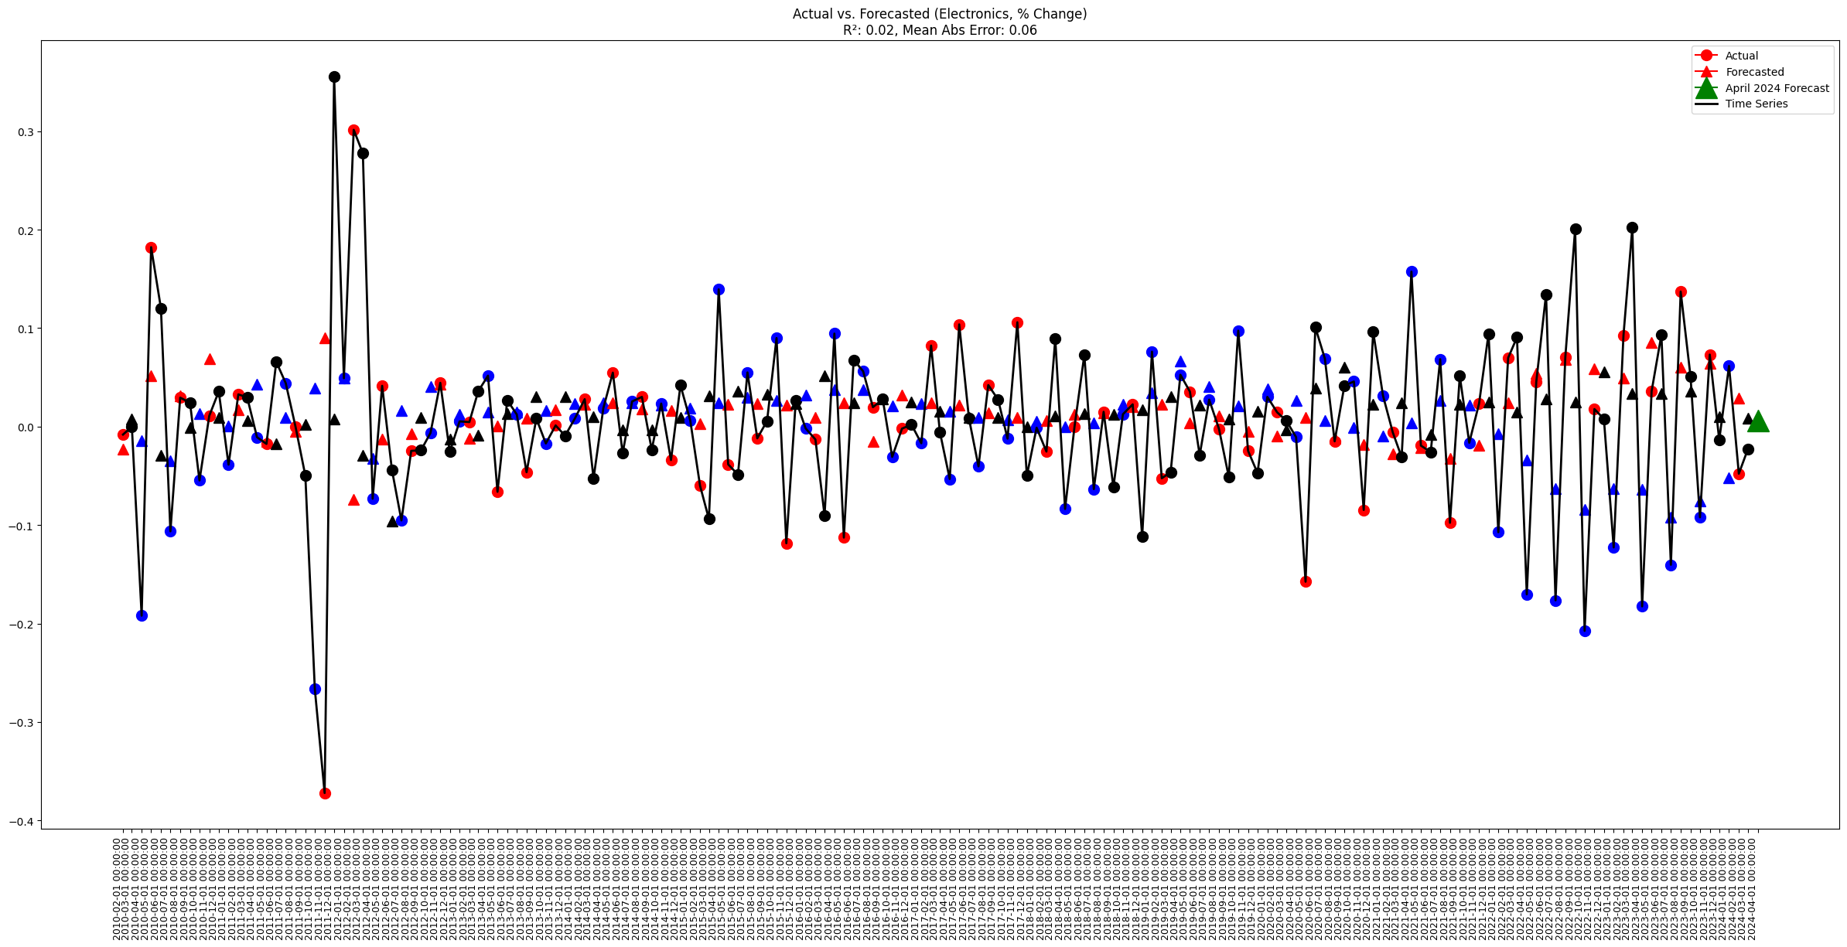

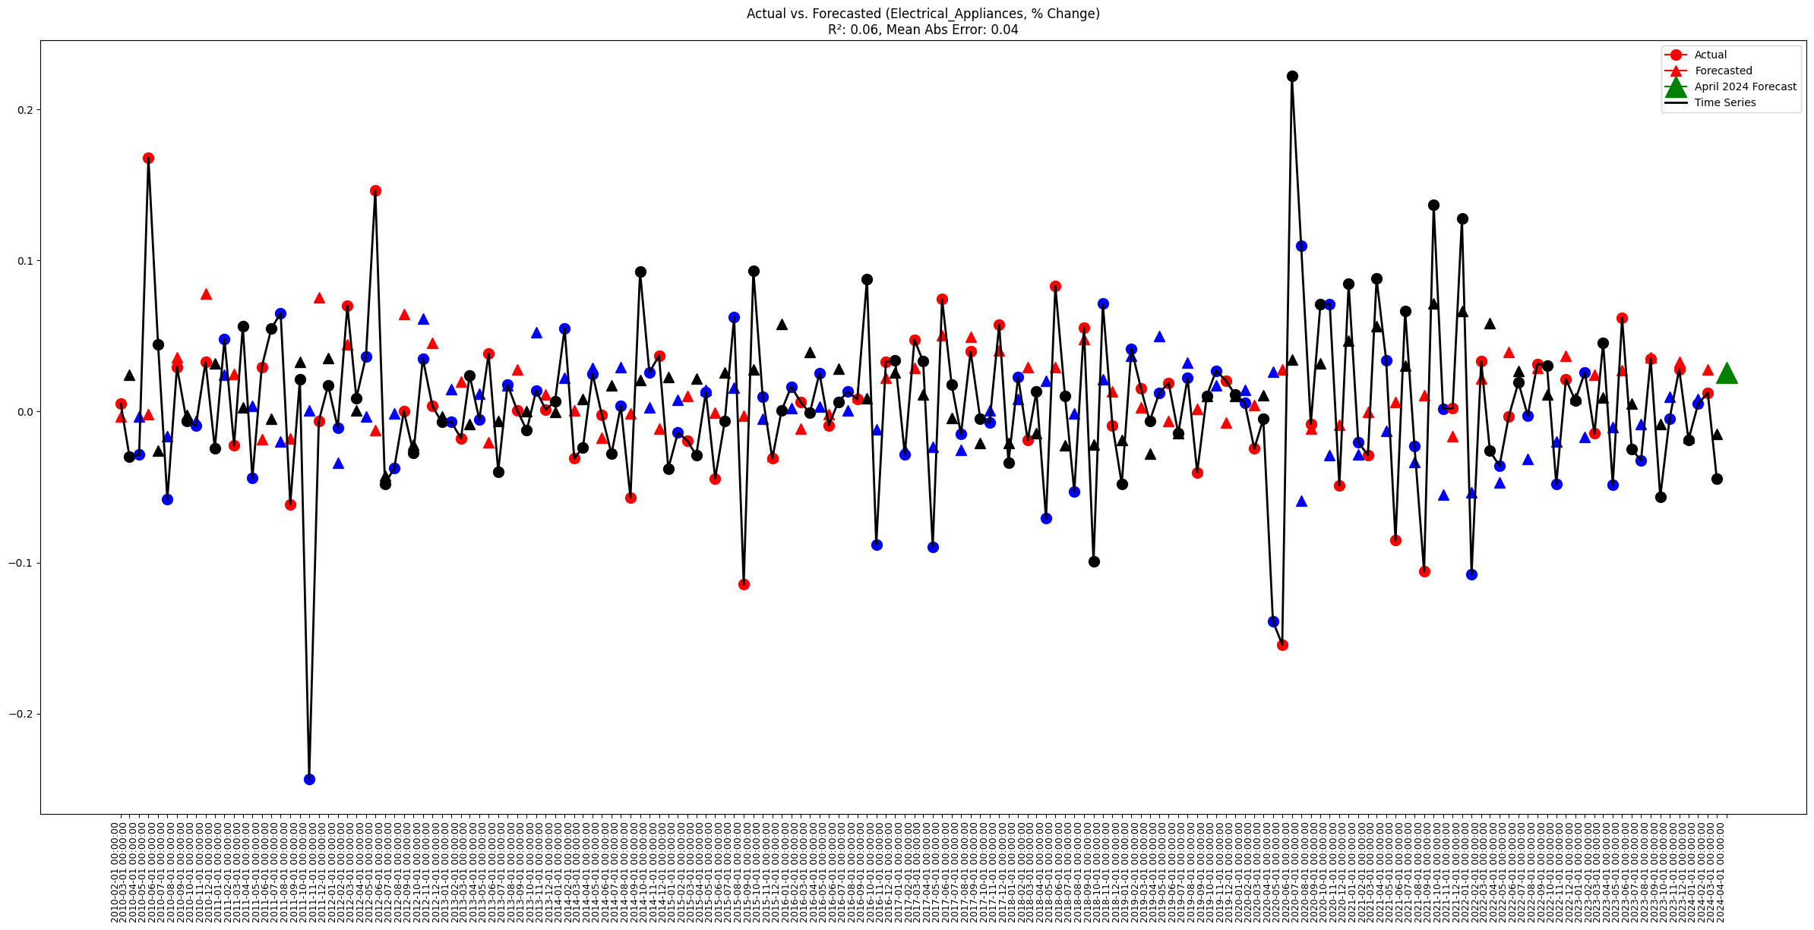

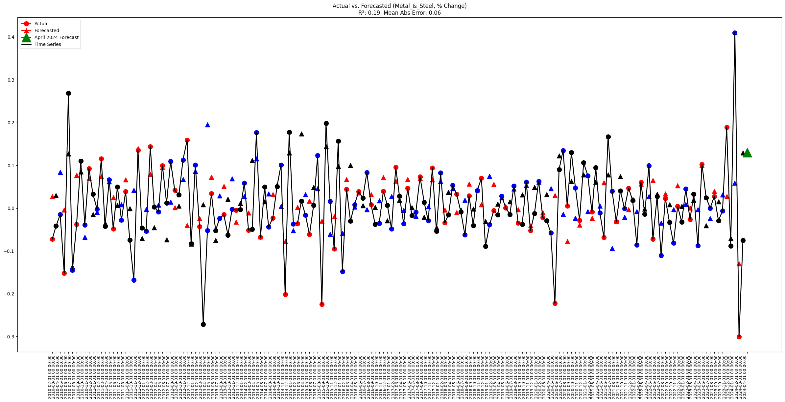

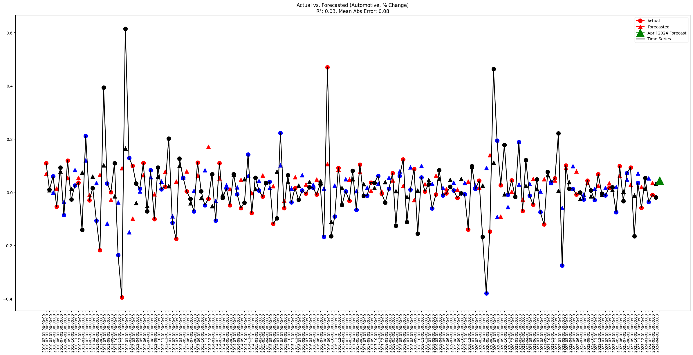

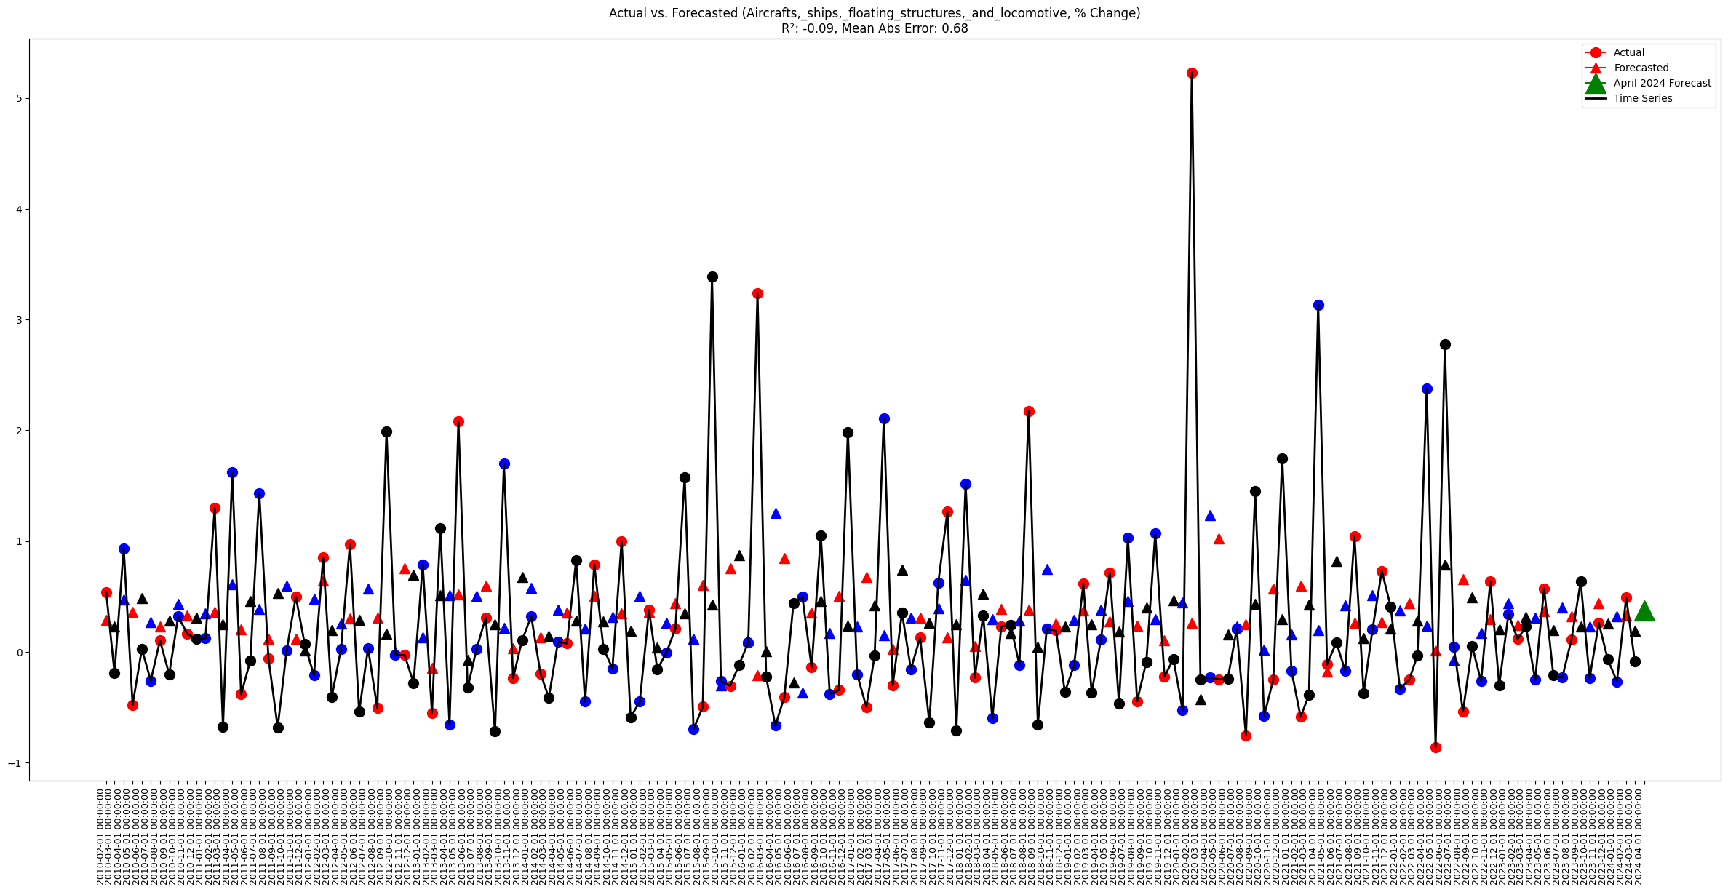

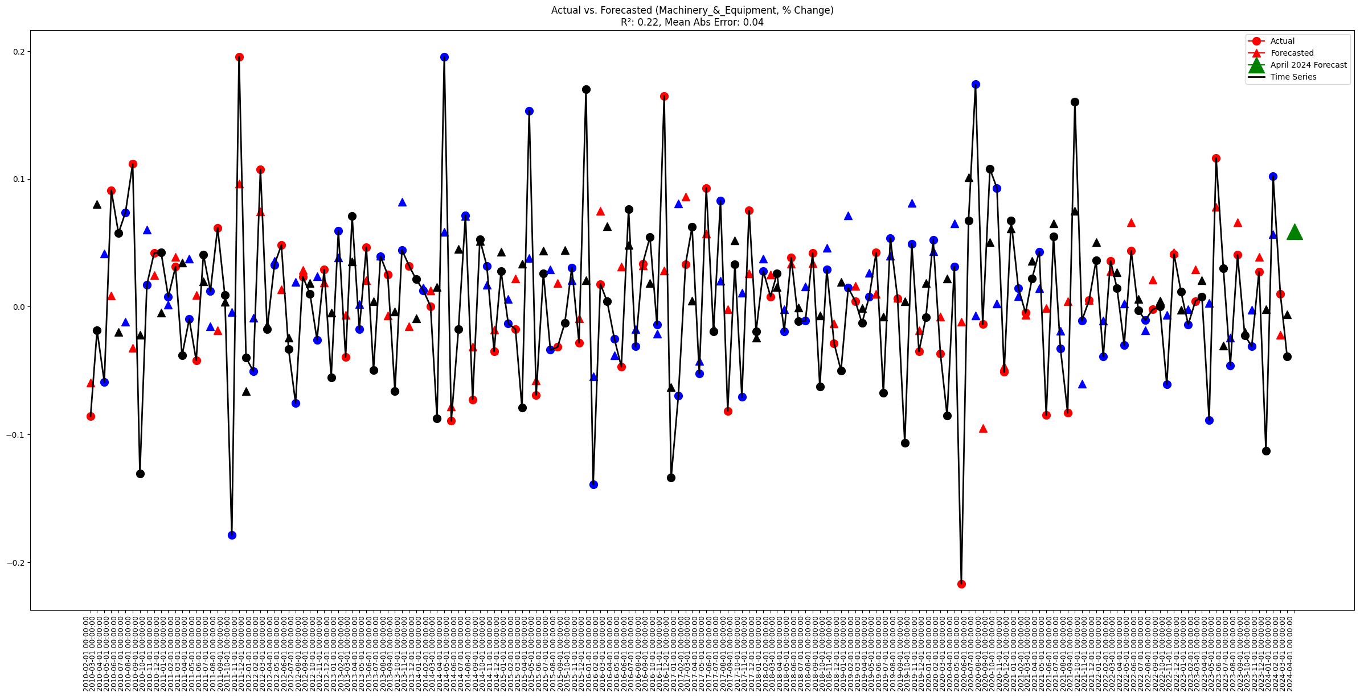

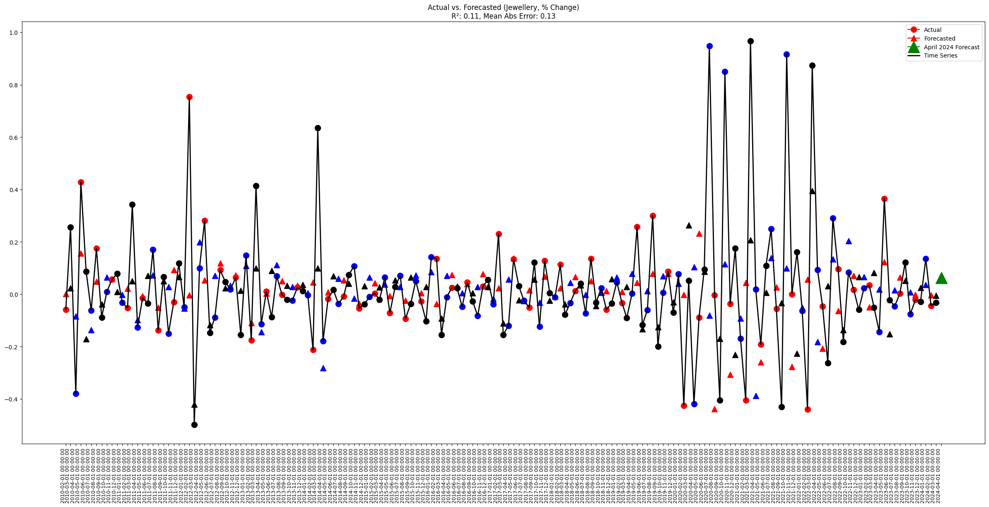

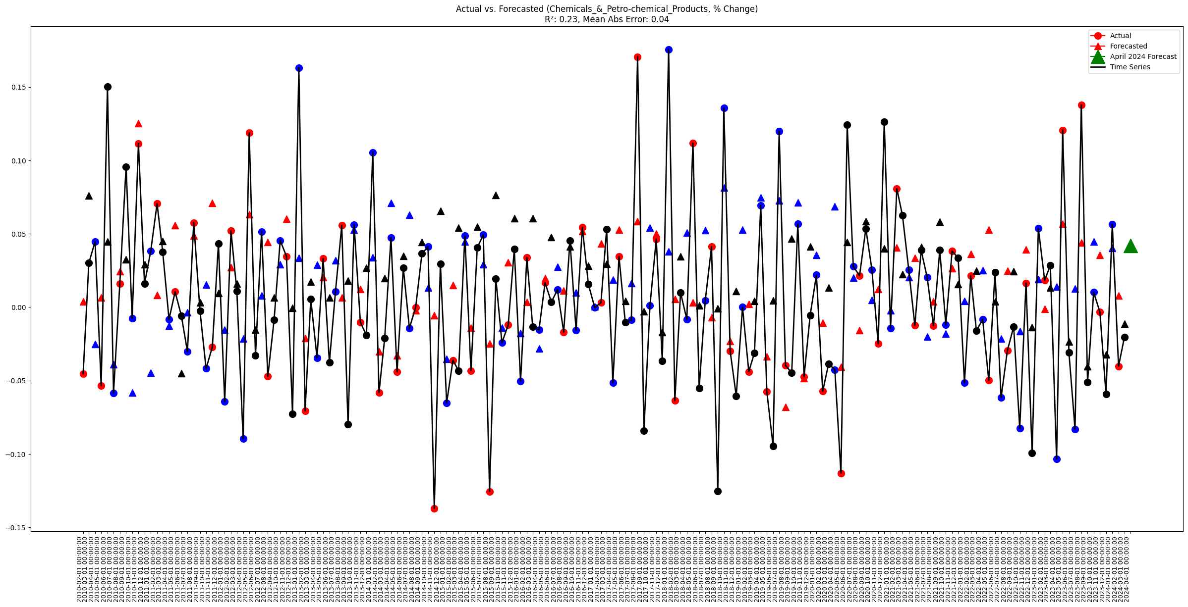

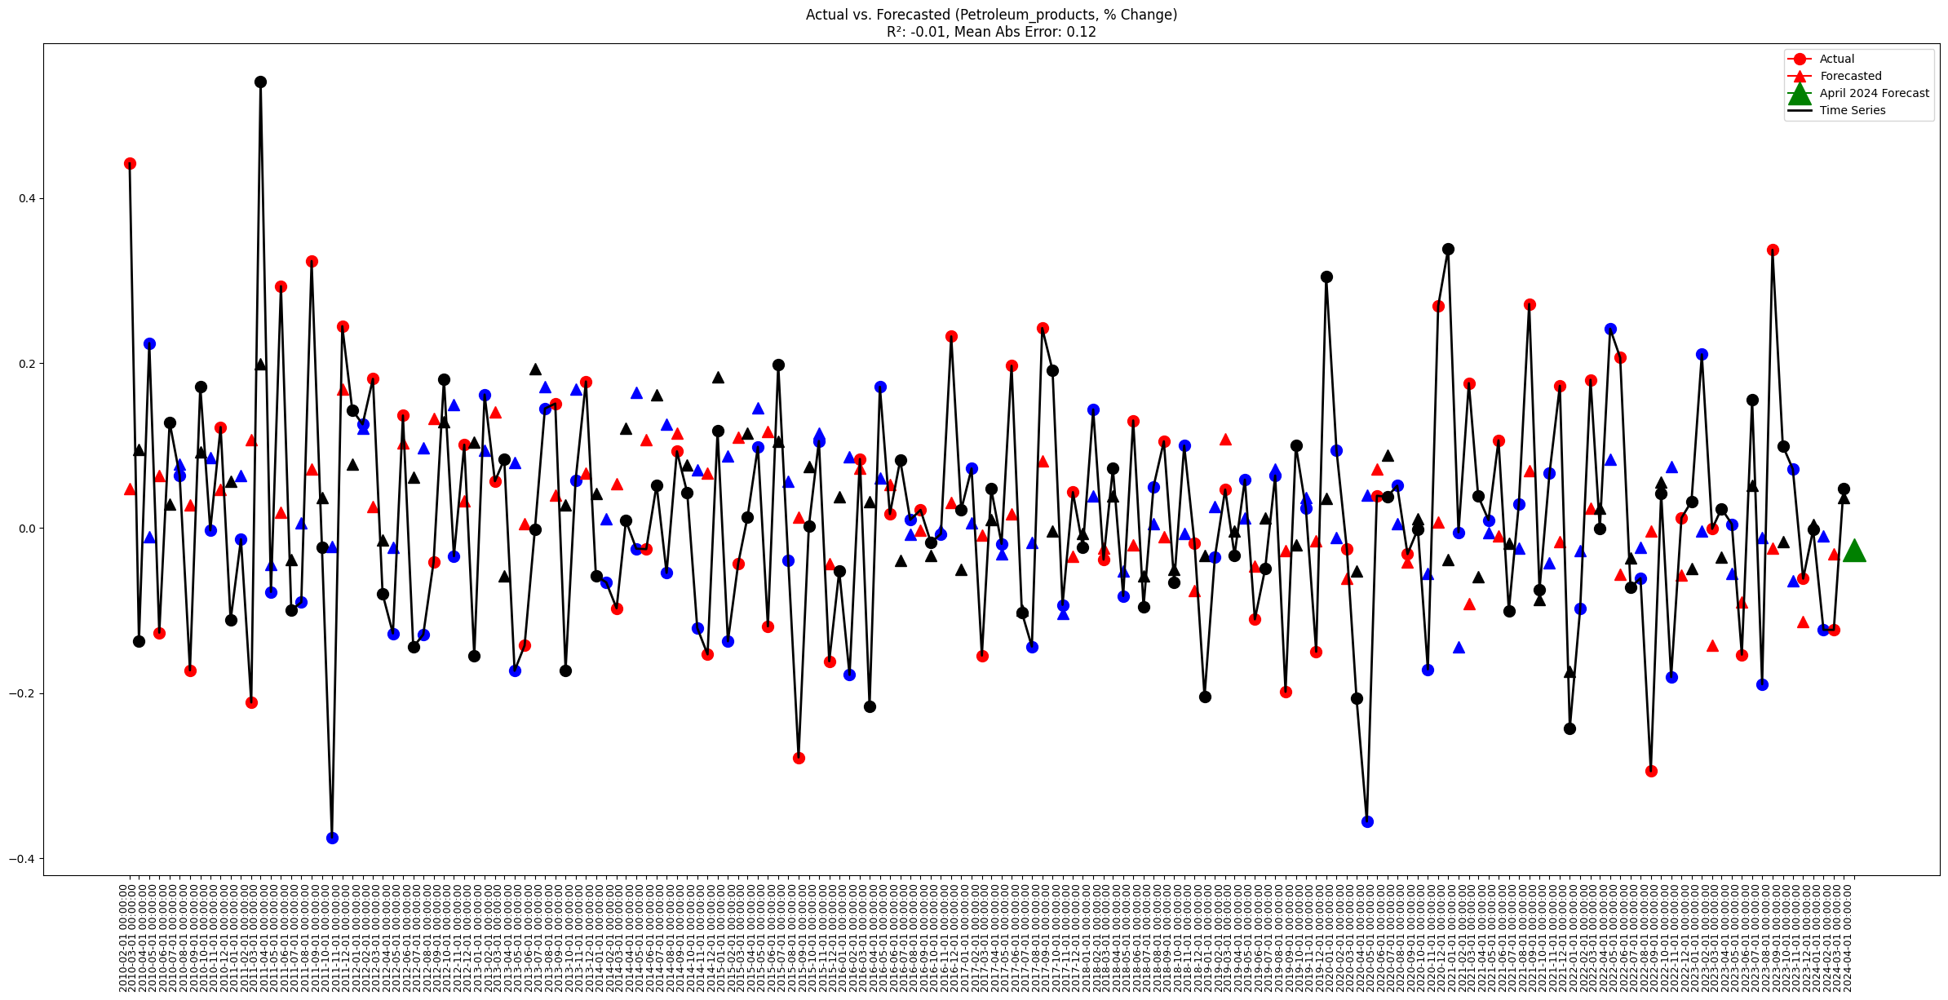

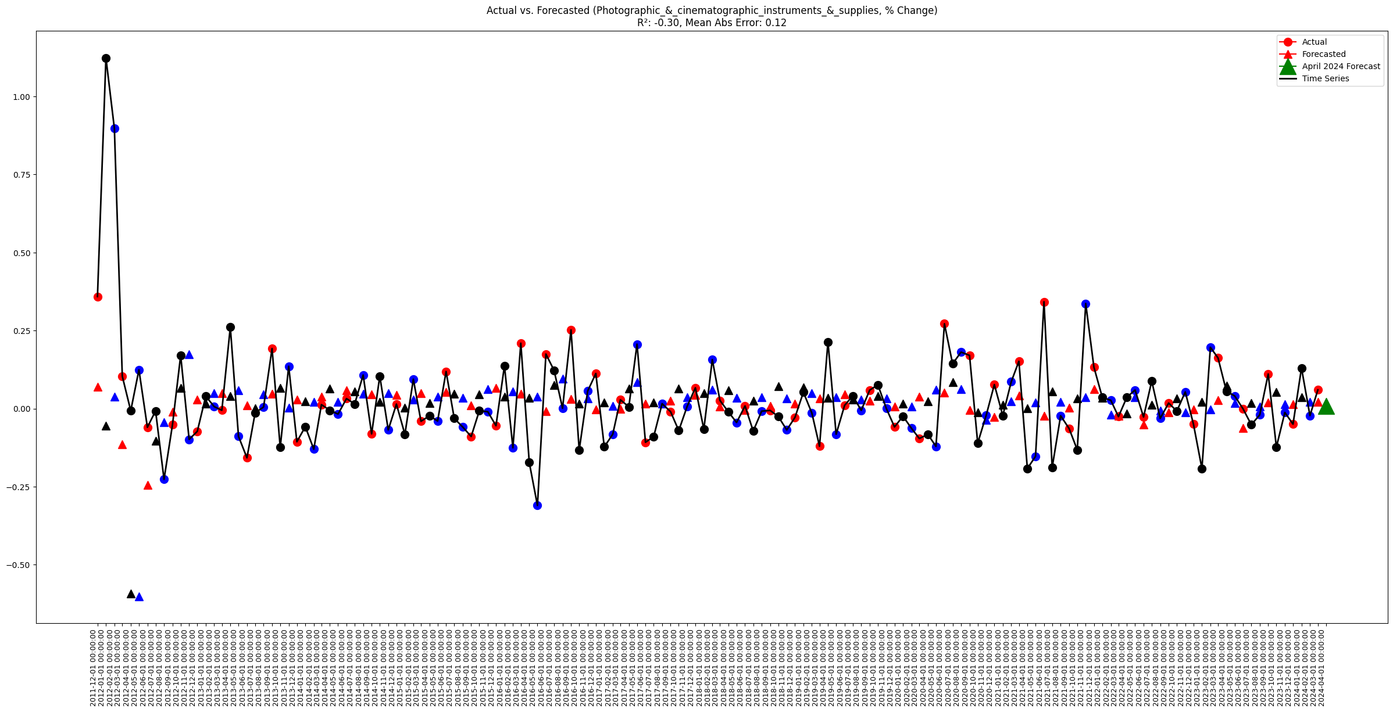

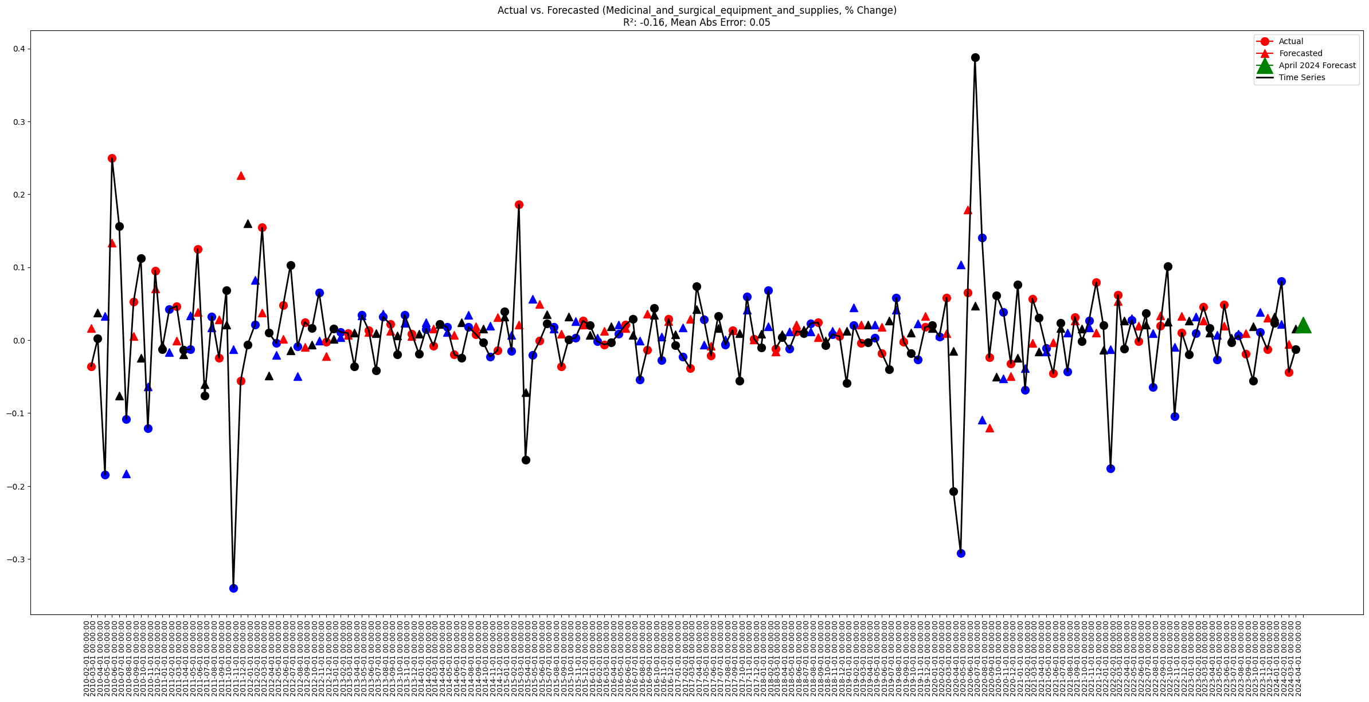

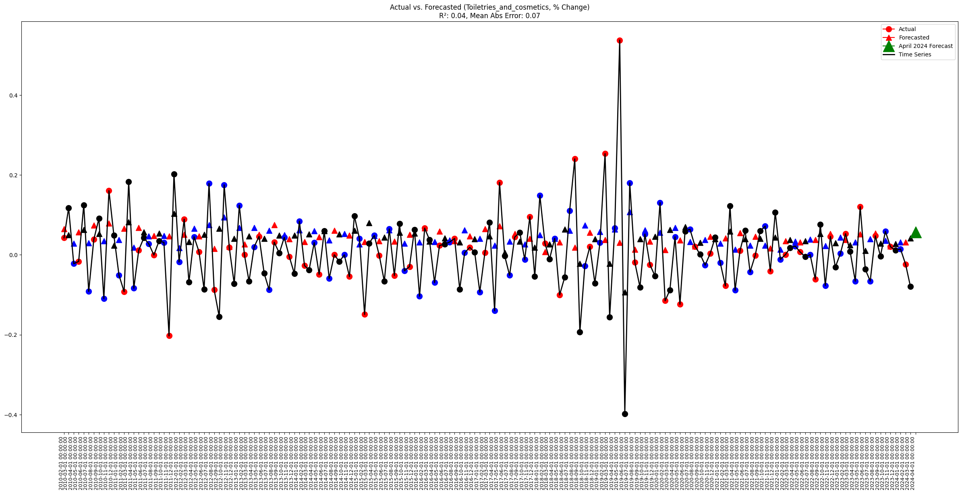

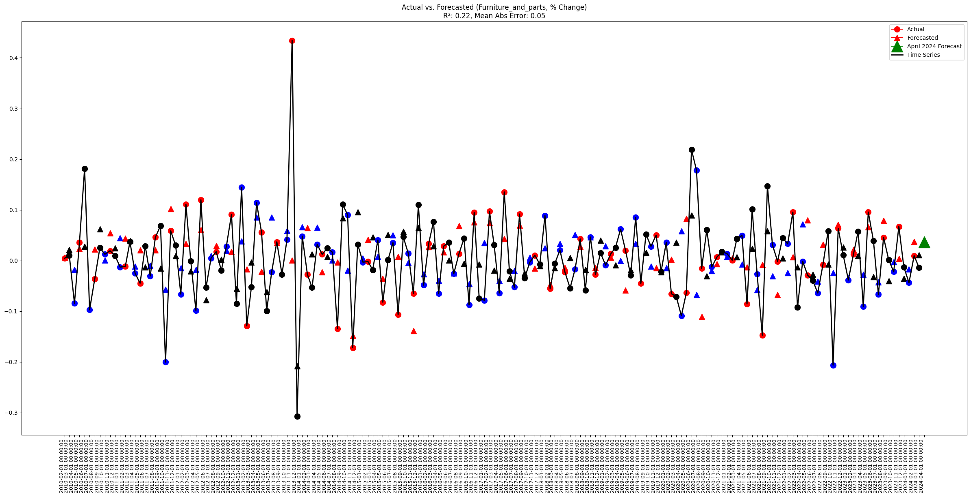

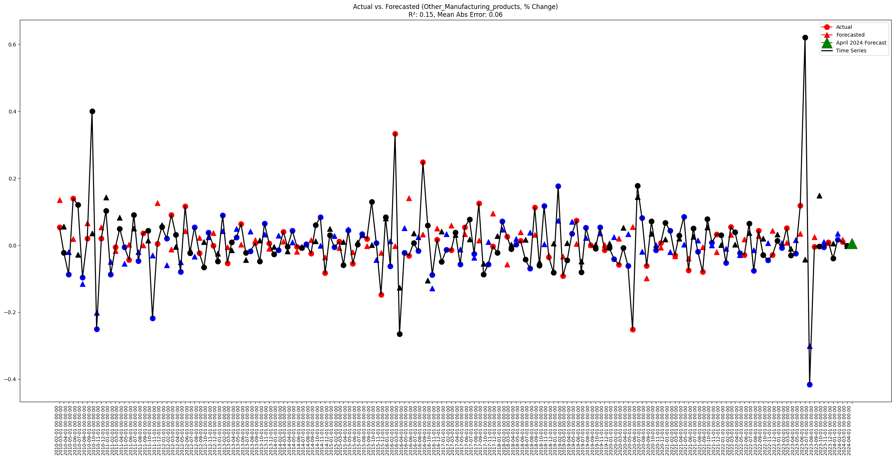

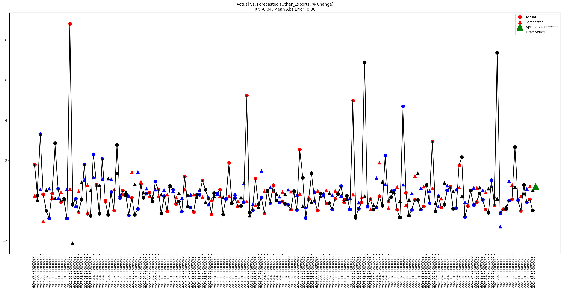

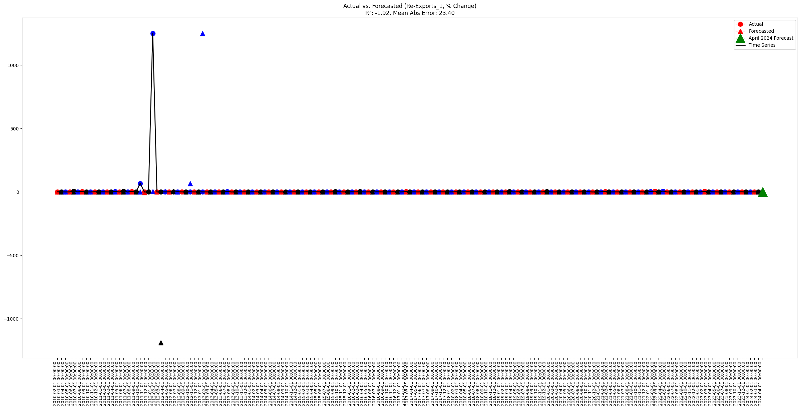

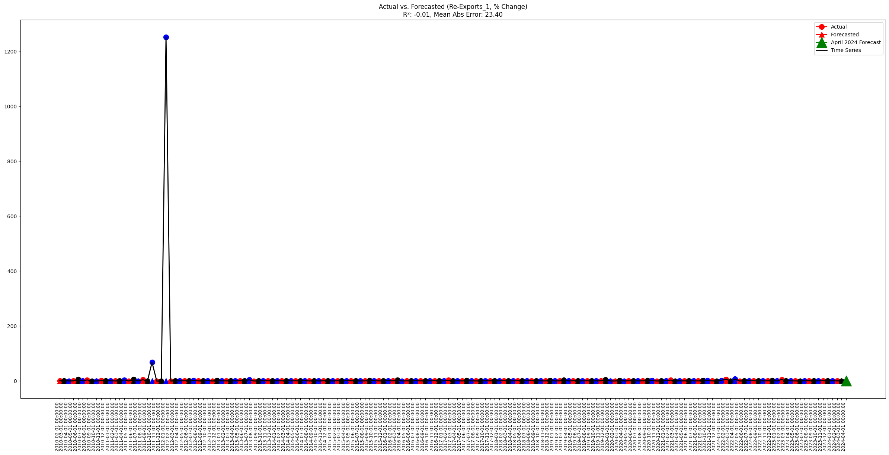

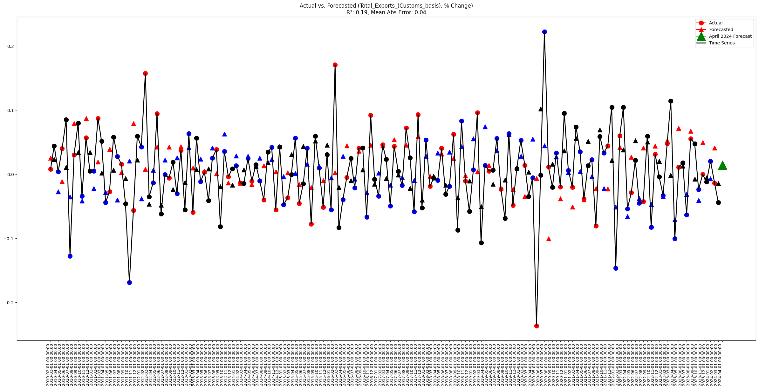

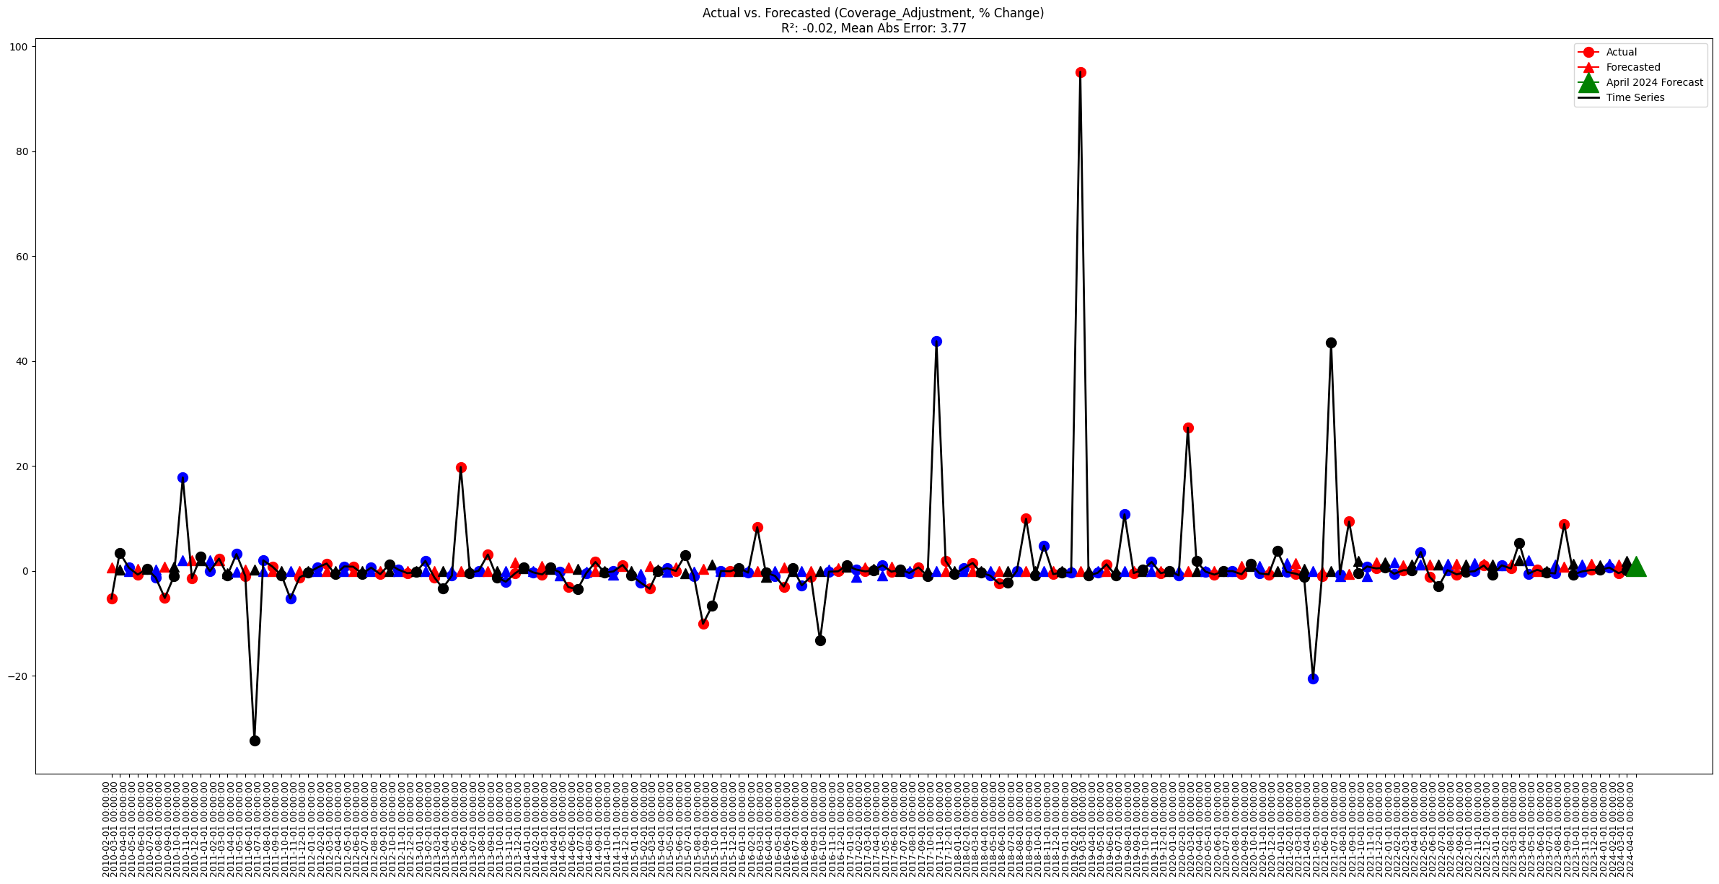

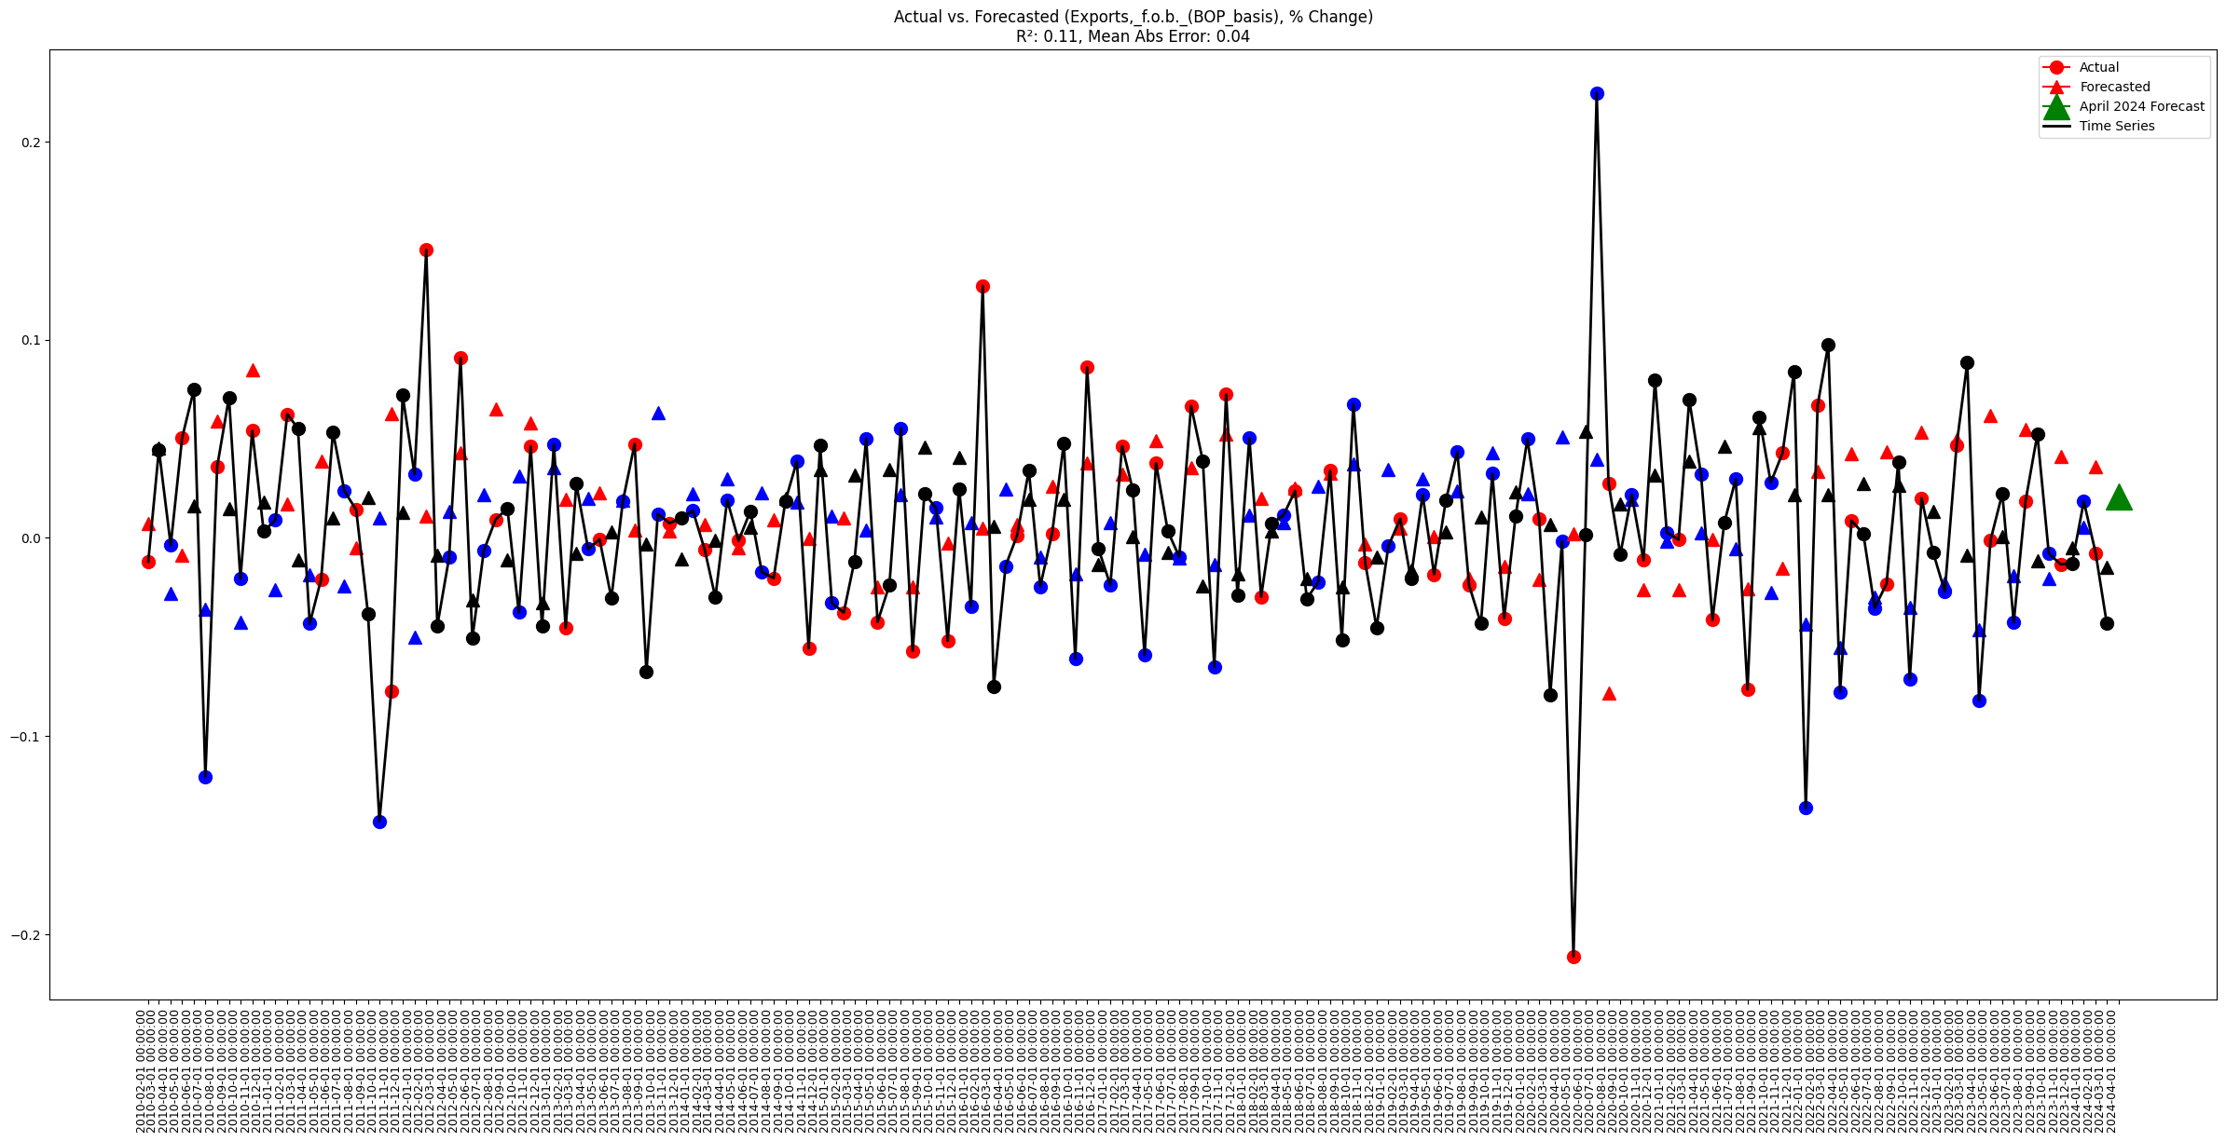

**Individual Weight Forecast**

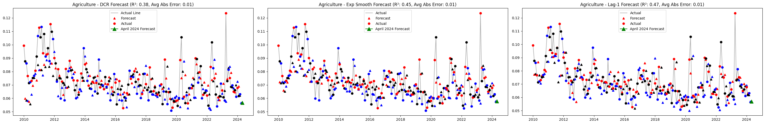

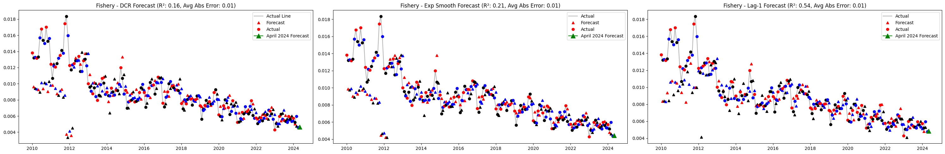

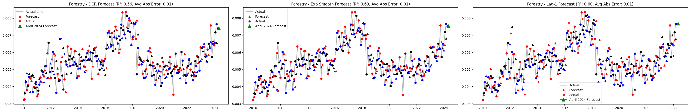

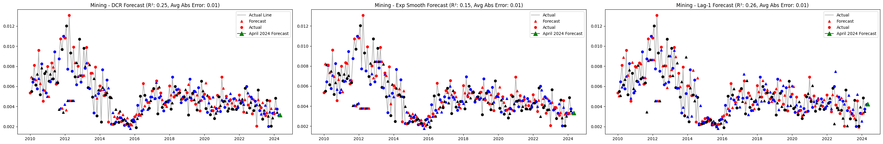

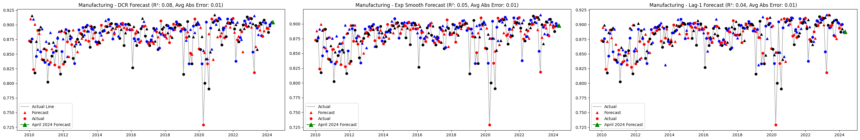

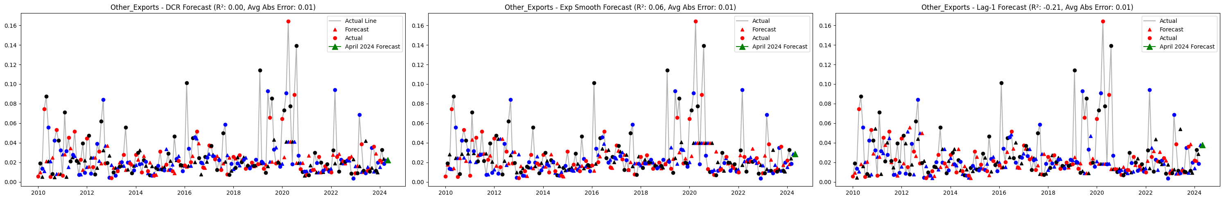

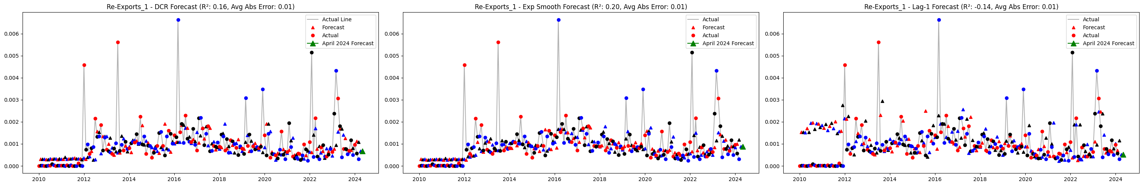

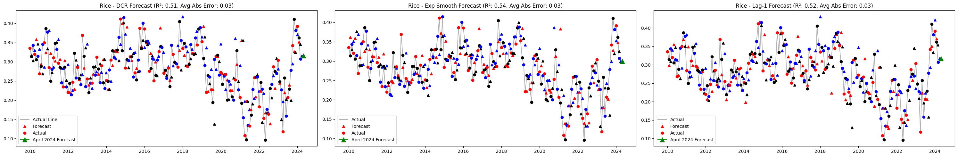

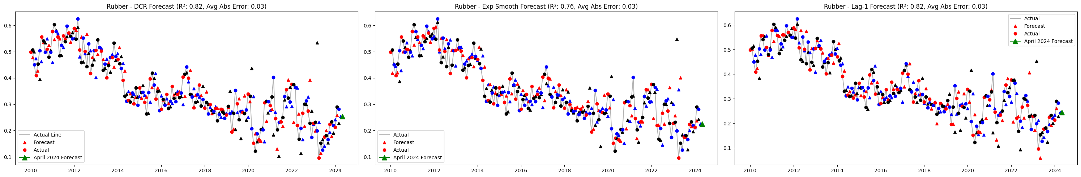

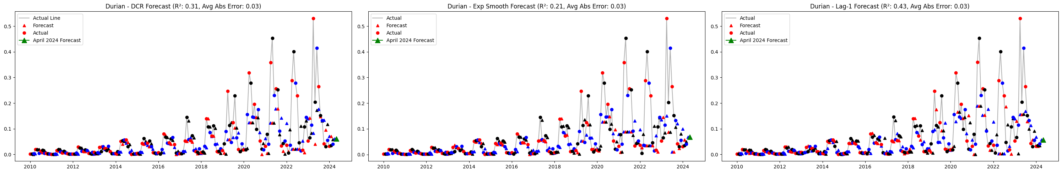

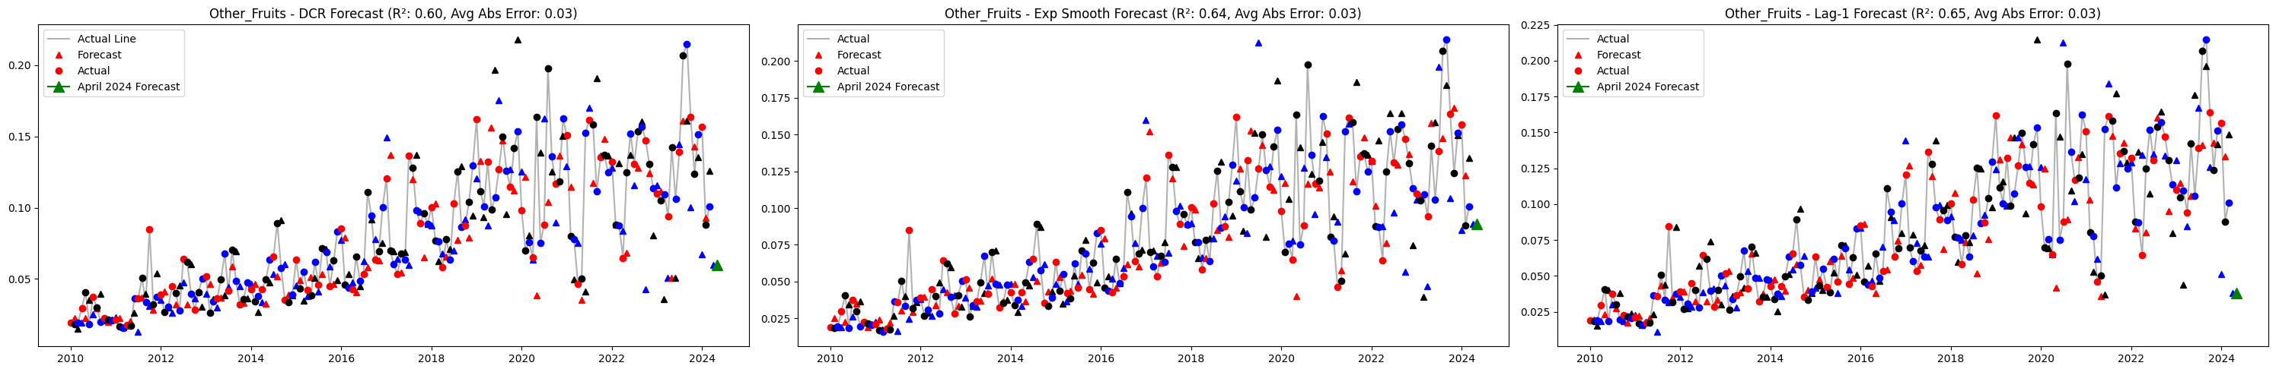

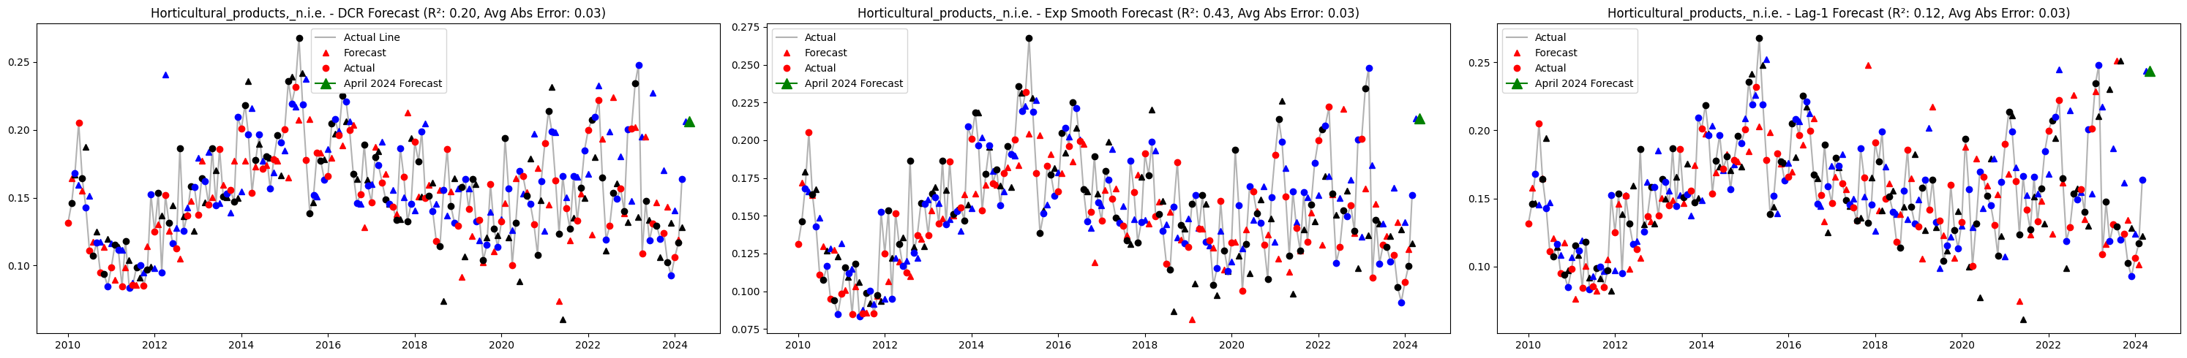

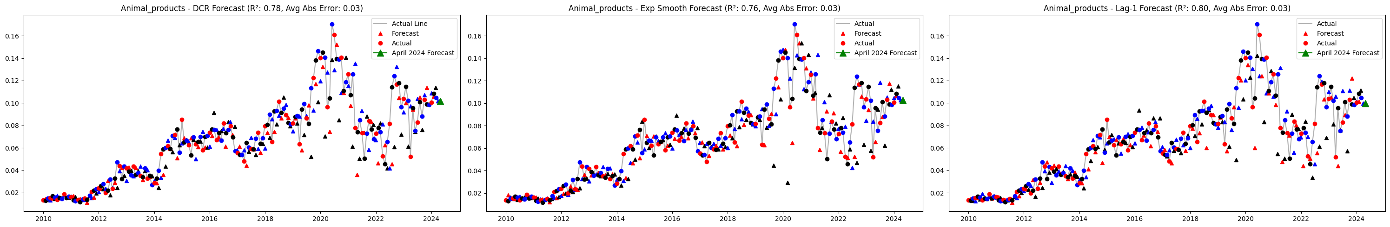

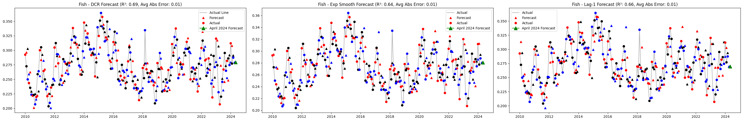

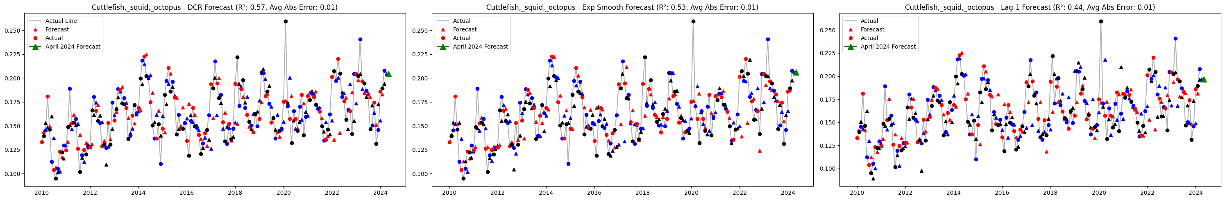

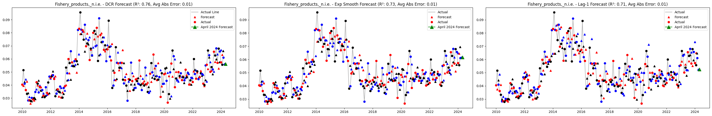

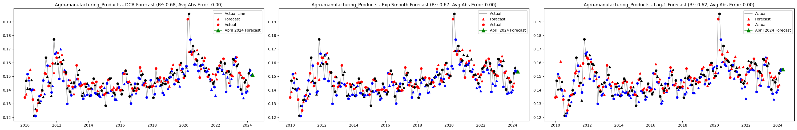

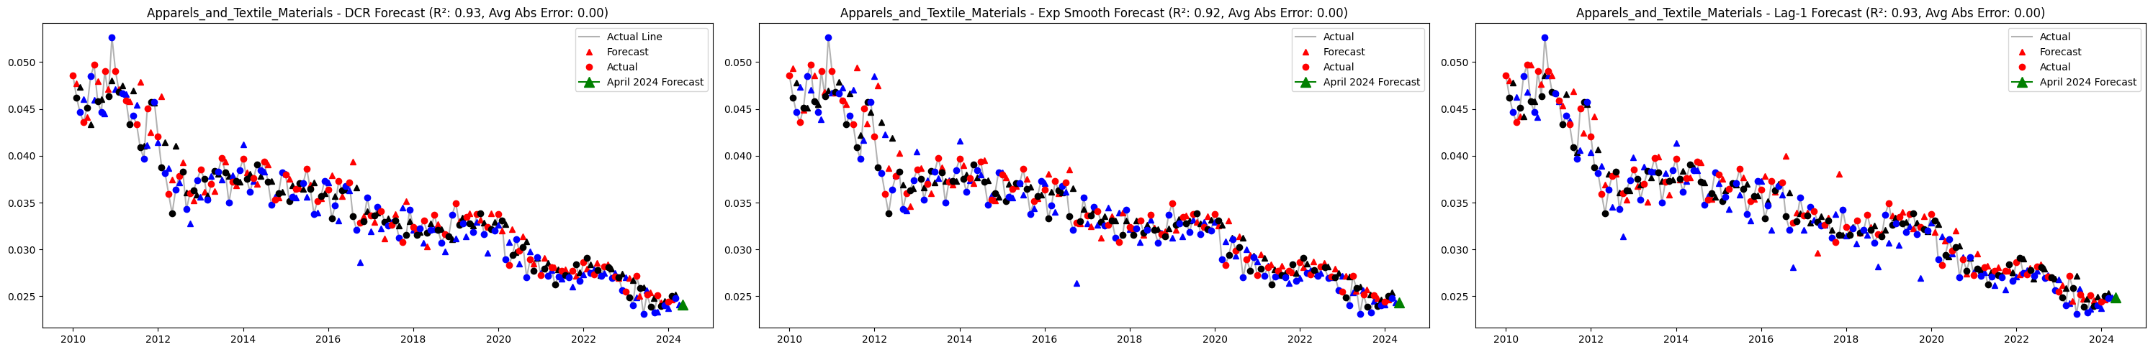

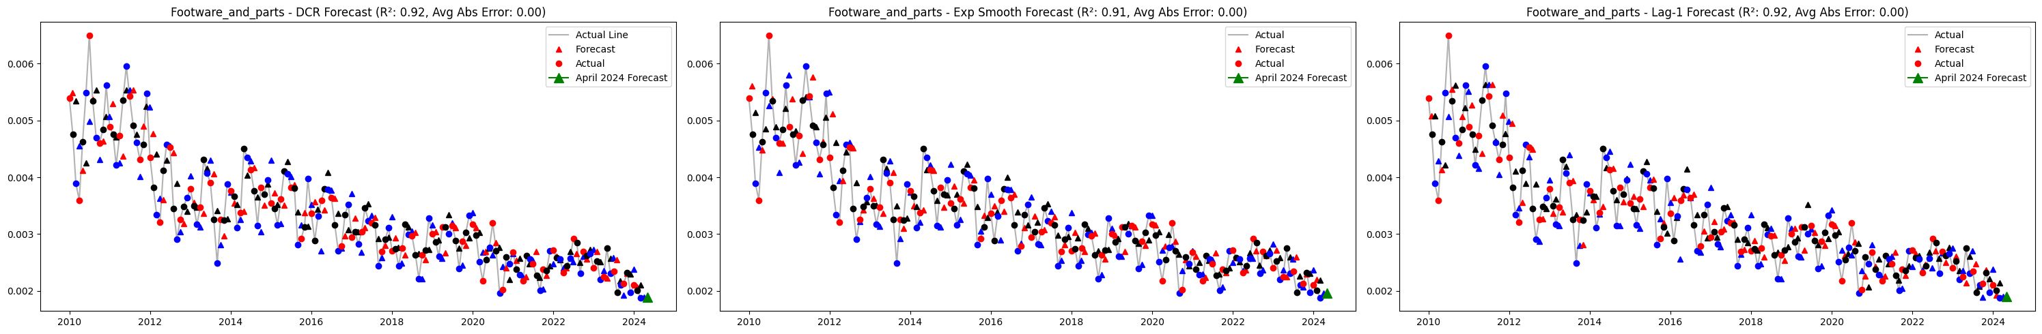

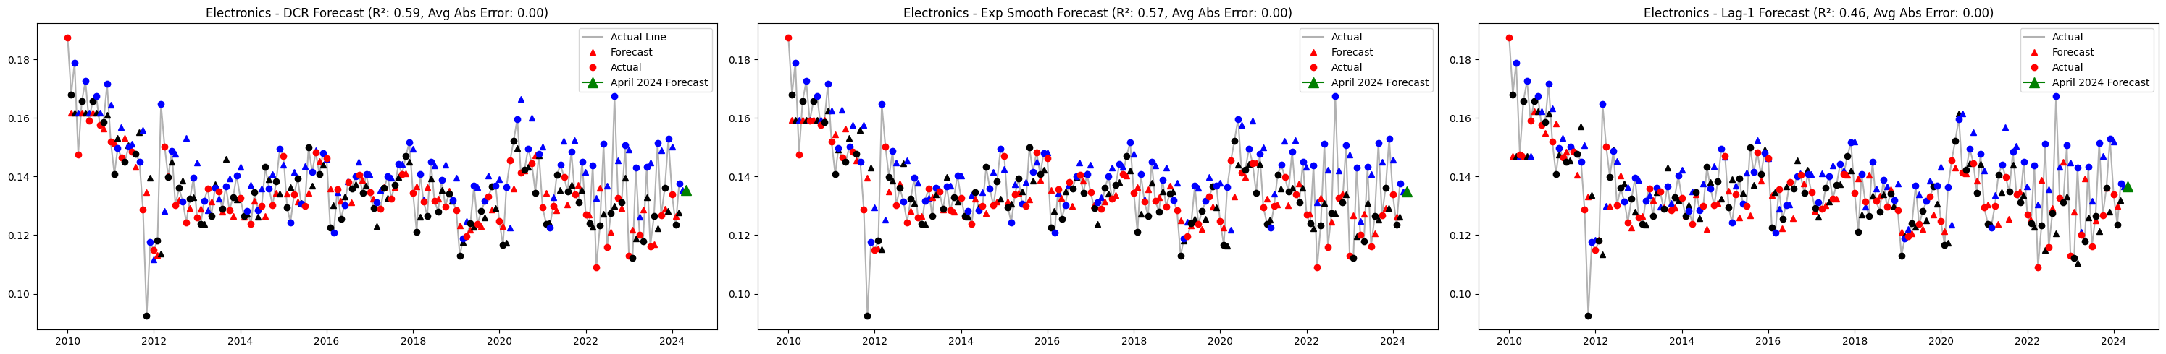

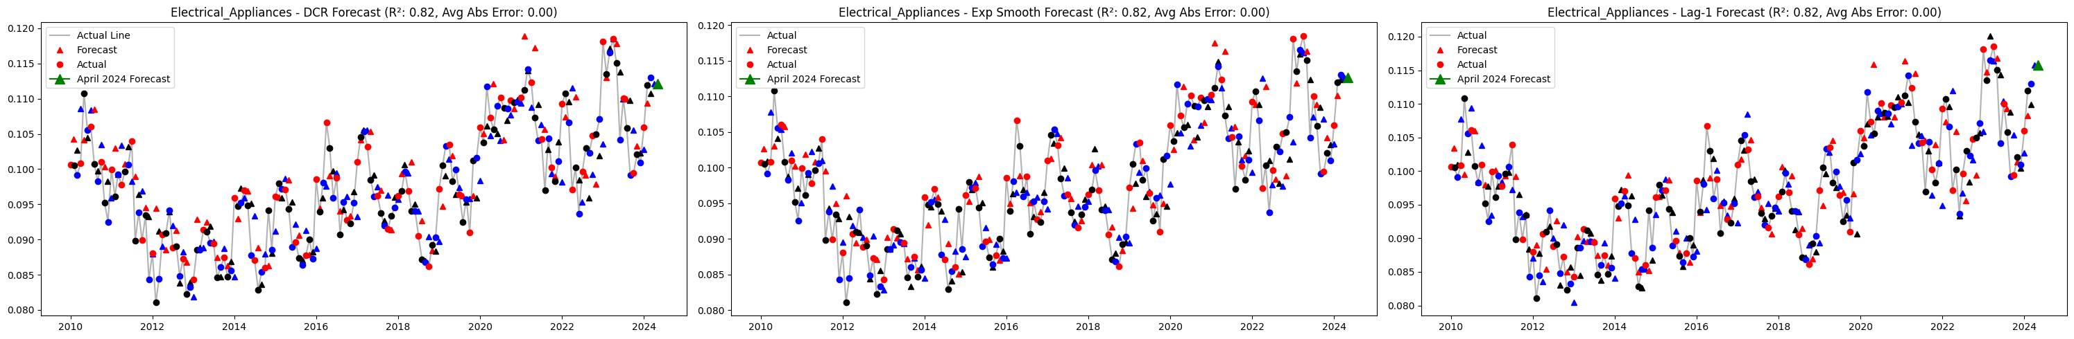

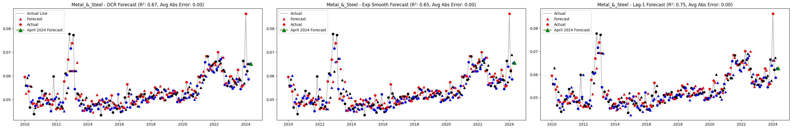

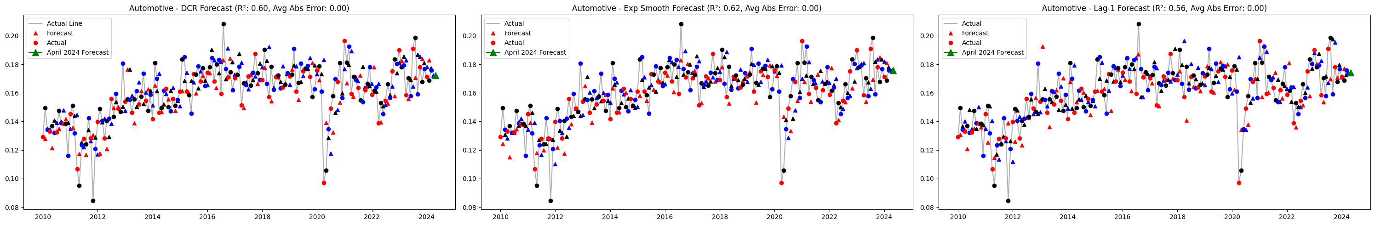

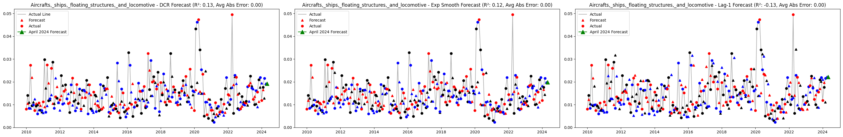

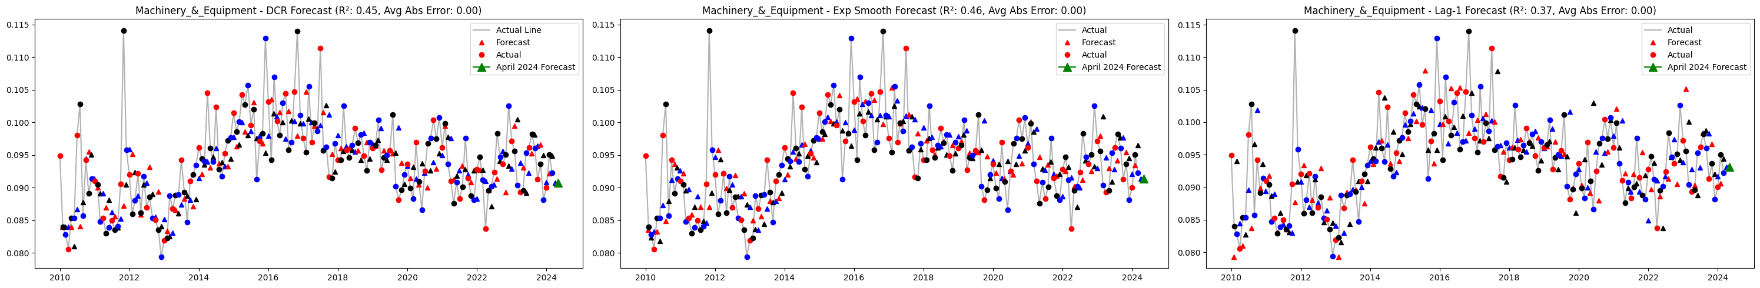

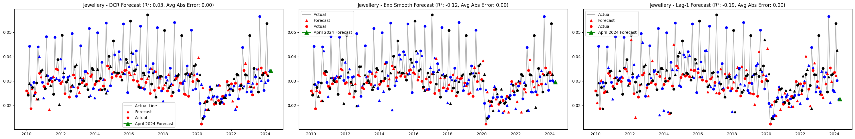

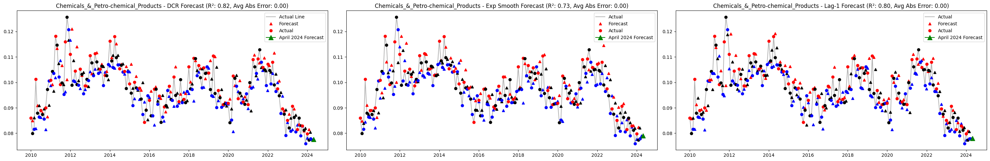

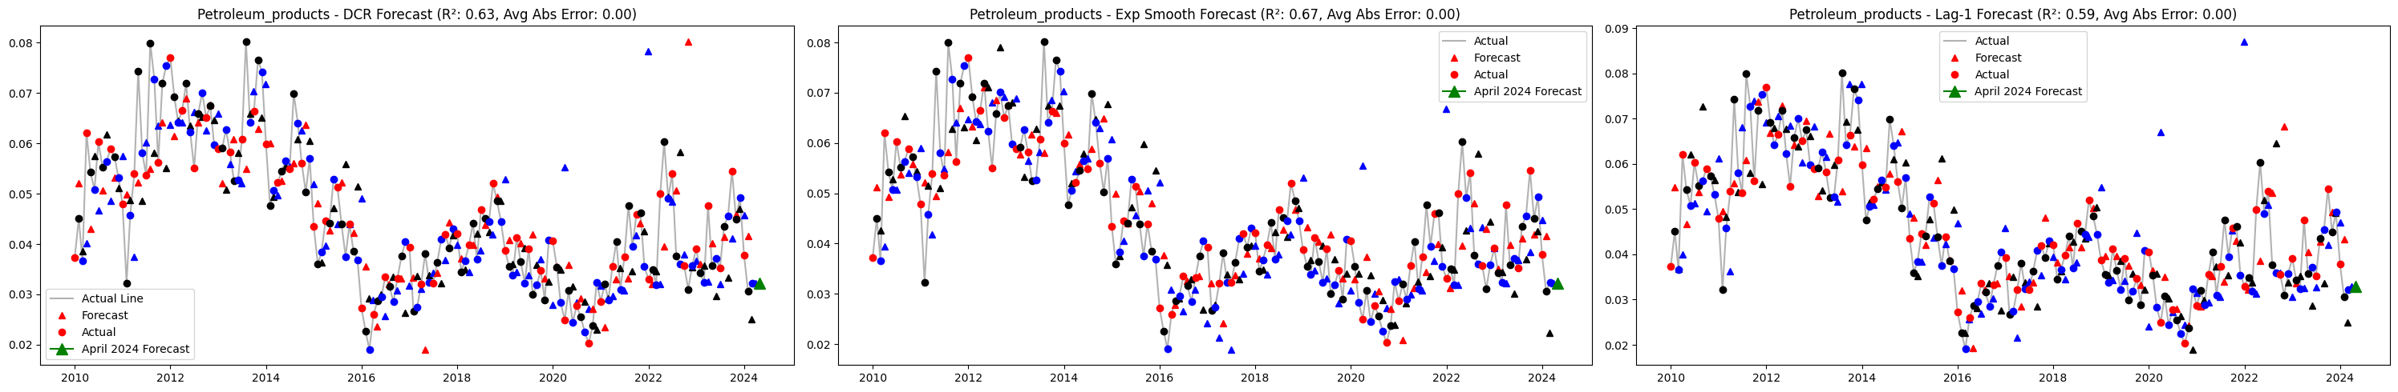

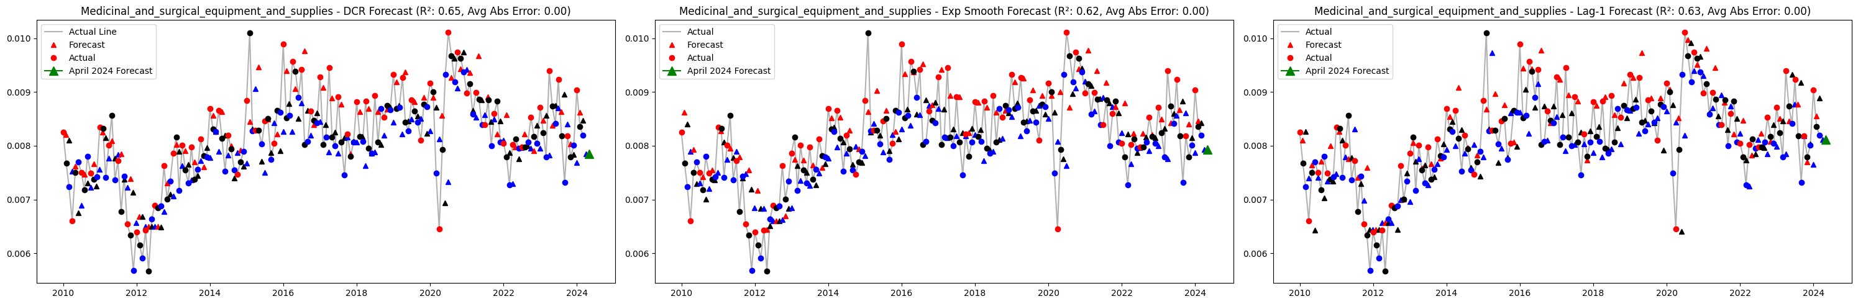

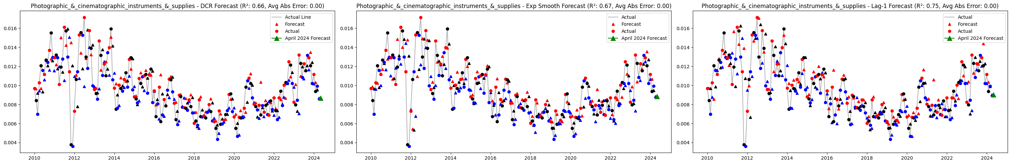



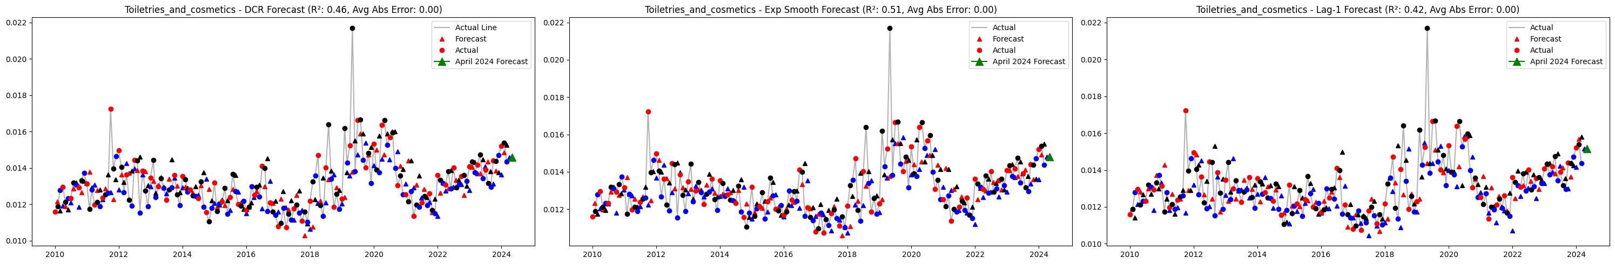

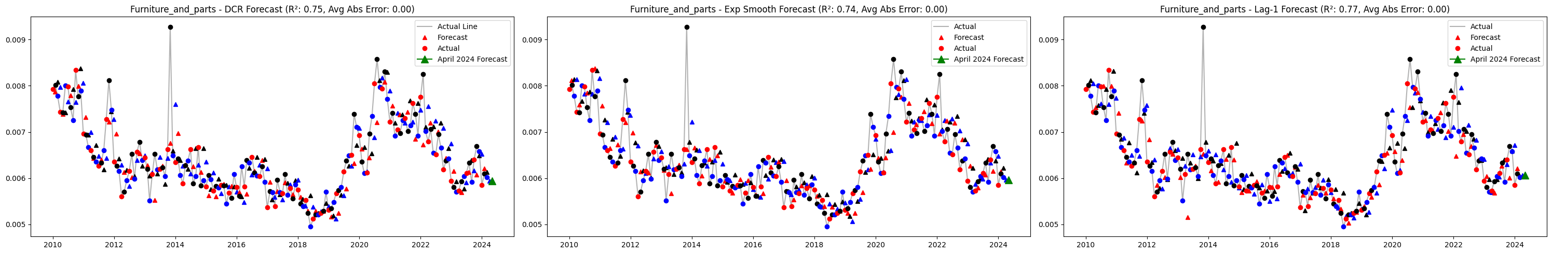

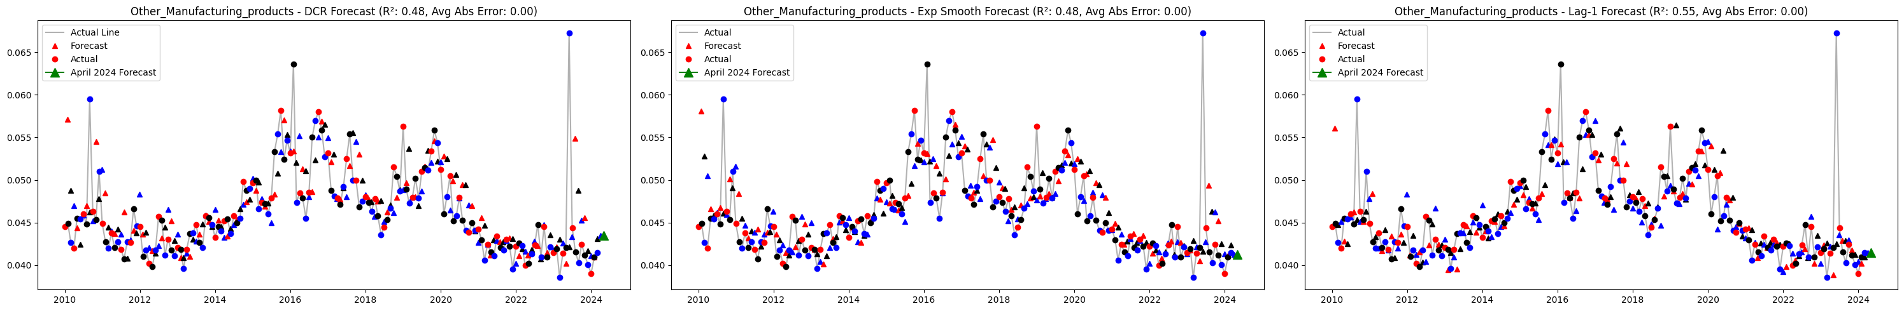

**Weights R^2**

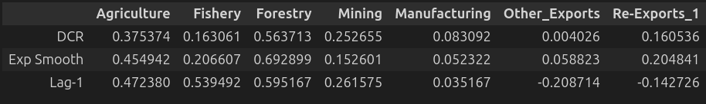

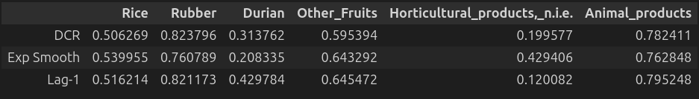

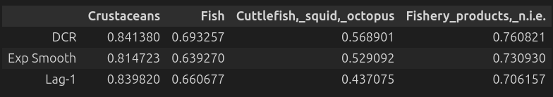

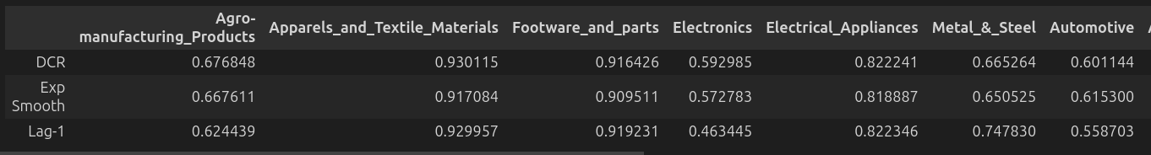



**Results after Restitching Components and Re-seasonalizing**

**Level 0 (Single BOP Series)**





**Benchmark: Exponential Smoothing**



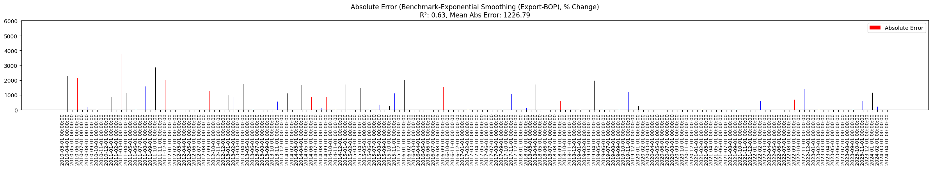

**Level 1 (Export-CustomBasis)**

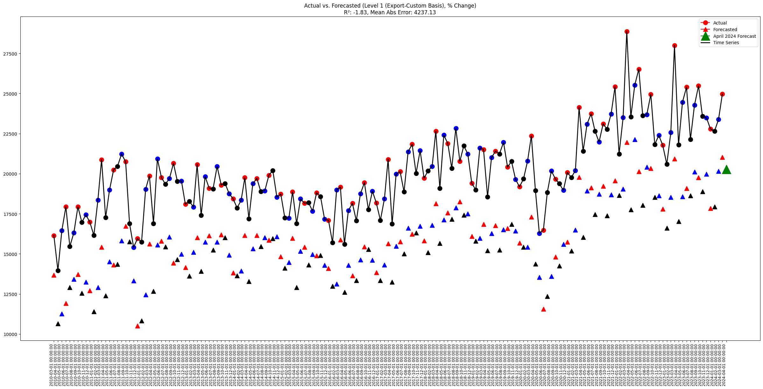

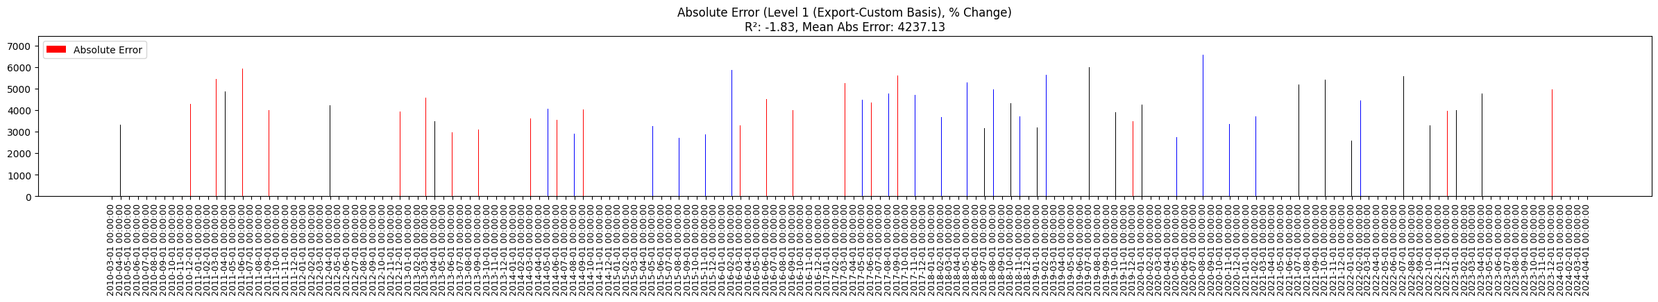

**Level 1 (Export-CustomBasis, Linear+Cap Optimization)**

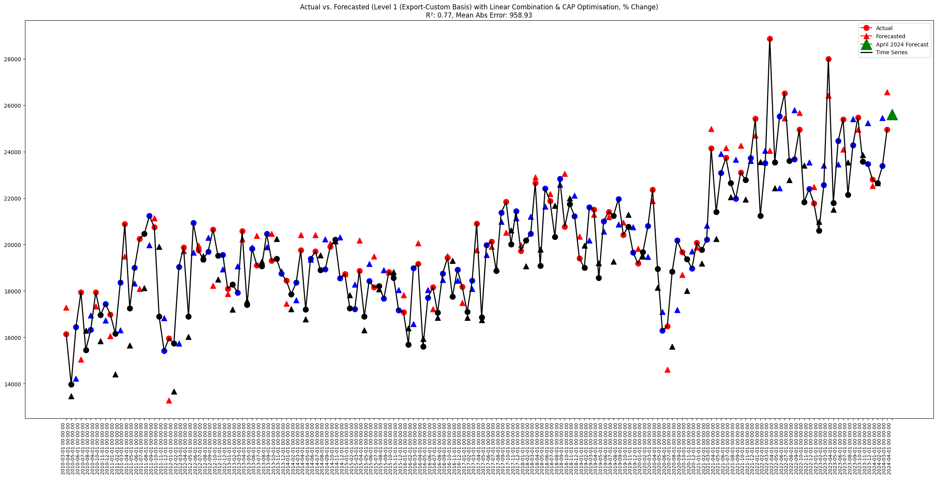

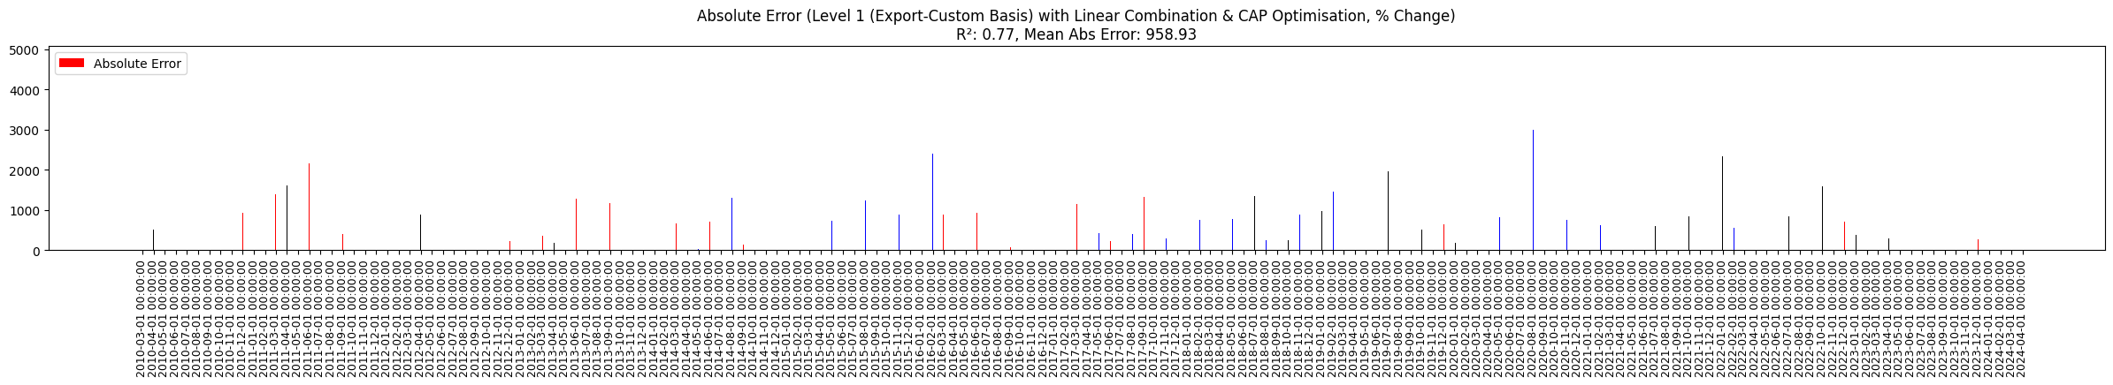

**Level 1 (Export-BOP)**

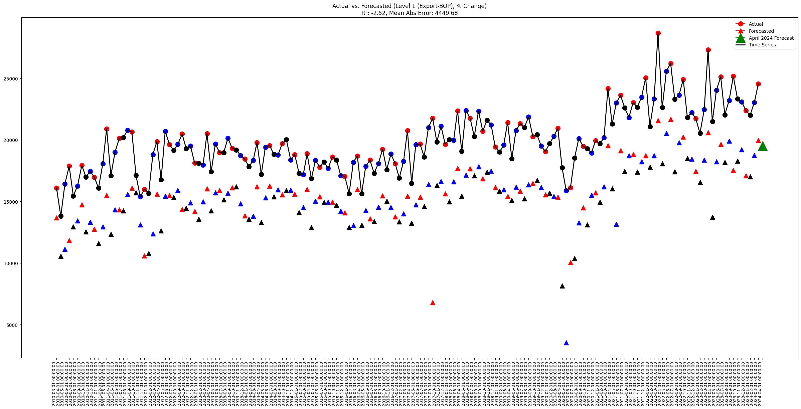

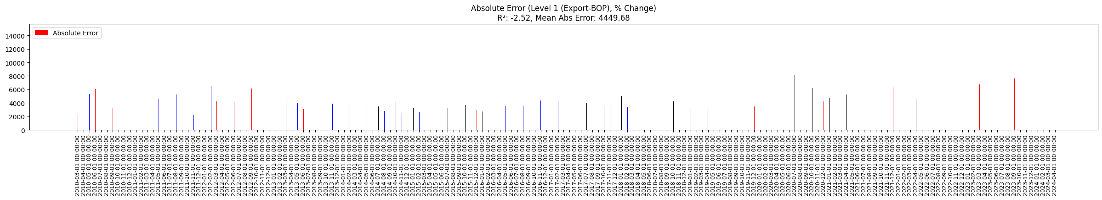

**Level 1 (Export-BOP, Linear+Cap Optimization)**

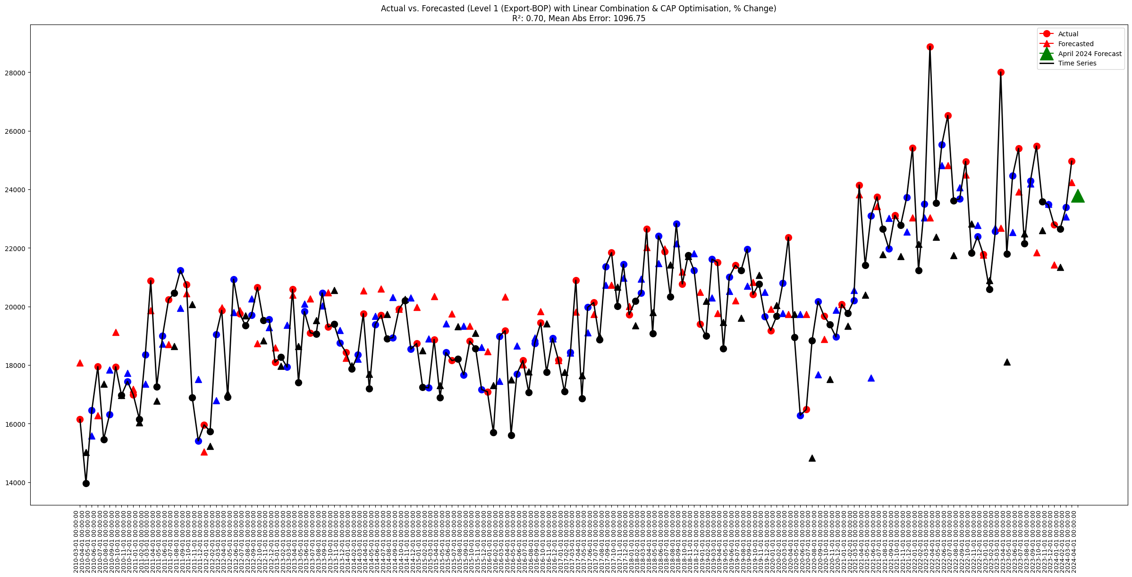

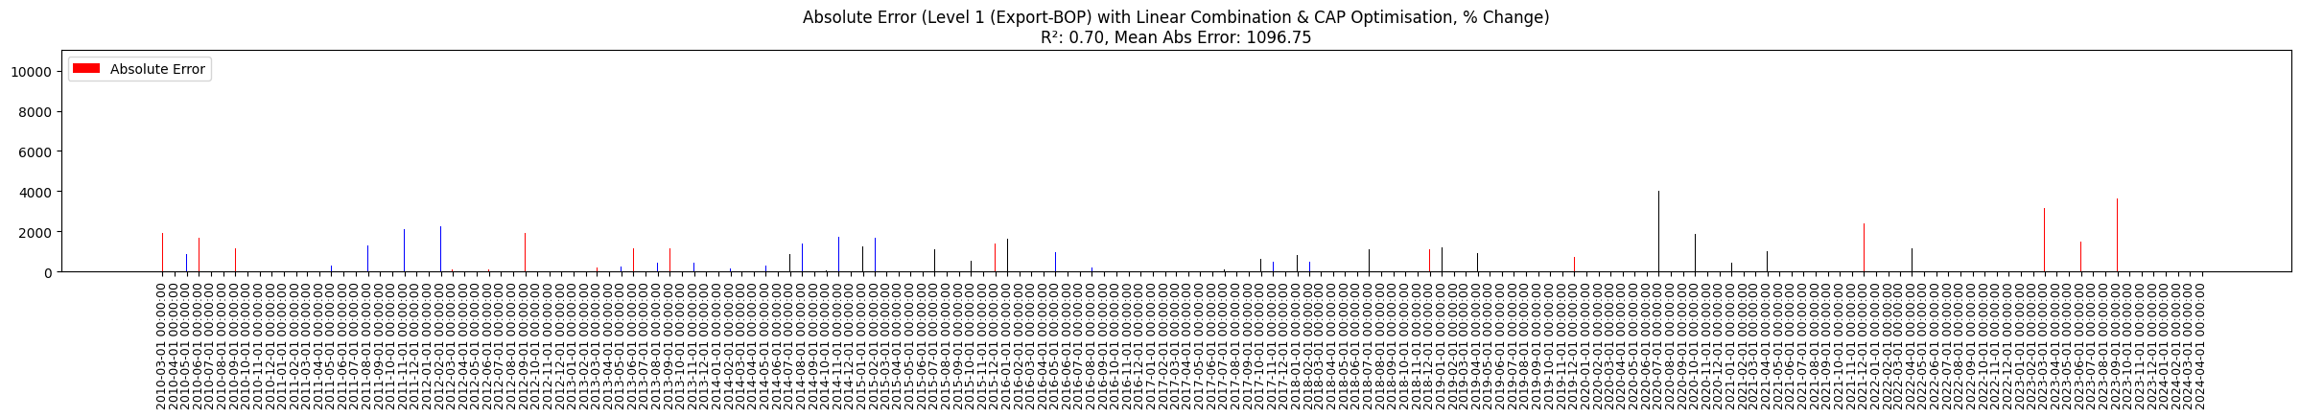

**Level 2 (Export-CustomBasis)**

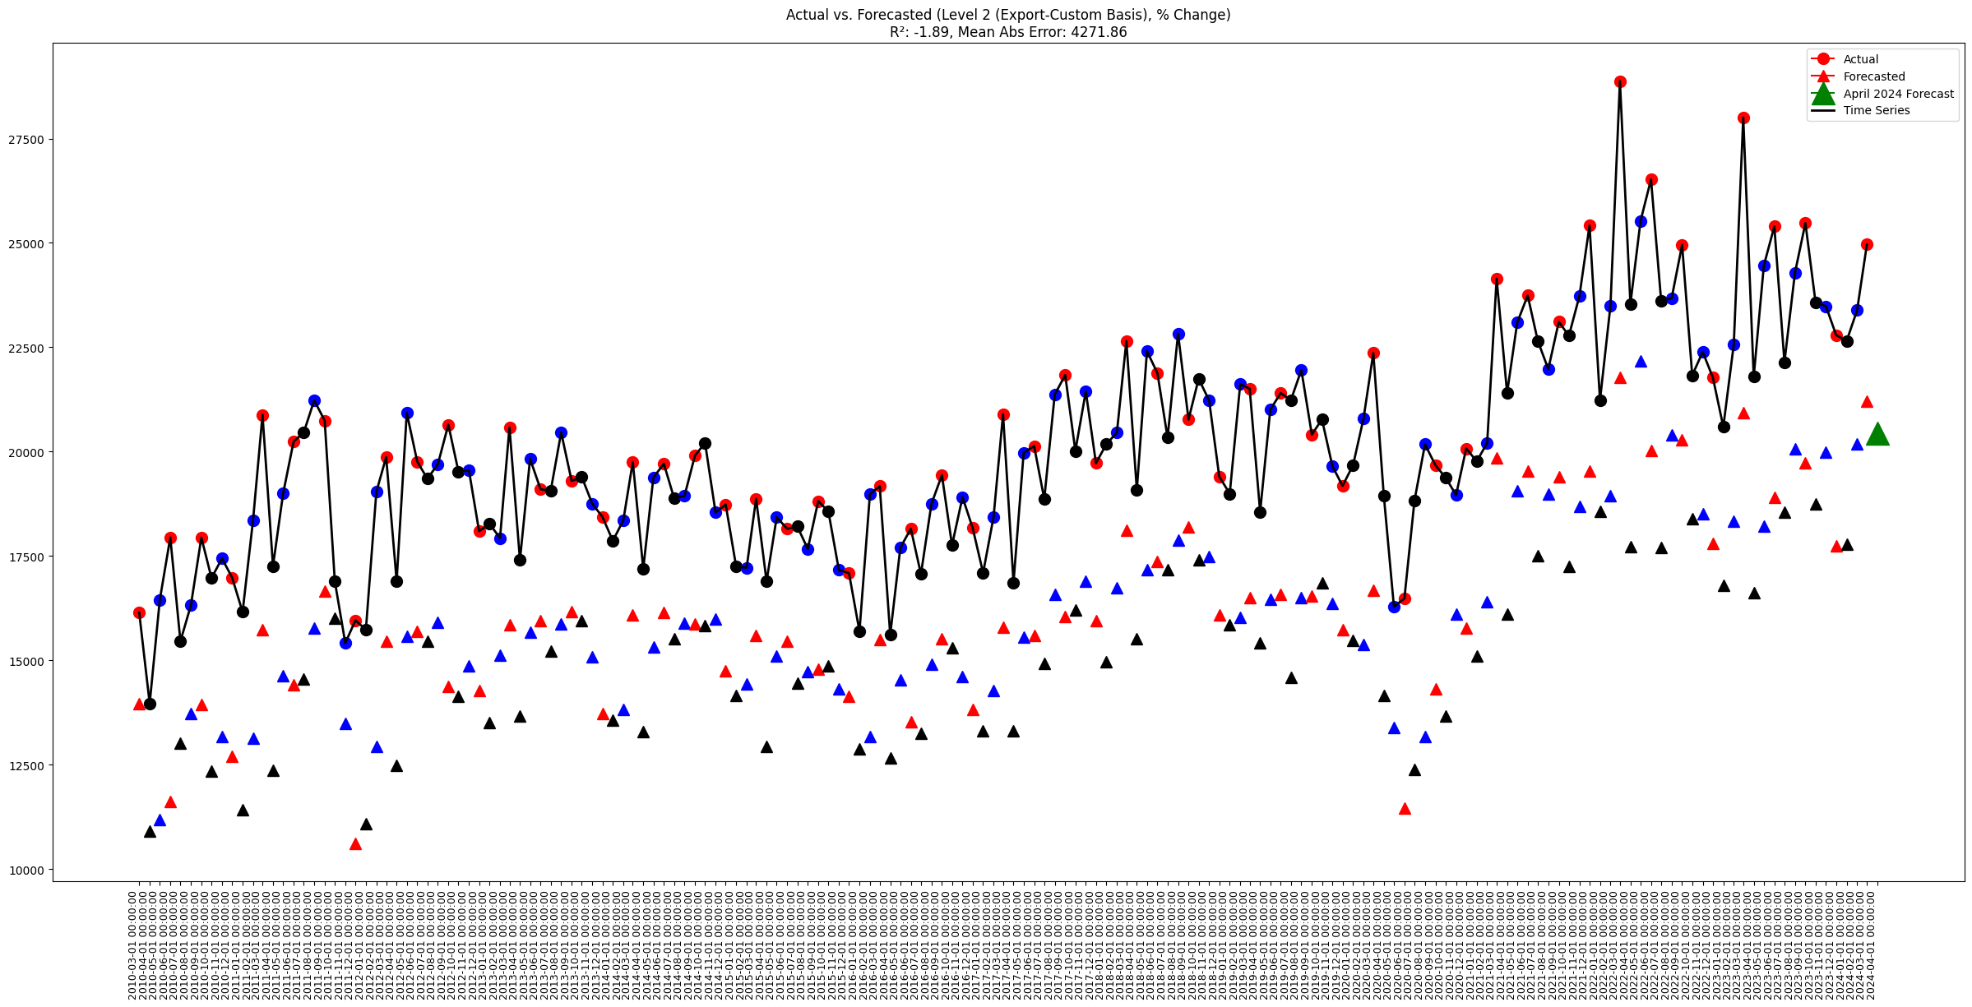

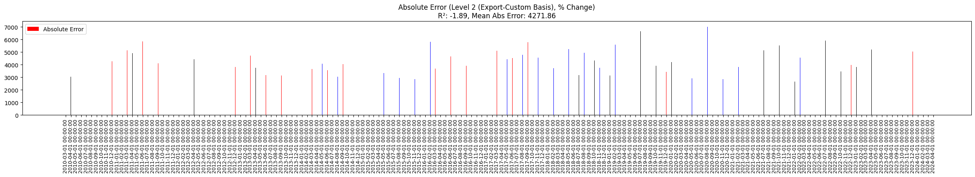

**Level 2 (Export-CustomBasis, Linear+Cap Optimization)**

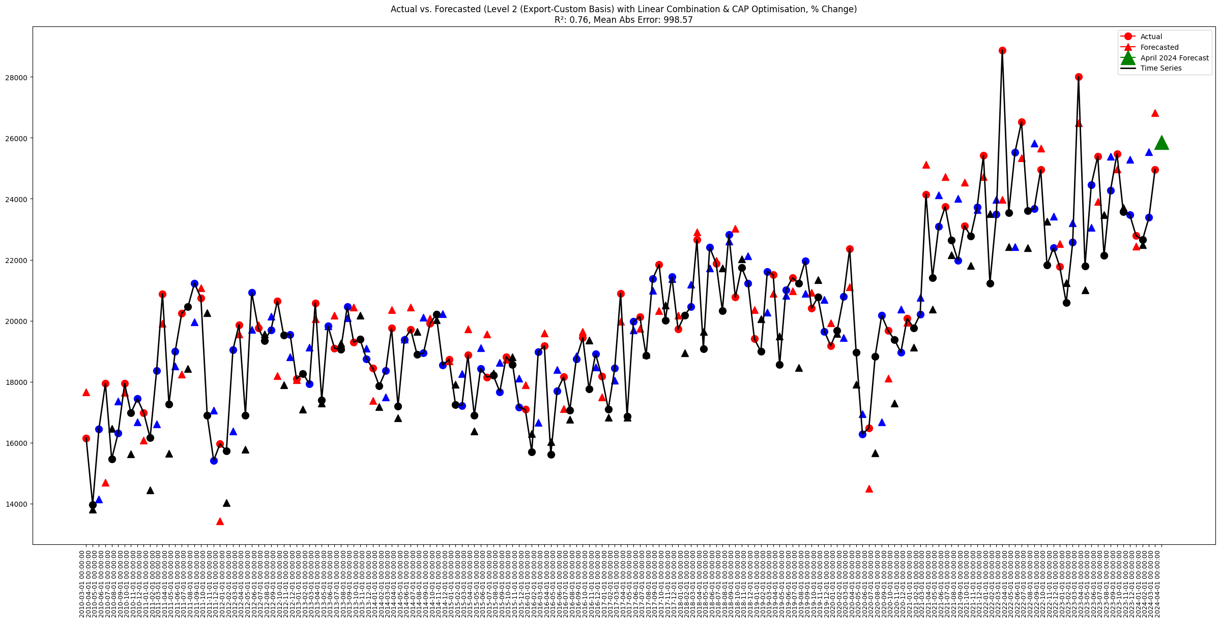

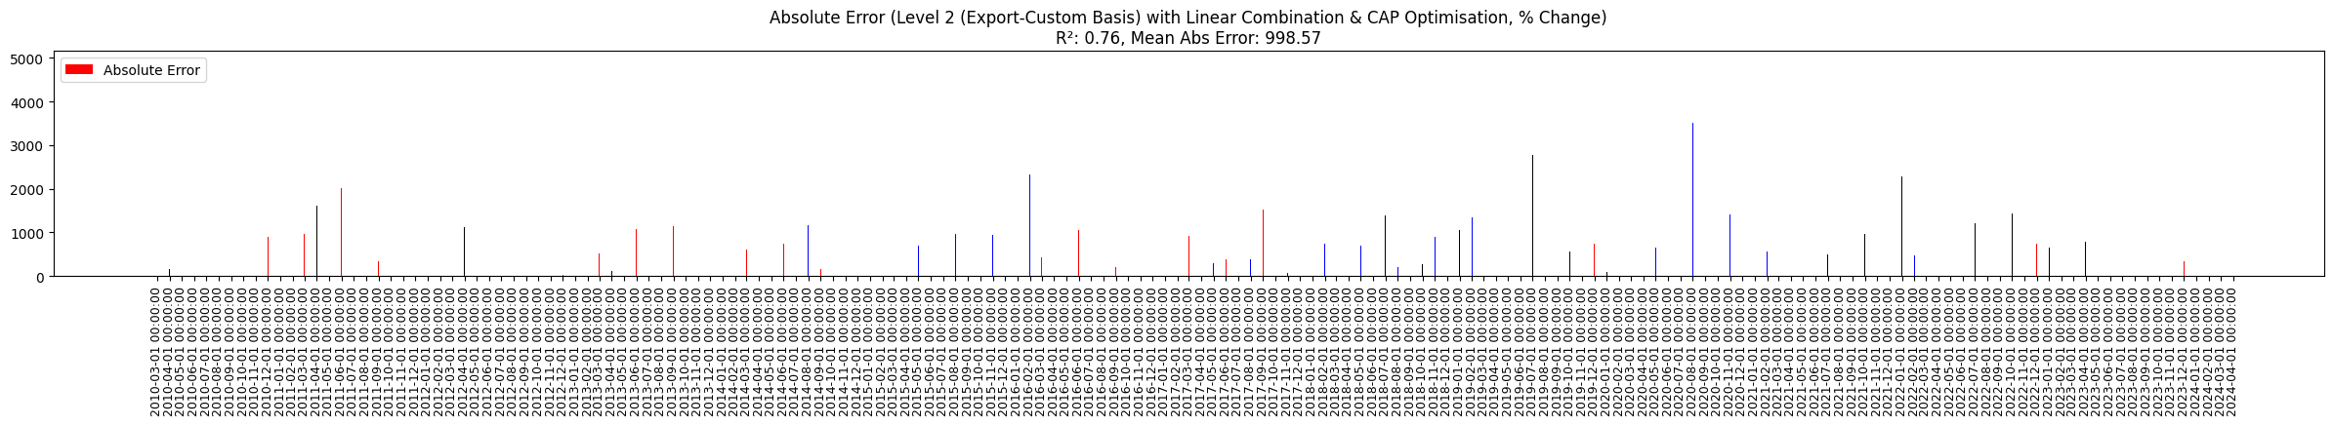

**Level 2 (Export-BOP)**



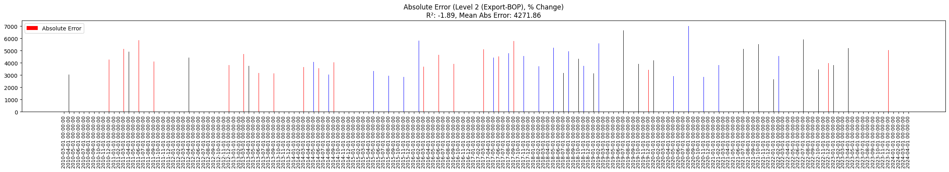

**Level 2 (Export-BOP, Linear+Cap Optimization)**



